<https://food.brothersmedia.site/>

https://github.com/brothersmedia190/food_delivery_laravel9

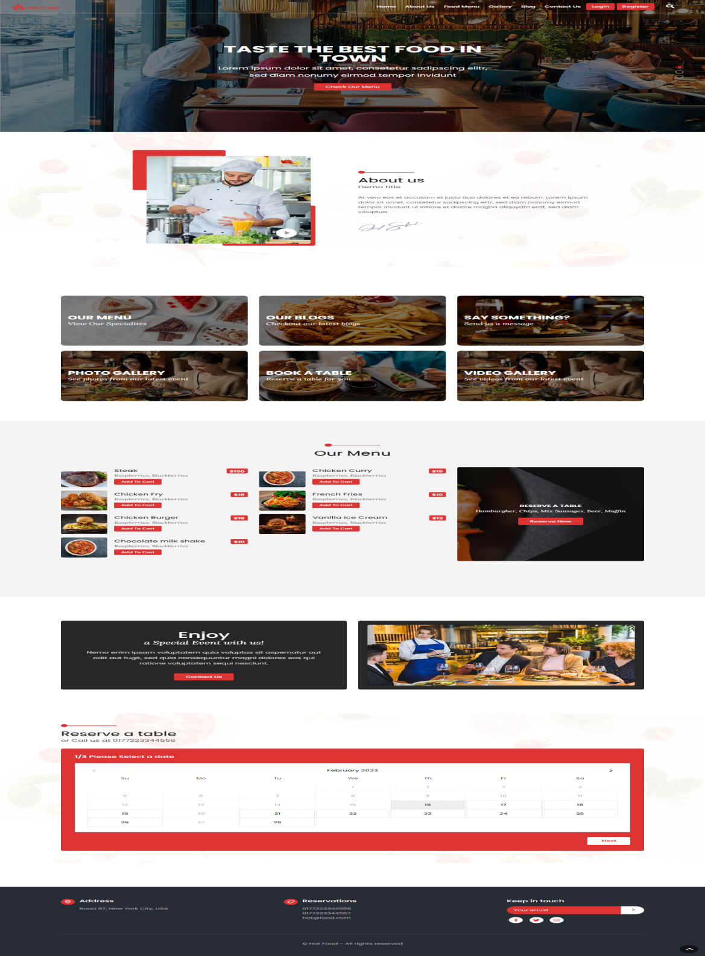

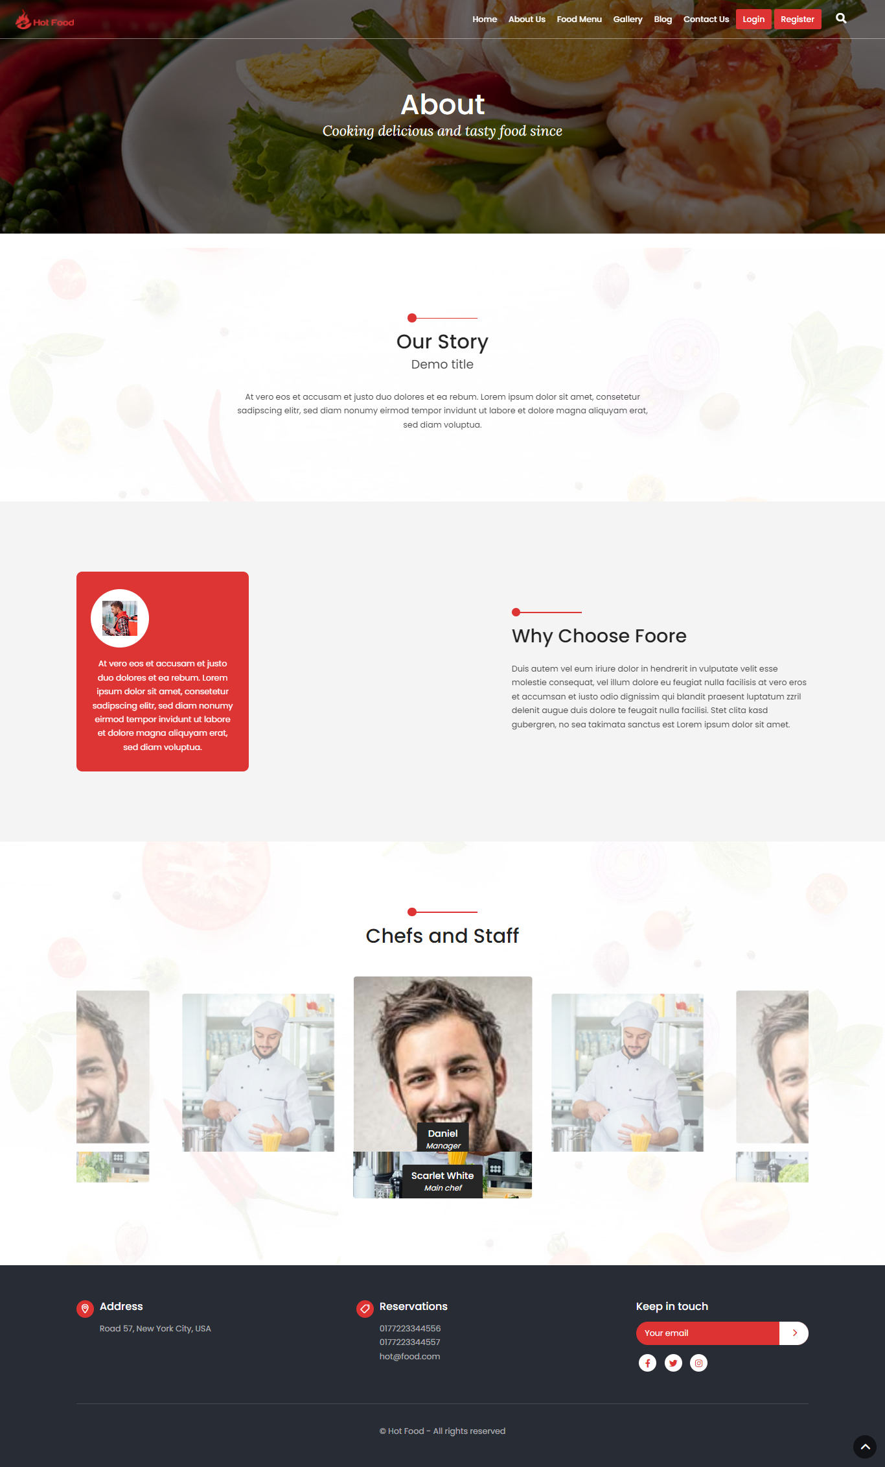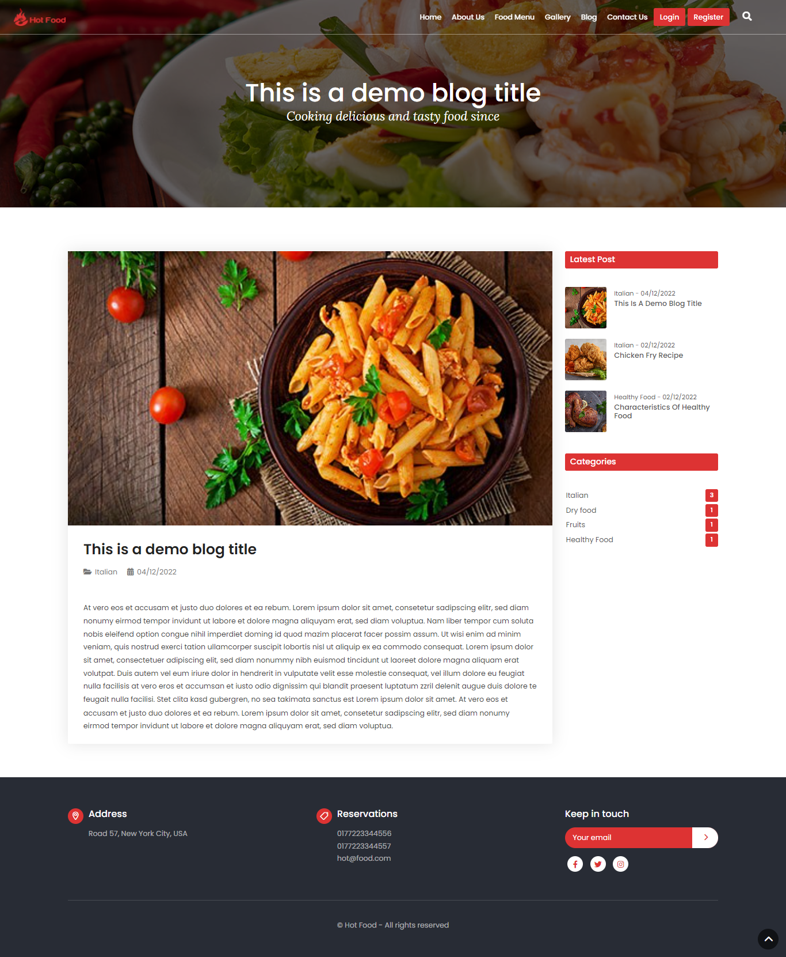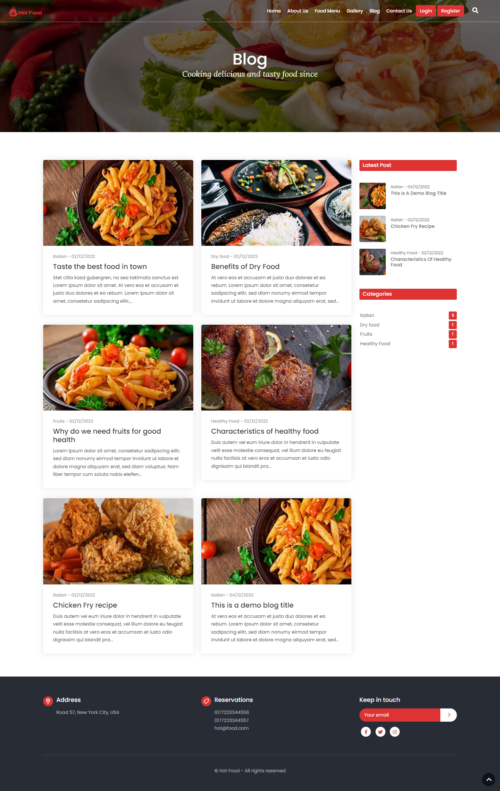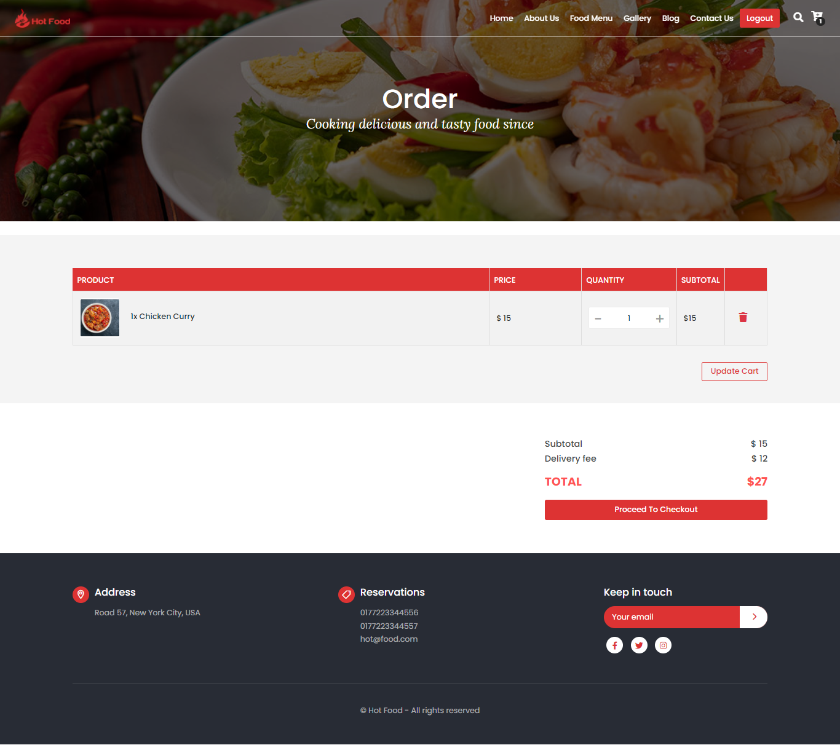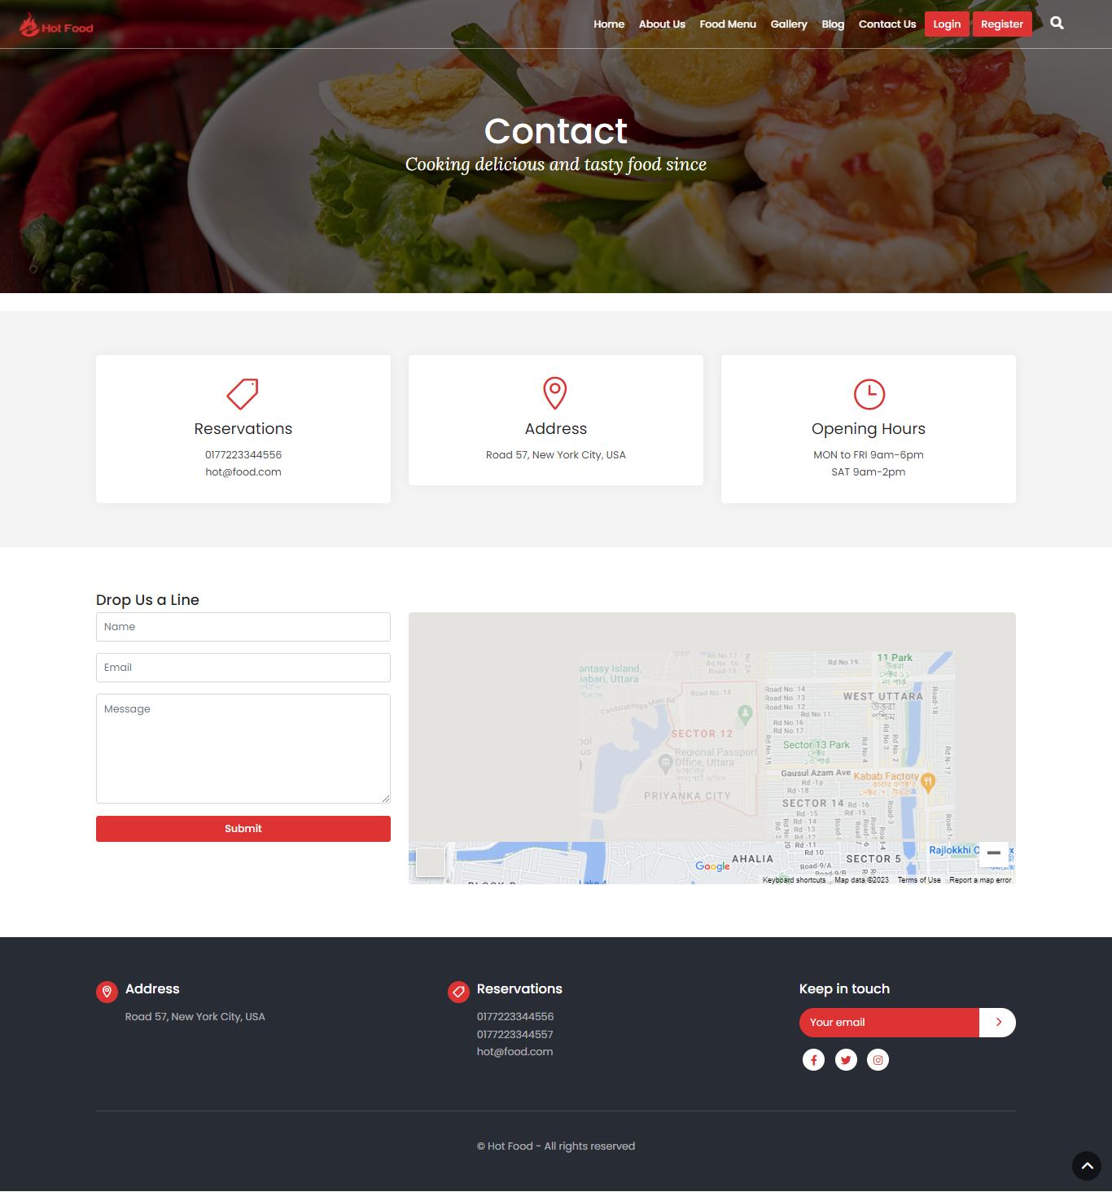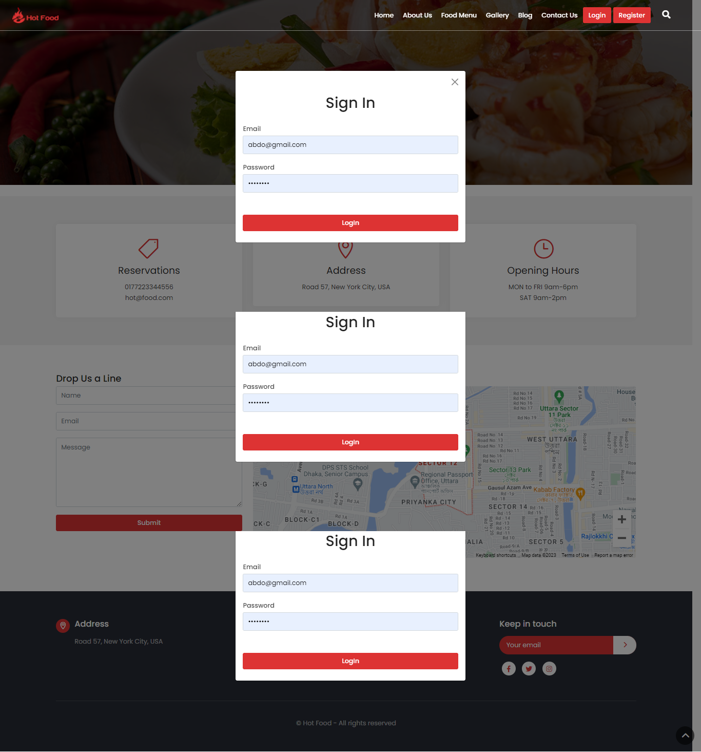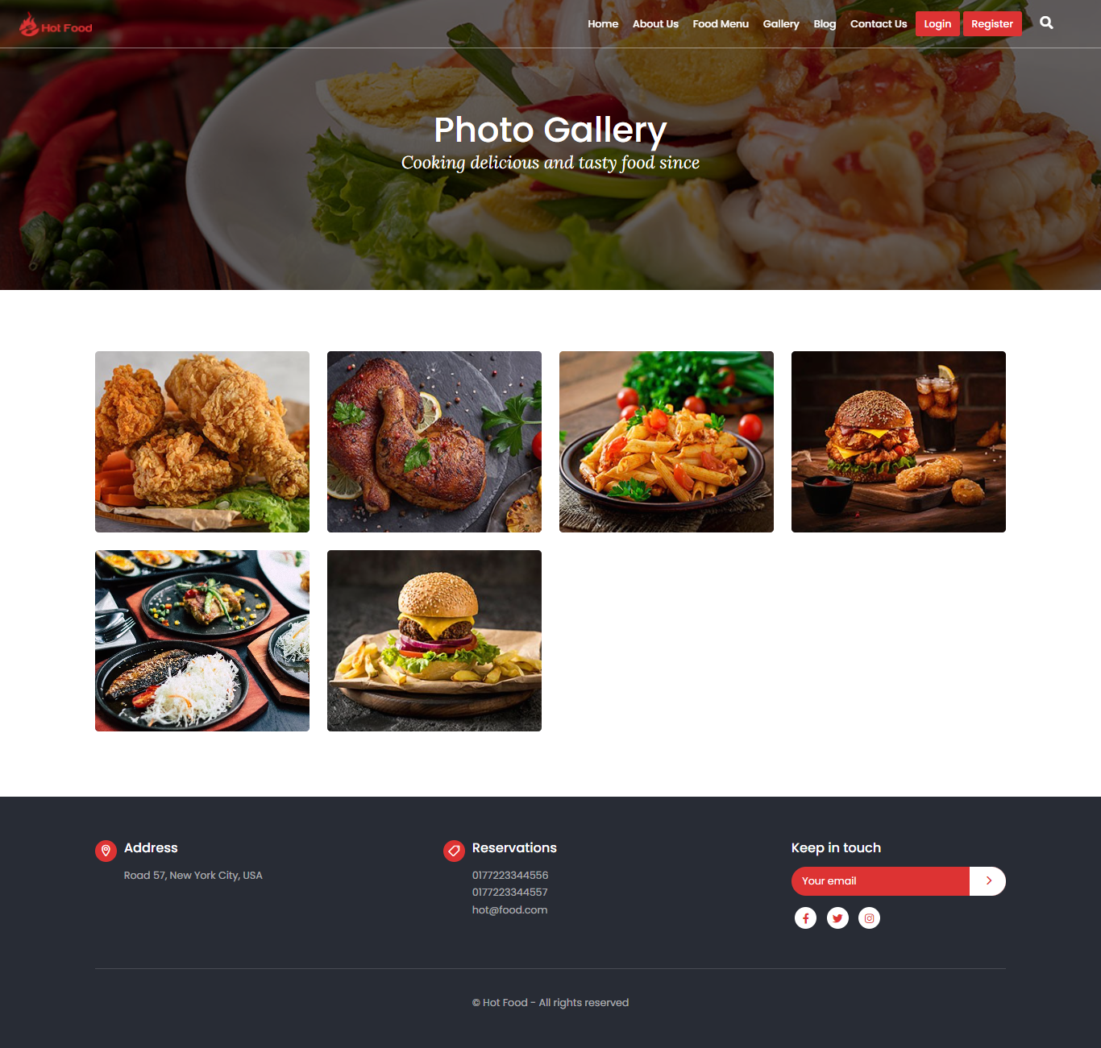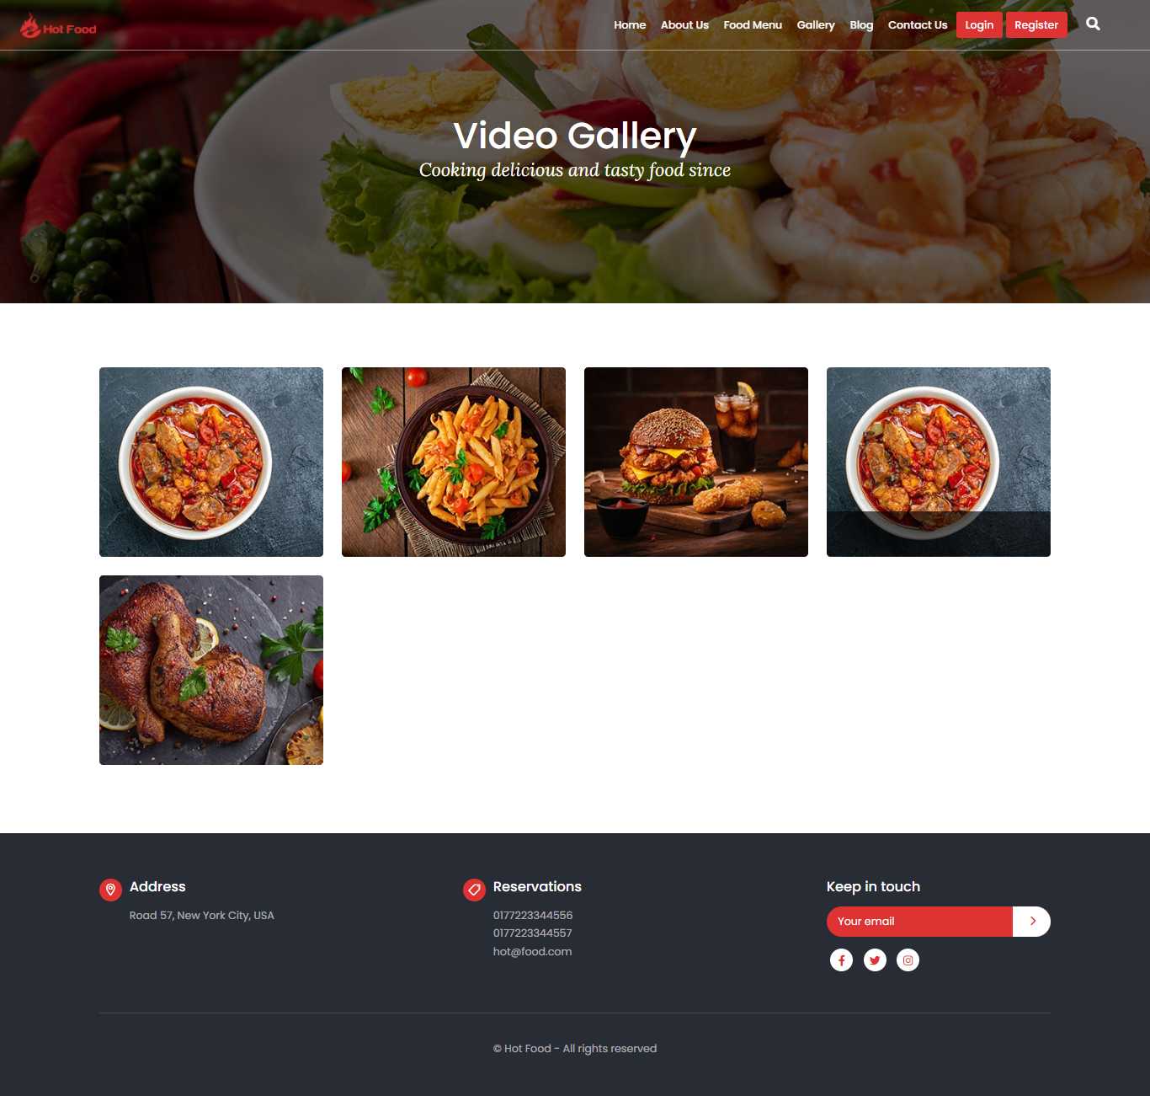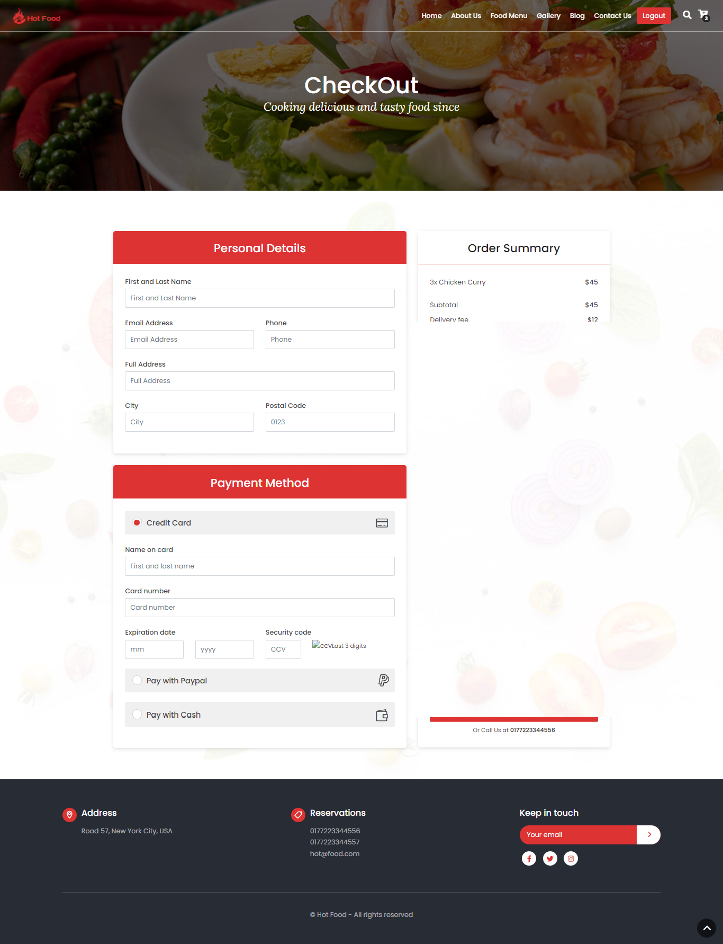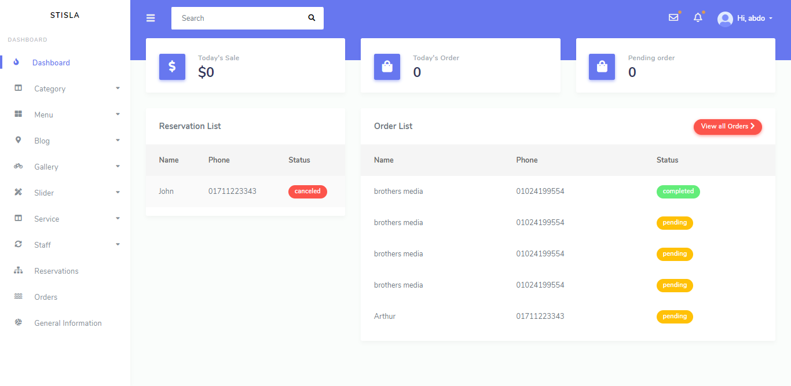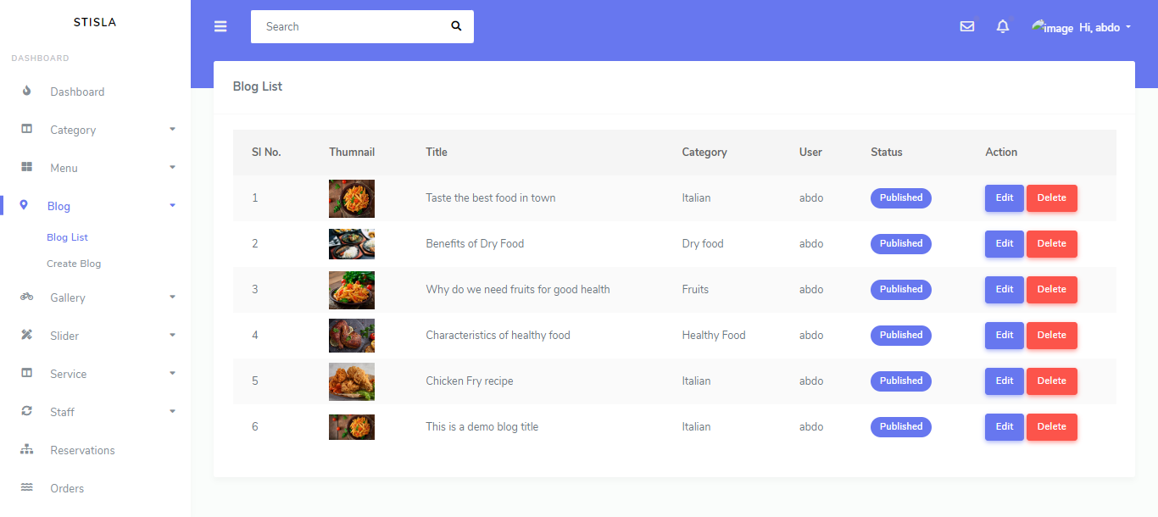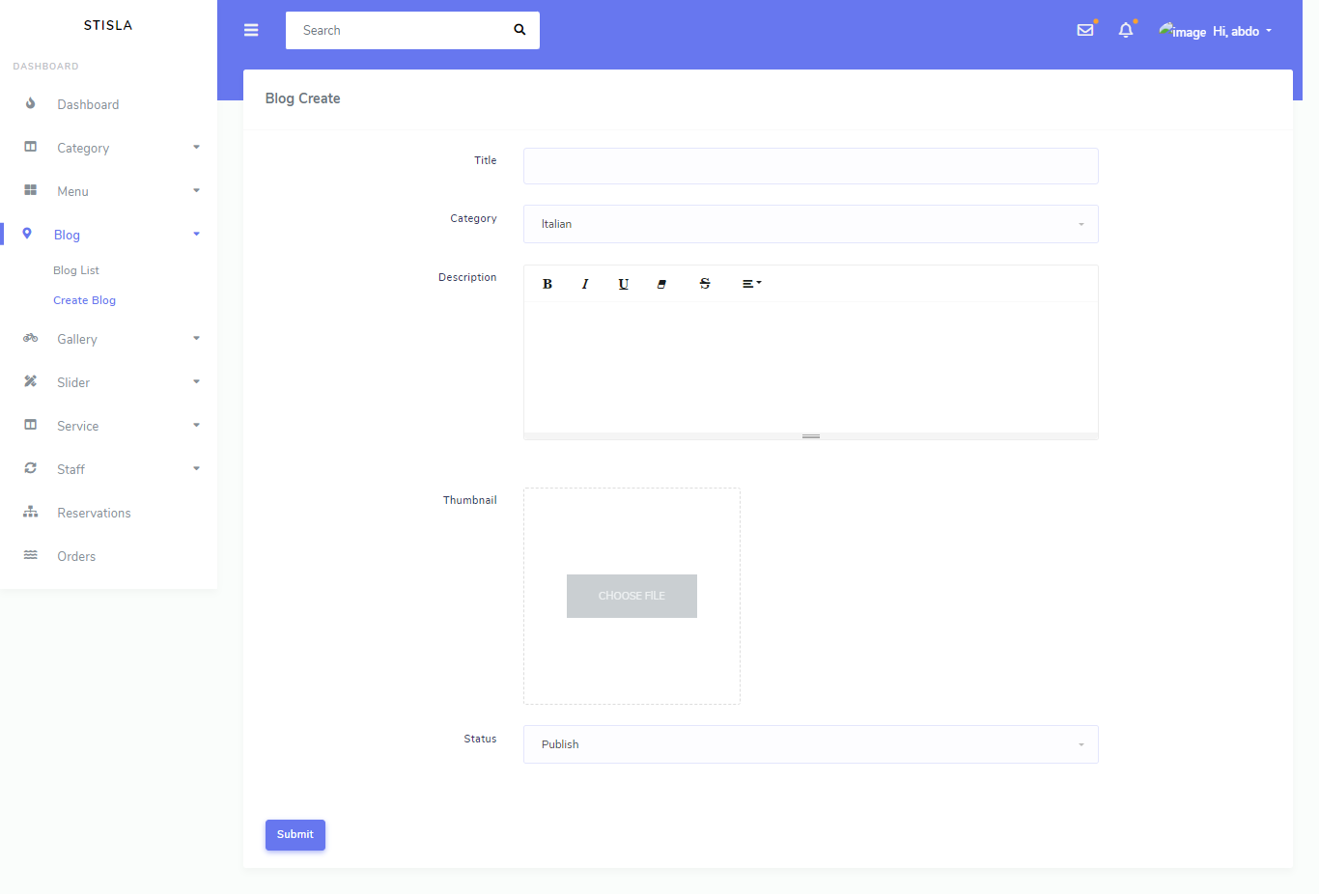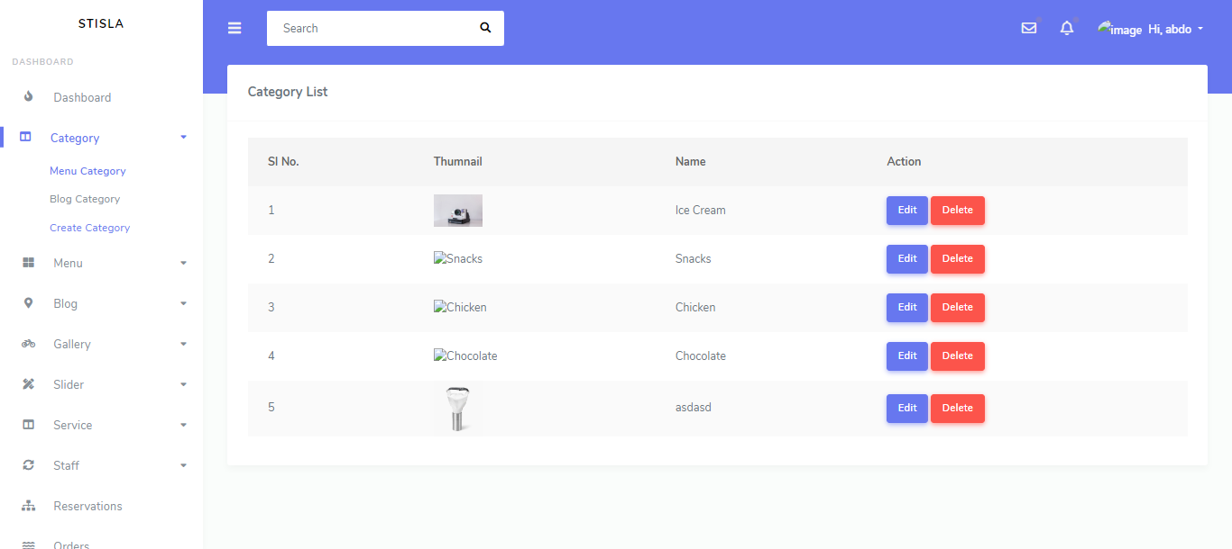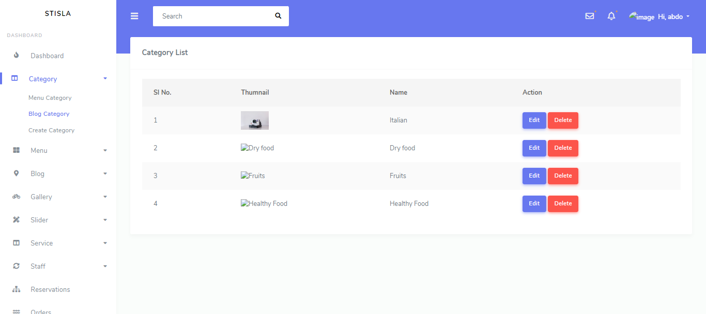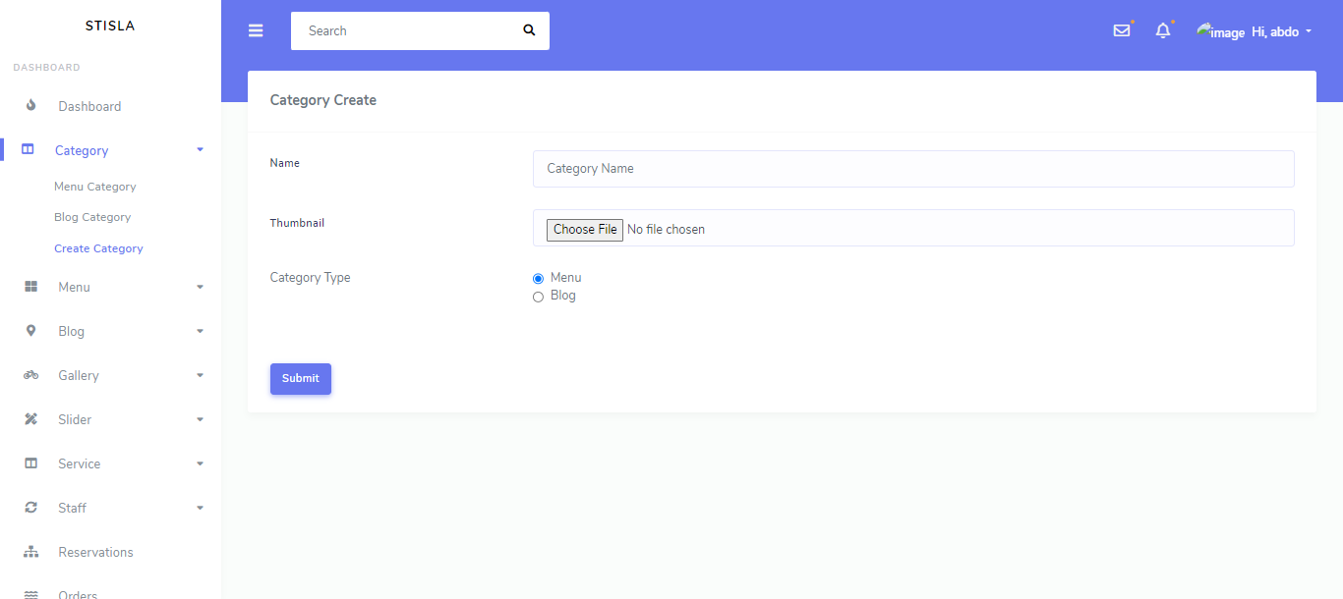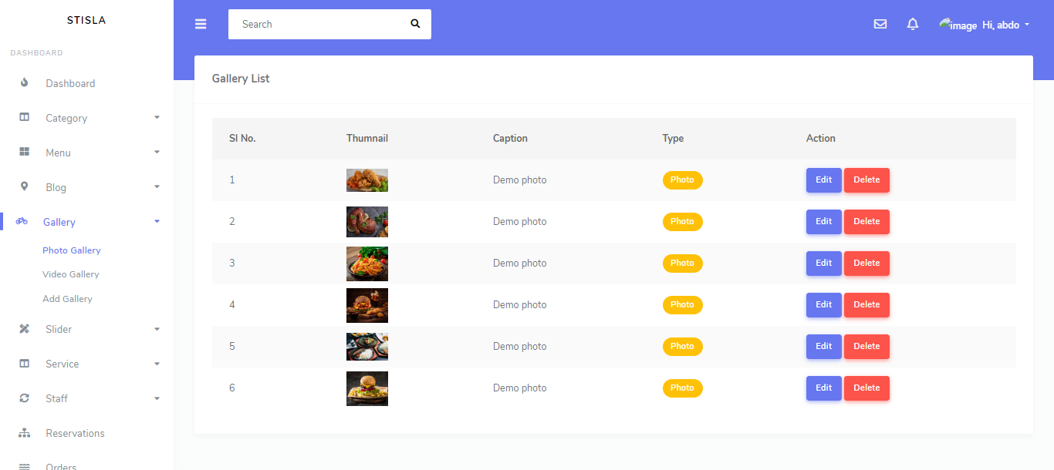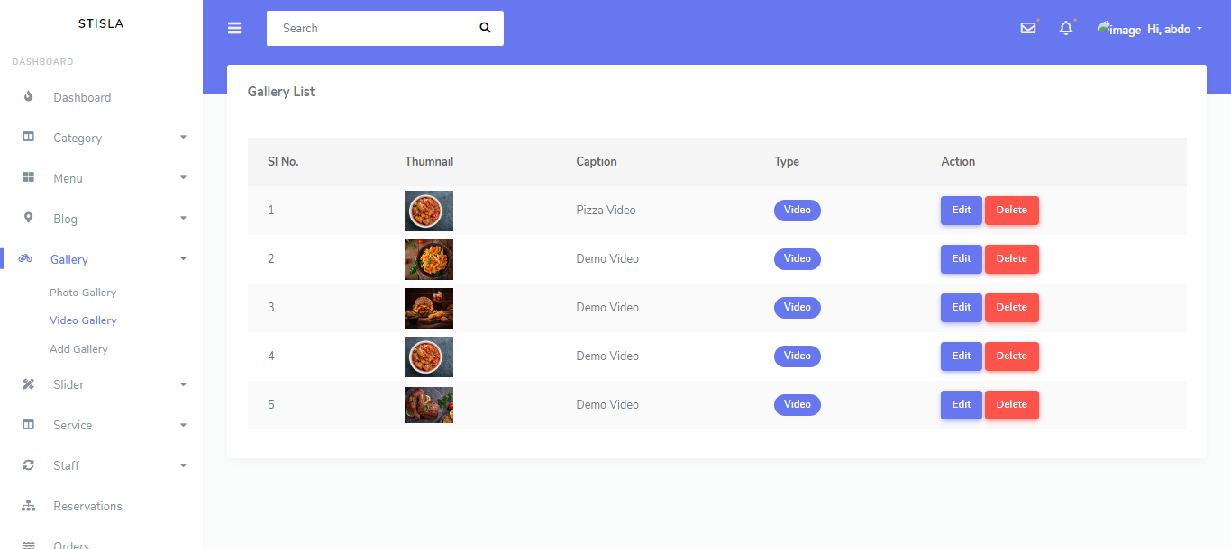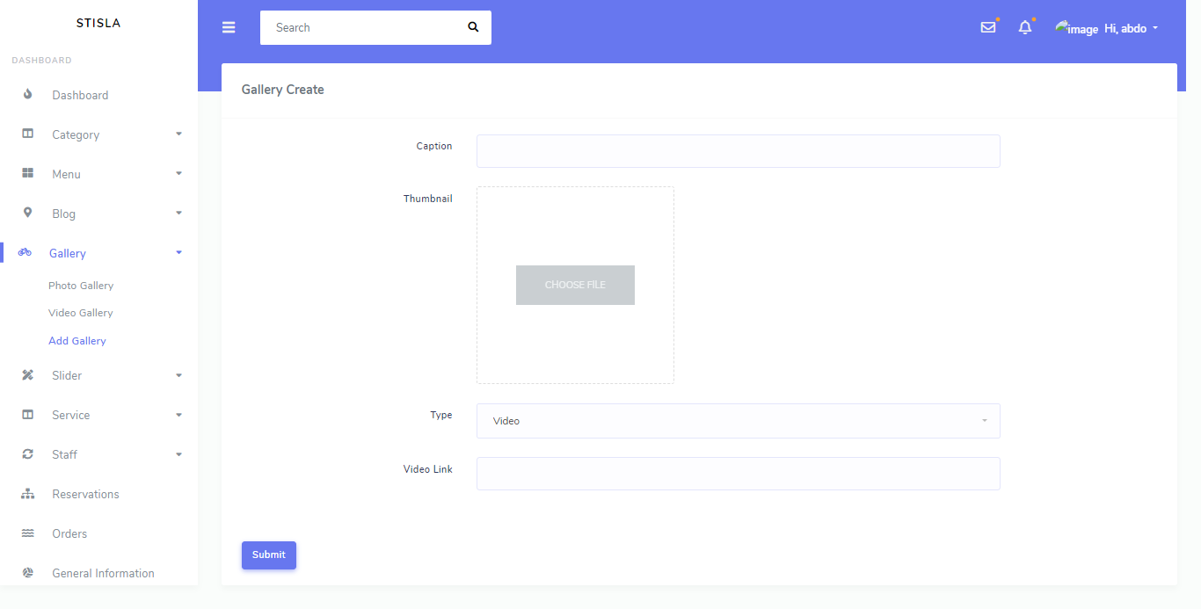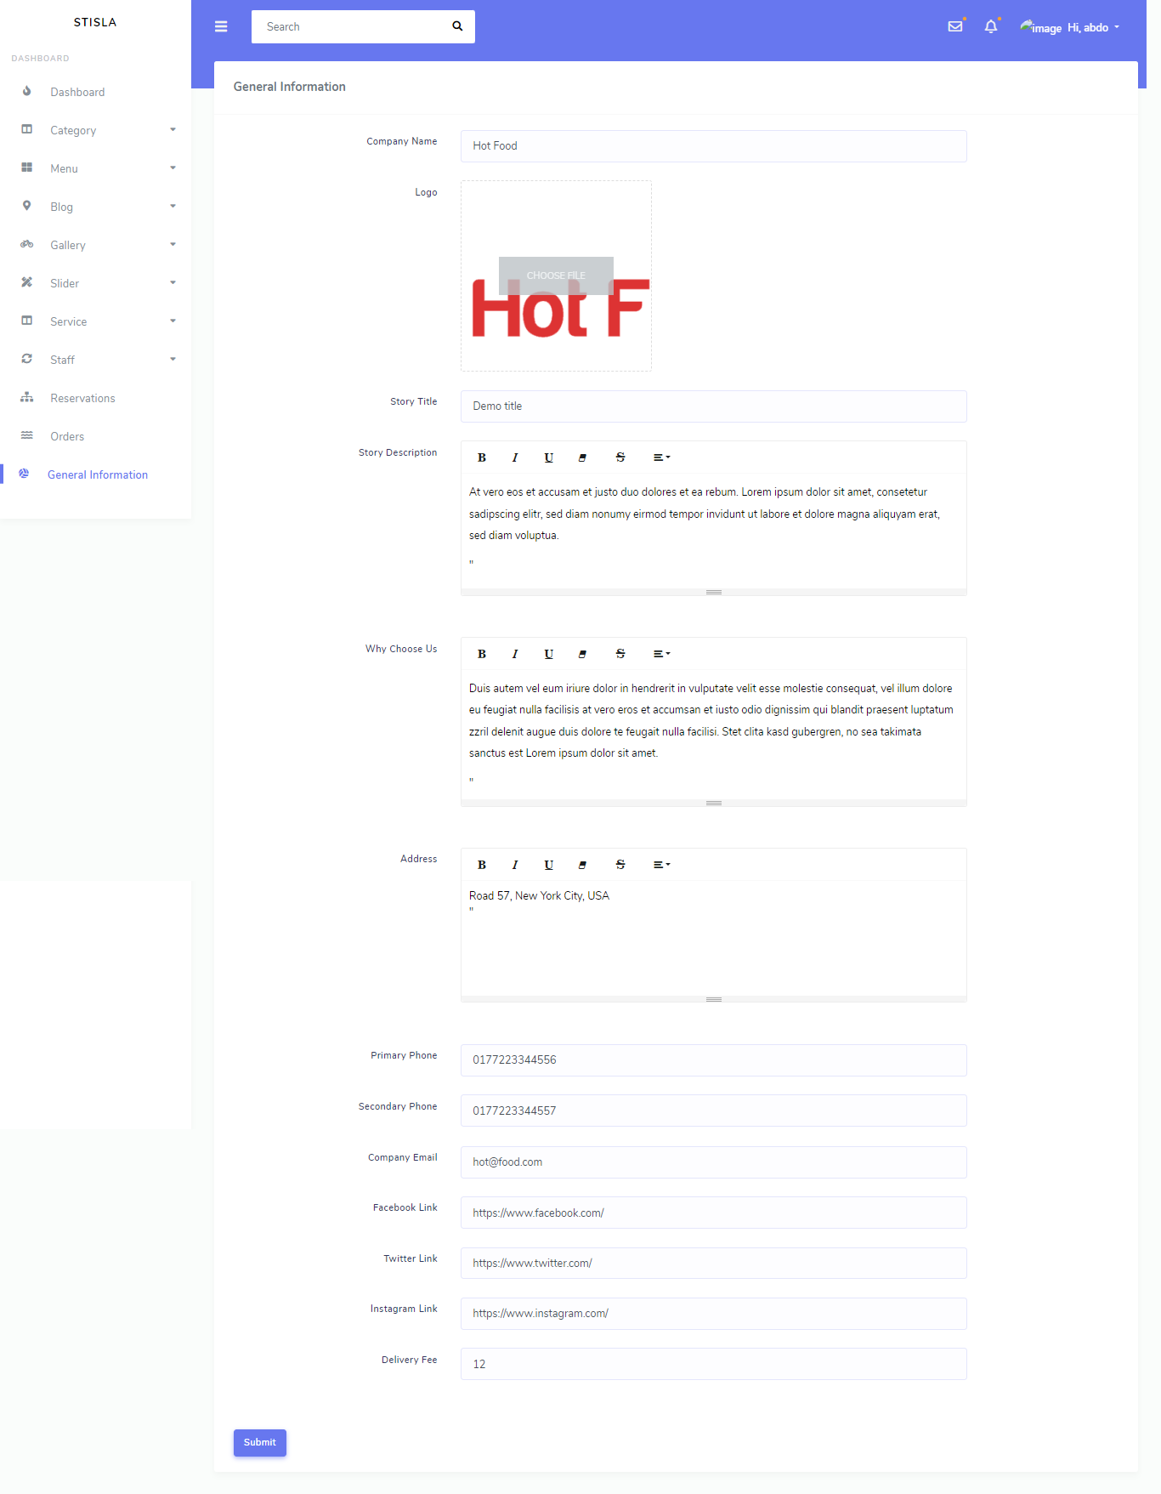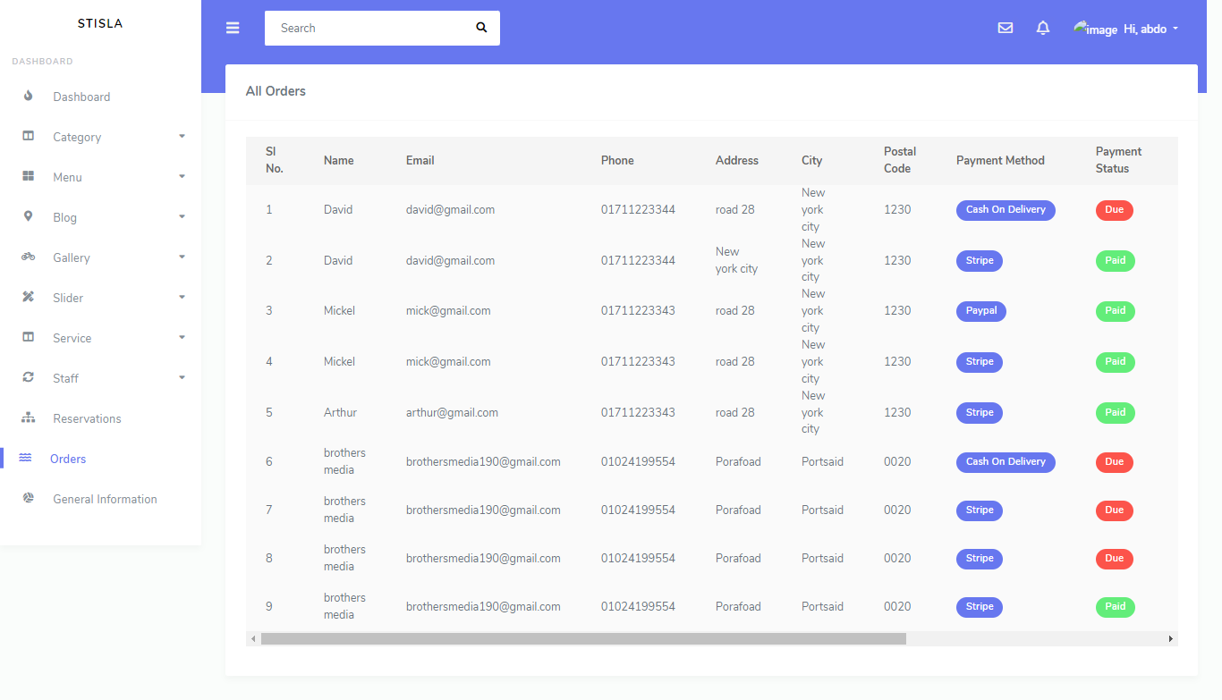

composer create-project --prefer-dist laravel/laravel:^9.5 food_delivery

php -S localhost:8000 -t public/

DB_CONNECTION=mysql

DB_HOST=127.0.0.1

DB_PORT=3306

DB_DATABASE=food_delivery

DB_USERNAME=root

DB_PASSWORD=

<https://github.com/laravel/ui/tree/4.x>

composer require laravel/ui

php artisan ui bootstrap --auth

npm install

npm run dev

<https://spatie.be/docs/laravel-permission/v5/introduction>

<https://spatie.be/docs/laravel-permission/v5/installation-laravel>

composer require spatie/laravel-permission

app.php

Spatie\Permission\PermissionServiceProvider::class,

<https://spatie.be/docs/laravel-permission/v5/basic-usage/middleware>

Kernel.php

'role' => \Spatie\Permission\Middlewares\RoleMiddleware::class,

'permission' => \Spatie\Permission\Middlewares\PermissionMiddleware::class,

'role_or_permission' => \Spatie\Permission\Middlewares\RoleOrPermissionMiddleware::class,

<https://image.intervention.io/v2/introduction/installation>

composer require intervention/image

app.php

Intervention\Image\ImageServiceProvider::class,

'Image' => Intervention\Image\Facades\Image::class,

php artisan vendor:publish --provider="Intervention\Image\ImageServiceProviderLaravelRecent"

app->Helper->helper.php

<?php

use Illuminate\Support\Facades\File;

use Intervention\Image\Facades\Image;

function uploadImage($image, $path, $old_path = null) {

if ($image) {

if (file_exists($old_path)) {

unlink($old_path);

}

$image_name = date('YmdHis').'.'.$image->extension();

$url = $path.$image_name;

if (!File::isDirectory(public_path($path))) {

File::makeDirectory(public_path($path), 0777, true, true);

}

Image::make($image)->save(public_path($path).$image_name);

return $url;

}

}

composer.json

"autoload": {

"psr-4": {

"App\\": "app/",

"Database\\Factories\\": "database/factories/",

"Database\\Seeders\\": "database/seeders/"

},

"files": [

"app/Helper/helper.php"

]

},

php artisan migrate

php -S localhost:8000 -t public/

composer dump-autoload

User.php

use Spatie\Permission\Traits\HasRoles;

use HasApiTokens, HasFactory, Notifiable, HasRoles;

php artisan make:seeder RoleSeeder

RoleSeeder.php

<?php

namespace Database\Seeders;

use App\Models\User;

use Illuminate\Database\Console\Seeds\WithoutModelEvents;

use Illuminate\Database\Seeder;

use Illuminate\Support\Facades\Hash;

use Spatie\Permission\Models\Role;

class RoleSeeder extends Seeder

{

public function run()

{

$roleAdmin = Role::create(['name' => 'admin']);

$roleUser = Role::create(['name' => 'user']);

$admin = User::create([

'name' => 'John Doe',

'email' => 'doe@gmail.com',

'password' => Hash::make('12345678')

]);

$user = User::create([

'name' => 'David Mold',

'email' => 'david@gmail.com',

'password' => Hash::make('12345678')

]);

$admin->assignRole($roleAdmin);

$user->assignRole($roleUser);

}

}

DatabaseSeeder.php

<?php

namespace Database\Seeders;

// use Illuminate\Database\Console\Seeds\WithoutModelEvents;

use Illuminate\Database\Seeder;

class DatabaseSeeder extends Seeder

{

public function run()

{

$this->call(RoleSeeder::class);

}

}

php artisan migrate:fresh –seed

RegisterController.php

use RegistersUsers;

RegistersUsers.php

event(new Registered($user = $this->create($request->all())));

$user->assignRole('user');

AuthenticatesUsers.php

use App\Providers\RouteServiceProvider;

protected function authenticated(Request $request, $user)

{

if ($user->hasRole('admin')) {

return redirect(RouteServiceProvider::ADMIN);

}

return redirect(RouteServiceProvider::HOME);

}

RouteServiceProvider.php

<?php

namespace App\Providers;

use Illuminate\Cache\RateLimiting\Limit;

use Illuminate\Foundation\Support\Providers\RouteServiceProvider as ServiceProvider;

use Illuminate\Http\Request;

use Illuminate\Support\Facades\RateLimiter;

use Illuminate\Support\Facades\Route;

class RouteServiceProvider extends ServiceProvider

{

public const HOME = '/home';

public const ADMIN = '/restaurent-backend';

public function boot()

{

$this->configureRateLimiting();

$this->routes(function () {

Route::middleware('api')

->prefix('api')

->group(base_path('routes/api.php'));

Route::middleware('web')

->group(base_path('routes/web.php'));

Route::middleware('web')

->prefix('restaurent-backend')

->group(base_path('routes/admin.php'));

});

}

protected function configureRateLimiting()

{

RateLimiter::for('api', function (Request $request) {

return Limit::perMinute(60)->by($request->user()?->id ?: $request->ip());

});

}

}

Routes

admin.php

<?php

use Illuminate\Support\Facades\Route;

/*

|--------------------------------------------------------------------------

| Web Routes

|--------------------------------------------------------------------------

|

| Here is where you can register web routes for your application. These

| routes are loaded by the RouteServiceProvider within a group which

| contains the "web" middleware group. Now create something great!

|

*/

Route::group(['middleware' => ['role:admin']], function () {

Route::get('/', [\App\Http\Controllers\Backend\HomeController::class, 'index'])->name('admin.home');

// Category routes

Route::resource('/category', \App\Http\Controllers\CategoryController::class, ['names' => 'category']);

// Menu routes

Route::resource('/menu', \App\Http\Controllers\MenuController::class, ['names' => 'menu']);

// Service routes

Route::resource('/service', \App\Http\Controllers\ServiceController::class, ['names' => 'service']);

// Staff routes

Route::resource('/staff', \App\Http\Controllers\StaffController::class, ['names' => 'staff']);

// Blog routes

Route::resource('/blog', \App\Http\Controllers\BlogController::class, ['names' => 'blog']);

// Gallery routes

Route::resource('/gallery', \App\Http\Controllers\GalleryController::class, ['names' => 'gallery']);

// Slider routes

Route::resource('/slider', \App\Http\Controllers\SliderController::class, ['names' => 'slider']);

// Reservation route

Route::get('/reservation', [App\Http\Controllers\ReserveController::class, 'index'])->name('admin.reserve');

Route::get('/reservation/{type}/{reserve}', [App\Http\Controllers\ReserveController::class, 'confirmation'])->name('admin.reserve.confirmation');

Route::delete('/reservation/{reserve}', [App\Http\Controllers\ReserveController::class, 'delete'])->name('admin.reserve.delete');

// Order route

Route::get('/order', [App\Http\Controllers\OrderShowController::class, 'index'])->name('admin.order');

Route::get('/order/{type}/{order}', [App\Http\Controllers\OrderShowController::class, 'confirmation'])->name('admin.order.confirmation');

Route::delete('/order/{order}', [App\Http\Controllers\OrderShowController::class, 'delete'])->name('admin.order.delete');

//General routes

Route::get('/general', [App\Http\Controllers\GeneralController::class, 'index'])->name('admin.general');

Route::put('/general/{type}', [App\Http\Controllers\GeneralController::class, 'store'])->name('admin.general.store');

});

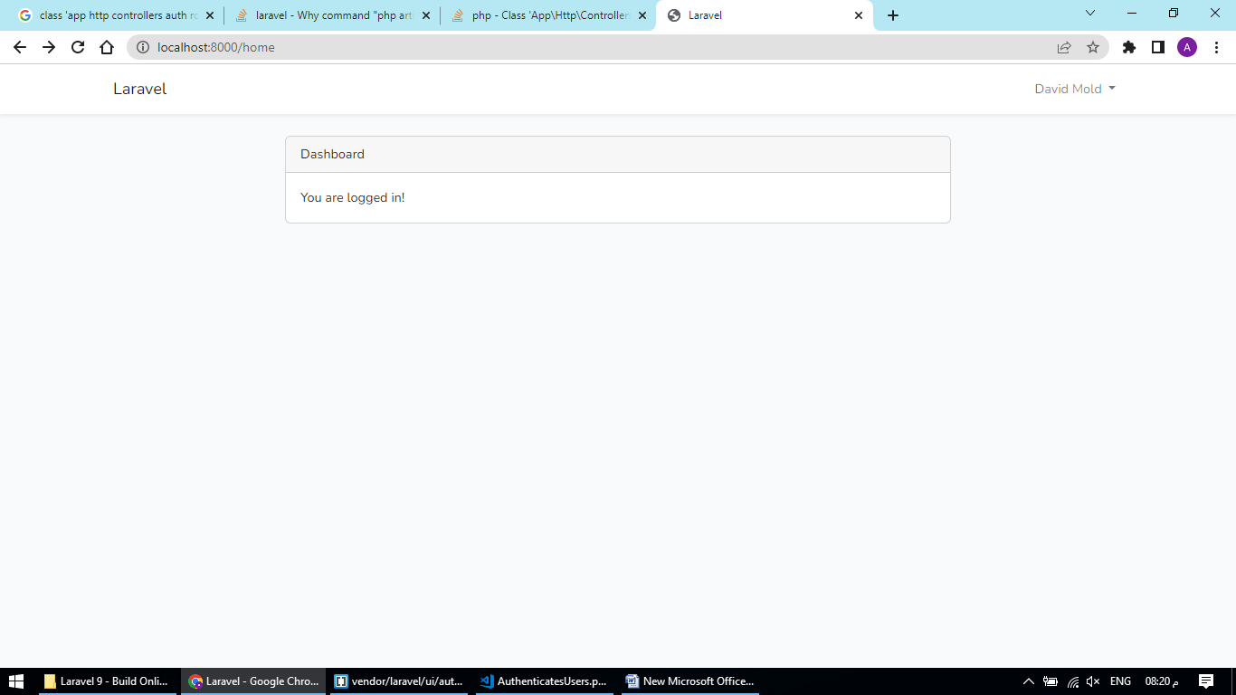

php artisan make:model Blog -m

INFO Model [C:\xampp\htdocs\food_delivery\app/Models/Blog.php] created successfully.

INFO Migration [C:\xampp\htdocs\food_delivery\database\migrations/2023_02_15_185200_create_blogs_table.php] created successfully.

PS C:\xampp\htdocs\food_delivery> php artisan make:model Cart -m

INFO Model [C:\xampp\htdocs\food_delivery\app/Models/Cart.php] created successfully.

INFO Migration [C:\xampp\htdocs\food_delivery\database\migrations/2023_02_15_185254_create_carts_table.php] created successfully.

PS C:\xampp\htdocs\food_delivery> php artisan make:model Gallery -m

INFO Model [C:\xampp\htdocs\food_delivery\app/Models/Gallery.php] created successfully.

INFO Migration [C:\xampp\htdocs\food_delivery\database\migrations/2023_02_15_185419_create_galleries_table.php] created successfully.

PS C:\xampp\htdocs\food_delivery> php artisan make:model General -m

INFO Model [C:\xampp\htdocs\food_delivery\app/Models/General.php] created successfully.

INFO Migration [C:\xampp\htdocs\food_delivery\database\migrations/2023_02_15_185434_create_generals_table.php] created successfully.

PS C:\xampp\htdocs\food_delivery> php artisan make:model Menu -m

INFO Model [C:\xampp\htdocs\food_delivery\app/Models/Menu.php] created successfully.

INFO Migration [C:\xampp\htdocs\food_delivery\database\migrations/2023_02_15_185458_create_menus_table.php] created successfully.

PS C:\xampp\htdocs\food_delivery> php artisan make:model Order -m

INFO Model [C:\xampp\htdocs\food_delivery\app/Models/Order.php] created successfully.

INFO Migration [C:\xampp\htdocs\food_delivery\database\migrations/2023_02_15_185527_create_orders_table.php] created successfully.

PS C:\xampp\htdocs\food_delivery> php artisan make:model OrderMeta -m

INFO Model [C:\xampp\htdocs\food_delivery\app/Models/OrderMeta.php] created successfully.

INFO Migration [C:\xampp\htdocs\food_delivery\database\migrations/2023_02_15_185547_create_order_metas_table.php] created successfully.

PS C:\xampp\htdocs\food_delivery> php artisan make:model Reserve -m

INFO Model [C:\xampp\htdocs\food_delivery\app/Models/Reserve.php] created successfully.

INFO Migration [C:\xampp\htdocs\food_delivery\database\migrations/2023_02_15_185606_create_reserves_table.php] created successfully.

PS C:\xampp\htdocs\food_delivery> php artisan make:model Service -m

INFO Model [C:\xampp\htdocs\food_delivery\app/Models/Service.php] created successfully.

INFO Migration [C:\xampp\htdocs\food_delivery\database\migrations/2023_02_15_185627_create_services_table.php] created successfully.

PS C:\xampp\htdocs\food_delivery> php artisan make:model Slider -m

INFO Model [C:\xampp\htdocs\food_delivery\app/Models/Slider.php] created successfully.

INFO Migration [C:\xampp\htdocs\food_delivery\database\migrations/2023_02_15_185647_create_sliders_table.php] created successfully.

PS C:\xampp\htdocs\food_delivery> php artisan make:model Staff -m

INFO Model [C:\xampp\htdocs\food_delivery\app/Models/Staff.php] created successfully.

INFO Migration [C:\xampp\htdocs\food_delivery\database\migrations/2023_02_15_185705_create_staff_table.php] created successfully.

php artisan make:model Category –m

public function up()

{

Schema::create('categories', function (Blueprint $table) {

$table->id();

$table->string('name');

$table->string('thumbnail')->nullable();

$table->boolean('type')->comment('0 => menu, 1 => blog');

$table->timestamps();

});

}

public function up()

{

Schema::create('menus', function (Blueprint $table) {

$table->id();

$table->bigInteger('category_id');

$table->string('title');

$table->string('thumbnail');

$table->text('description');

$table->string('price');

$table->integer('status');

$table->timestamps();

});

}

public function up()

{

Schema::create('blogs', function (Blueprint $table) {

$table->id();

$table->bigInteger('category_id');

$table->string('title');

$table->string('thumbnail');

$table->text('description');

$table->bigInteger('user_id');

$table->integer('status');

$table->timestamps();

});

}

public function up()

{

Schema::create('galleries', function (Blueprint $table) {

$table->id();

$table->string('caption');

$table->string('thumbnail');

$table->string('video_link')->nullable();

$table->boolean('type')->comment('0 => photo, 1 => video');

$table->timestamps();

});

}

public function up()

{

Schema::create('sliders', function (Blueprint $table) {

$table->id();

$table->string('title');

$table->text('sub_title');

$table->string('thumbnail');

$table->timestamps();

});

}

public function up()

{

Schema::create('reserves', function (Blueprint $table) {

$table->id();

$table->string('date');

$table->string('time');

$table->string('people');

$table->string('name');

$table->string('email');

$table->string('phone');

$table->longText('description');

$table->integer('status');

$table->timestamps();

});

}

public function up()

{

Schema::create('services', function (Blueprint $table) {

$table->id();

$table->string('title');

$table->string('thumbnail');

$table->text('description');

$table->timestamps();

});

}

public function up()

{

Schema::create('staff', function (Blueprint $table) {

$table->id();

$table->string('name');

$table->string('designation');

$table->string('thumbnail');

$table->timestamps();

});

}

public function up()

{

Schema::create('generals', function (Blueprint $table) {

$table->id();

$table->string('company_name');

$table->string('logo');

$table->string('story_title');

$table->longText('story_description');

$table->longText('why_choose_us');

$table->string('address');

$table->string('primary_phone');

$table->string('secondary_phone');

$table->string('email');

$table->string('facebook')->nullable();

$table->string('twitter')->nullable();

$table->string('instagram')->nullable();

$table->string('delivery_fee');

$table->timestamps();

});

}

public function up()

{

Schema::create('carts', function (Blueprint $table) {

$table->id();

$table->integer('user_id');

$table->integer('menu_id');

$table->string('quantity');

$table->timestamps();

});

}

public function up()

{

Schema::create('orders', function (Blueprint $table) {

$table->id();

$table->integer('user_id');

$table->string('name');

$table->string('email');

$table->string('phone');

$table->string('address');

$table->string('city');

$table->string('postal_code');

$table->string('total');

$table->integer('payment_method')->comment('1 => cash on delivery, 2 => paypal, 3 => card');

$table->integer('payment_status')->comment('0 => due, 1 => paid');

$table->integer('order_status')->comment('0 => pending, 1 => completed, 2 => canceled');

$table->timestamps();

});

}

public function up()

{

Schema::create('order_metas', function (Blueprint $table) {

$table->id();

$table->integer('order_id');

$table->integer('menu_id');

$table->string('quantity');

$table->string('price');

$table->timestamps();

});

}

<?php

namespace App\Models;

use Illuminate\Database\Eloquent\Factories\HasFactory;

use Illuminate\Database\Eloquent\Model;

class Blog extends Model

{

use HasFactory;

protected $fillable = [

'category_id',

'title',

'thumbnail',

'description',

'user_id',

'status'

];

public function user()

{

return $this->belongsTo(User::class);

}

public function category()

{

return $this->belongsTo(Category::class);

}

}

<?php

namespace App\Models;

use Illuminate\Database\Eloquent\Factories\HasFactory;

use Illuminate\Database\Eloquent\Model;

class Cart extends Model

{

use HasFactory;

protected $fillable = [

'user_id', 'menu_id', 'quantity'

];

public function menu()

{

return $this->belongsTo('App\Models\Menu', 'menu_id');

}

}

<?php

namespace App\Models;

use Illuminate\Database\Eloquent\Factories\HasFactory;

use Illuminate\Database\Eloquent\Model;

class Category extends Model

{

use HasFactory;

protected $fillable = [

'name',

'thumbnail',

'type'

];

function blogs()

{

return $this->hasMany('App\Models\Blog');

}

}

<?php

namespace App\Models;

use Illuminate\Database\Eloquent\Factories\HasFactory;

use Illuminate\Database\Eloquent\Model;

class Gallery extends Model

{

use HasFactory;

protected $fillable = [

'caption',

'thumbnail',

'video_link',

'type'

];

}

<?php

namespace App\Models;

use Illuminate\Database\Eloquent\Factories\HasFactory;

use Illuminate\Database\Eloquent\Model;

class General extends Model

{

use HasFactory;

protected $fillable = [

'company_name', 'logo', 'story_title', 'story_description', 'why_choose_us', 'address', 'primary_phone', 'secondary_phone', 'email', 'facebook', 'twitter', 'instagram', 'delivery_fee'

];

}

<?php

namespace App\Models;

use Illuminate\Database\Eloquent\Factories\HasFactory;

use Illuminate\Database\Eloquent\Model;

class Menu extends Model

{

use HasFactory;

protected $fillable = [

'category_id',

'title',

'thumbnail',

'description',

'price',

'status'

];

public function category()

{

return $this->belongsTo(Category::class);

}

}

<?php

namespace App\Models;

use Illuminate\Database\Eloquent\Factories\HasFactory;

use Illuminate\Database\Eloquent\Model;

class Order extends Model

{

use HasFactory;

protected $fillable = [

'user_id', 'name', 'email', 'phone', 'address', 'city', 'postal_code', 'total', 'payment_method', 'payment_status', 'order_status'

];

public function details()

{

return $this->hasMany('App\Models\OrderMeta');

}

}

<?php

namespace App\Models;

use Illuminate\Database\Eloquent\Factories\HasFactory;

use Illuminate\Database\Eloquent\Model;

class OrderMeta extends Model

{

use HasFactory;

protected $fillable = [

'order_id', 'menu_id', 'quantity', 'price'

];

public function menu()

{

return $this->belongsTo('App\Models\Menu');

}

}

<?php

namespace App\Models;

use Illuminate\Database\Eloquent\Factories\HasFactory;

use Illuminate\Database\Eloquent\Model;

class Reserve extends Model

{

use HasFactory;

protected $fillable = [

'date', 'time', 'people', 'name', 'email', 'phone', 'description', 'status'

];

}

<?php

namespace App\Models;

use Illuminate\Database\Eloquent\Factories\HasFactory;

use Illuminate\Database\Eloquent\Model;

class Service extends Model

{

use HasFactory;

protected $fillable = [

'title', 'description', 'thumbnail'

];

}

<?php

namespace App\Models;

use Illuminate\Database\Eloquent\Factories\HasFactory;

use Illuminate\Database\Eloquent\Model;

class Slider extends Model

{

use HasFactory;

protected $fillable = [

'title',

'sub_title',

'thumbnail'

];

}

<?php

namespace App\Models;

use Illuminate\Database\Eloquent\Factories\HasFactory;

use Illuminate\Database\Eloquent\Model;

class Staff extends Model

{

use HasFactory;

protected $fillable = [

'name', 'designation', 'thumbnail'

];

}

php artisan migrate

composer require realrashid/sweet-alert

app.php

RealRashid\SweetAlert\SweetAlertServiceProvider::class,

'Alert' => RealRashid\SweetAlert\Facades\Alert::class,

Providers

<?php

namespace App\Providers;

use App\Models\General;

use Illuminate\Support\Facades\View;

use Illuminate\Support\ServiceProvider;

class AppServiceProvider extends ServiceProvider

{

public function register()

{

//

}

public function boot()

{

View::composer('*', function ($view) {

$general = General::latest('created_at')->first();

$view->with(['general' => $general]);

});

}

}

web.php

<?php

use Illuminate\Support\Facades\Route;

Auth::routes();

Route::get('/', [App\Http\Controllers\HomeController::class, 'index'])->name('home');

Route::get('/menu', [App\Http\Controllers\HomeController::class, 'menu'])->name('menu');

Route::post('/mail', [App\Http\Controllers\HomeController::class, 'mail'])->name('mail');

//cart routes

Route::get('/carts/{user}', [App\Http\Controllers\CartController::class, 'getCart'])->name('getcart');

Route::post('/cart/update/{user}', [App\Http\Controllers\CartController::class, 'updateCart'])->name('cart.update');

Route::get('/cart/delete/{cart}/{user}', [App\Http\Controllers\CartController::class, 'destroy'])->name('cart.delete');

Route::get('/cart/{menu}/{user}', [App\Http\Controllers\CartController::class, 'addCart'])->name('cart.add');

// checkout

Route::get('/order/{user}', [App\Http\Controllers\OrderController::class, 'checkout'])->name('checkout');

Route::post('/order/{user}', [App\Http\Controllers\OrderController::class, 'order'])->name('order');

Route::get('/payment/succes/{order}', [App\Http\Controllers\OrderController::class, 'success'])->name('success');

Route::get('/payment/cancel', [App\Http\Controllers\OrderController::class, 'cancel'])->name('cancel');

Route::get('/about', [App\Http\Controllers\HomeController::class, 'about'])->name('about');

Route::get('/contact', [App\Http\Controllers\HomeController::class, 'contact'])->name('contact');

Route::post('/reserve', [App\Http\Controllers\HomeController::class, 'reserve'])->name('reserve');

Route::get('/gallery/{type}', [App\Http\Controllers\HomeController::class, 'gallery'])->name('gallery');

Route::get('/blogs', [App\Http\Controllers\HomeController::class, 'blog'])->name('allblogs');

Route::get('/blog/{blog}', [App\Http\Controllers\HomeController::class, 'getBlog'])->name('get.blog');

Route::get('/category/blog/{id}', [App\Http\Controllers\HomeController::class, 'getCategoryBlogs'])->name('category.blog');

<https://mailtrap.io/>

MAIL_MAILER=smtp

MAIL_HOST=sandbox.smtp.mailtrap.io

MAIL_PORT=587

MAIL_USERNAME=fa8ea2466d5e9a

MAIL_PASSWORD=ab26cd7df3b3ec

MAIL_FROM_ADDRESS="abdulrhman.plaza2@gmail.com"

MAIL_FROM_NAME="${APP_NAME}"

php artisan cache:clear

php artisan config:cache

<https://dashboard.stripe.com/>

composer require stripe/stripe-php

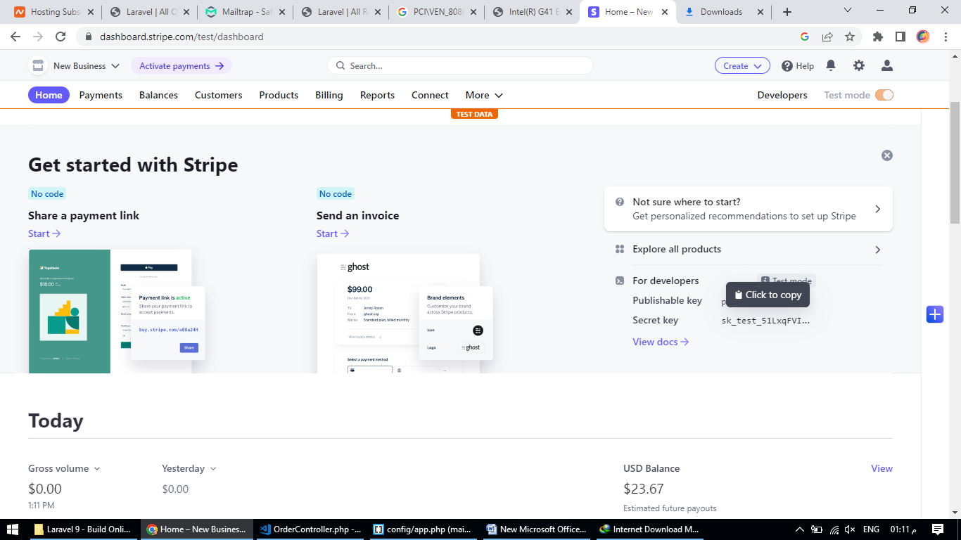

<https://github.com/thephpleague/omnipay-paypal>

composer require league/omnipay omnipay/paypal

<https://developer.paypal.com/dashboard/>

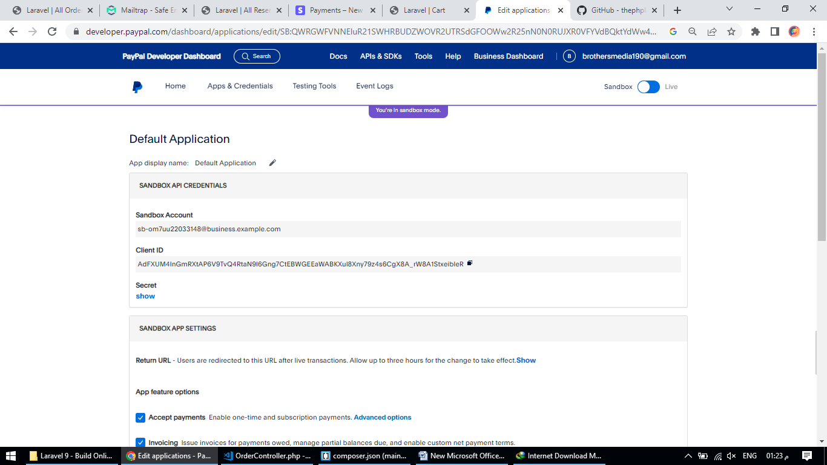

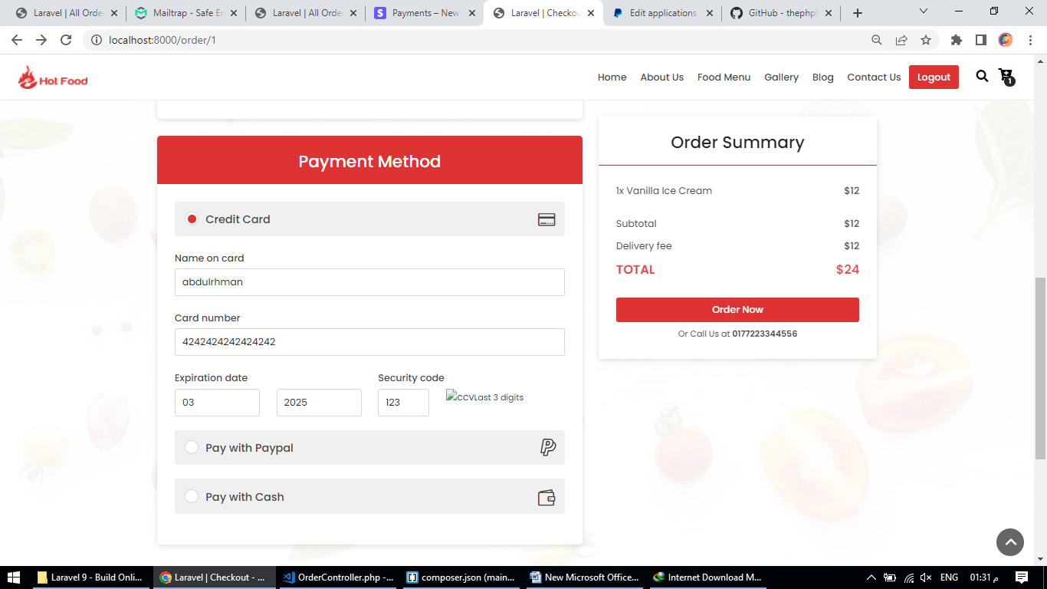

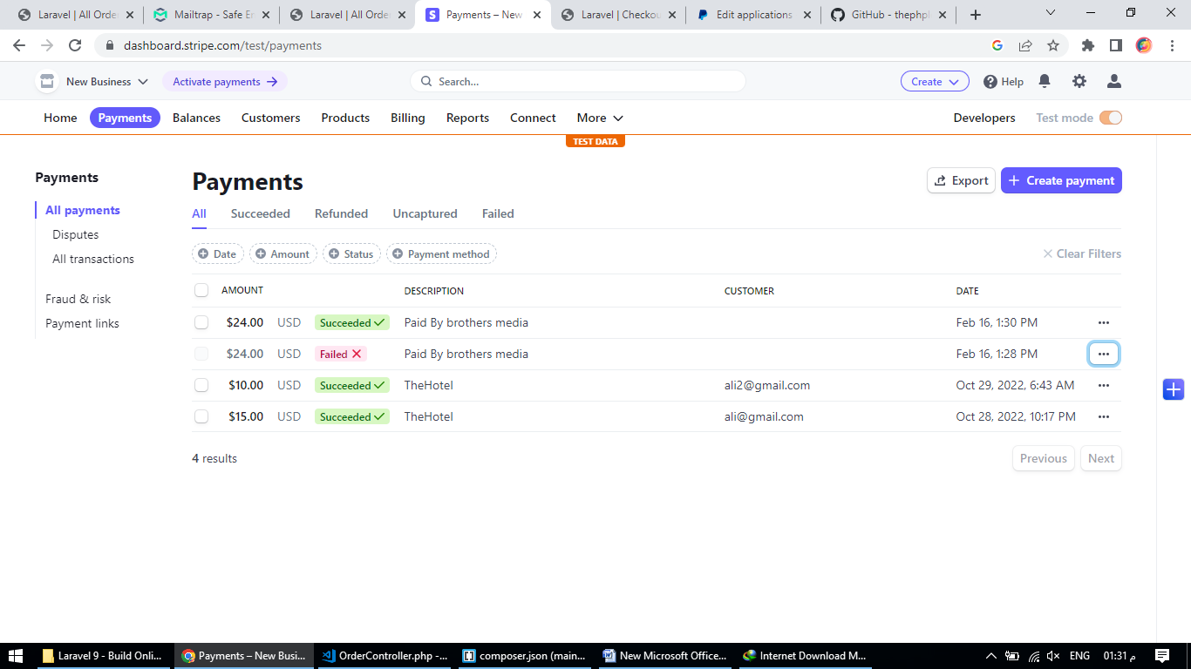

<https://realrashid.github.io/sweet-alert/install>

composer require realrashid/sweet-alert

Kernel.php

\RealRashid\SweetAlert\ToSweetAlert::class,

app.php

RealRashid\SweetAlert\SweetAlertServiceProvider::class,

'Alert' => RealRashid\SweetAlert\Facades\Alert::class,

Routes

admin.php

<?php

use Illuminate\Support\Facades\Route;

Route::group(['middleware' => ['role:admin']], function () {

Route::get('/', [\App\Http\Controllers\Backend\HomeController::class, 'index'])->name('admin.home');

// Category routes

Route::resource('/category', \App\Http\Controllers\CategoryController::class, ['names' => 'category']);

// Menu routes

Route::resource('/menu', \App\Http\Controllers\MenuController::class, ['names' => 'menu']);

// Service routes

Route::resource('/service', \App\Http\Controllers\ServiceController::class, ['names' => 'service']);

// Staff routes

Route::resource('/staff', \App\Http\Controllers\StaffController::class, ['names' => 'staff']);

// Blog routes

Route::resource('/blog', \App\Http\Controllers\BlogController::class, ['names' => 'blog']);

// Gallery routes

Route::resource('/gallery', \App\Http\Controllers\GalleryController::class, ['names' => 'gallery']);

// Slider routes

Route::resource('/slider', \App\Http\Controllers\SliderController::class, ['names' => 'slider']);

// Reservation route

Route::get('/reservation', [App\Http\Controllers\ReserveController::class, 'index'])->name('admin.reserve');

Route::get('/reservation/{type}/{reserve}', [App\Http\Controllers\ReserveController::class, 'confirmation'])->name('admin.reserve.confirmation');

Route::delete('/reservation/{reserve}', [App\Http\Controllers\ReserveController::class, 'delete'])->name('admin.reserve.delete');

// Order route

Route::get('/order', [App\Http\Controllers\OrderShowController::class, 'index'])->name('admin.order');

Route::get('/order/{type}/{order}', [App\Http\Controllers\OrderShowController::class, 'confirmation'])->name('admin.order.confirmation');

Route::delete('/order/{order}', [App\Http\Controllers\OrderShowController::class, 'delete'])->name('admin.order.delete');

//General routes

Route::get('/general', [App\Http\Controllers\GeneralController::class, 'index'])->name('admin.general');

Route::put('/general/{type}', [App\Http\Controllers\GeneralController::class, 'store'])->name('admin.general.store');

});

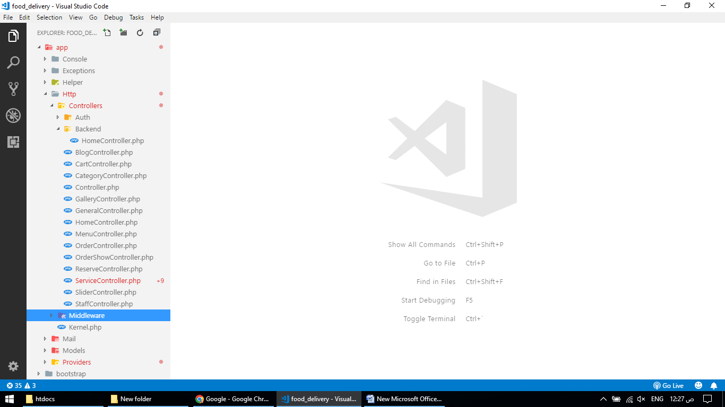

Backend

HomeController.php

<?php

namespace App\Http\Controllers\Backend;

use App\Http\Controllers\Controller;

use App\Models\Order;

use App\Models\Reserve;

use Carbon\Carbon;

use Illuminate\Http\Request;

class HomeController extends Controller

{

public function index()

{

$todaySale = Order::whereDate('created_at', Carbon::today())->sum('total');

$todayOrder = Order::whereDate('created_at', Carbon::today())->count();

$pendinnOrder = Order::where('order_status', 0)->count();

$orders = Order::latest('created_at')->limit(5)->get();

$reservations = Reserve::latest('created_at')->limit(5)->get();

return view('dashboard', compact('todaySale', 'todayOrder', 'pendinnOrder', 'orders', 'reservations'));

}

}

BlogController.php

<?php

namespace App\Http\Controllers;

use App\Models\Blog;

use App\Models\Category;

use Illuminate\Http\Request;

use Illuminate\Support\Facades\Auth;

class BlogController extends Controller

{

/**

* Display a listing of the resource.

*

* @return \Illuminate\Http\Response

*/

public function index()

{

$page_title = "Blog List";

$blogs = Blog::all();

return view('blog.index', compact('page_title', 'blogs'));

}

/**

* Show the form for creating a new resource.

*

* @return \Illuminate\Http\Response

*/

public function create()

{

$page_title = "Blog Create";

$categories = Category::where('type', 1)->get();

return view('blog.create', compact('page_title', 'categories'));

}

/**

* Store a newly created resource in storage.

*

* @param \Illuminate\Http\Request $request

* @return \Illuminate\Http\Response

*/

public function store(Request $request)

{

$request->validate([

'category_id' => 'required',

'title' => 'required',

'thumbnail' => 'required|mimes:jpg,jpeg,png',

'description' => 'required',

'status' => 'required',

]);

$image = $request->file('thumbnail');

$path = 'uploads/blog/';

Blog::create([

'category_id' => $request->category_id,

'title' => $request->title,

'thumbnail' => uploadImage($image, $path),

'description' => $request->description,

'user_id' => Auth::user()->id,

'status' => $request->status,

]);

return redirect()->route('blog.index')->with('toast_success', 'Blog Added Successfully.');

}

/**

* Display the specified resource.

*

* @param \App\Models\Blog $blog

* @return \Illuminate\Http\Response

*/

public function show(Blog $blog)

{

//

}

/**

* Show the form for editing the specified resource.

*

* @param \App\Models\Blog $blog

* @return \Illuminate\Http\Response

*/

public function edit(Blog $blog)

{

$page_title = "Blog Edit";

$categories = Category::where('type', 1)->get();

return view('blog.edit', compact('page_title', 'categories', 'blog'));

}

/**

* Update the specified resource in storage.

*

* @param \Illuminate\Http\Request $request

* @param \App\Models\Blog $blog

* @return \Illuminate\Http\Response

*/

public function update(Request $request, Blog $blog)

{

$request->validate([

'category_id' => 'required',

'title' => 'required',

'thumbnail' => 'mimes:jpg,jpeg,png',

'description' => 'required',

'status' => 'required',

]);

if ($request->hasFile('thumbnail')) {

$image = $request->file('thumbnail');

$path = 'uploads/blog/';

$old_path = public_path($blog->thumbnail);

}

$blog->update([

'category_id' => $request->category_id,

'title' => $request->title,

'thumbnail' => $request->hasFile('thumbnail') ? uploadImage($image, $path, $old_path):$blog->thumbnail,

'description' => $request->description,

'user_id' => Auth::user()->id,

'status' => $request->status,

]);

return redirect()->route('blog.index')->with('toast_success', 'Blog Updated Successfully.');

}

/**

* Remove the specified resource from storage.

*

* @param \App\Models\Blog $blog

* @return \Illuminate\Http\Response

*/

public function destroy(Blog $blog)

{

if (file_exists(public_path($blog->thumbnail))) {

unlink(public_path($blog->thumbnail));

}

$blog->delete();

return back()->with('toast_success', 'Blog Deleted Successfully.');

}

}

CartController.php

<?php

namespace App\Http\Controllers;

use App\Models\Cart;

use Illuminate\Http\Request;

class CartController extends Controller

{

public function addCart($menu, $user)

{

$cart = Cart::where('user_id', $user)->where('menu_id', $menu)->first();

if ($cart) {

$cart->increment('quantity');

}else {

Cart::create([

'user_id' => $user,

'menu_id' => $menu,

'quantity' => 1

]);

}

return back()->with('success', 'Item added to Cart!');

}

public function getCart($user)

{

$carts = Cart::where('user_id', $user)->get();

$subtotal = 0;

foreach ($carts as $cart) {

$subtotal += $cart->quantity * $cart->menu->price;

}

return view('frontend.cart', compact('carts', 'subtotal'));

}

public function updateCart(Request $request, $user)

{

$carts = Cart::where('user_id', $user)->get();

foreach ($carts as $cart) {

$quantity = "item_".$cart->menu_id;

$cart->update([

$cart->quantity = $request->$quantity

]);

}

return redirect(route('getcart', $user));

}

public function destroy(Cart $cart, $user)

{

$cart->delete();

return redirect(route('getcart', $user));

}

}

CategoryController.php

<?php

namespace App\Http\Controllers;

use App\Models\Category;

use Illuminate\Http\Request;

use RealRashid\SweetAlert\Facades\Alert;

class CategoryController extends Controller

{

/**

* Display a listing of the resource.

*

* @return \Illuminate\Http\Response

*/

public function index()

{

$page_title = 'Category List';

if (request('type') == 'blog') {

$categories = Category::where('type', 1)->get();

}else{

$categories = Category::where('type', 0)->get();

}

return view('category.index', compact('page_title', 'categories'));

}

/**

* Show the form for creating a new resource.

*

* @return \Illuminate\Http\Response

*/

public function create()

{

$page_title = 'Category Create';

return view('category.create', compact('page_title'));

}

/**

* Store a newly created resource in storage.

*

* @param \Illuminate\Http\Request $request

* @return \Illuminate\Http\Response

*/

public function store(Request $request)

{

$request->validate([

'name' => 'required',

'type' => 'required'

]);

if ($request->hasFile('thumbnail')) {

$image = $request->file('thumbnail');

$path = '/uploads/category/';

}

Category::create([

'name' => $request->name,

'thumbnail' => $request->hasFile('thumbnail') ? uploadImage($image, $path):'',

'type' => $request->type

]);

if ($request->type == 0) {

return redirect(route('category.index').'?type=menu')->with('toast_success', 'Category Updated Successfully!');

}else{

return redirect(route('category.index').'?type=blog')->with('toast_success', 'Category Updated Successfully!');

}

}

/**

* Display the specified resource.

*

* @param \App\Models\Category $category

* @return \Illuminate\Http\Response

*/

public function show(Category $category)

{

//

}

/**

* Show the form for editing the specified resource.

*

* @param \App\Models\Category $category

* @return \Illuminate\Http\Response

*/

public function edit(Category $category)

{

$page_title = 'Category Edit';

return view('category.edit', compact('page_title', 'category'));

}

/**

* Update the specified resource in storage.

*

* @param \Illuminate\Http\Request $request

* @param \App\Models\Category $category

* @return \Illuminate\Http\Response

*/

public function update(Request $request, Category $category)

{

$request->validate([

'name' => 'required',

'type' => 'required'

]);

if ($request->hasFile('thumbnail')) {

$image = $request->file('thumbnail');

$path = '/uploads/category/';

$old_path = public_path($category->thumbnail);

}

$category->update([

'name' => $request->name,

'thumbnail' => $request->hasFile('thumbnail') ? uploadImage($image, $path, $old_path):$category->thumbnail,

'type' => $request->type

]);

if ($category->type == 0) {

return redirect(route('category.index').'?type=menu')->with('toast_success', 'Category Updated Successfully!');

}else{

return redirect(route('category.index').'?type=blog')->with('toast_success', 'Category Updated Successfully!');

}

}

/**

* Remove the specified resource from storage.

*

* @param \App\Models\Category $category

* @return \Illuminate\Http\Response

*/

public function destroy(Category $category)

{

if (file_exists(public_path($category->thumbnail))) {

unlink(public_path($category->thumbnail));

}

$category->delete();

return back()->with('toast_success', 'Category Deleted Successfully');

}

}

GalleryController.php

<?php

namespace App\Http\Controllers;

use App\Models\Gallery;

use Illuminate\Http\Request;

class GalleryController extends Controller

{

/**

* Display a listing of the resource.

*

* @return \Illuminate\Http\Response

*/

public function index()

{

$page_title = 'Gallery List';

if (request('type') == 'photo') {

$galleries = Gallery::where('type', 0)->get();

}else{

$galleries = Gallery::where('type', 1)->get();

}

return view('gallery.index', compact('page_title', 'galleries'));

}

/**

* Show the form for creating a new resource.

*

* @return \Illuminate\Http\Response

*/

public function create()

{

$page_title = "Gallery Create";

return view('gallery.create', compact('page_title'));

}

/**

* Store a newly created resource in storage.

*

* @param \Illuminate\Http\Request $request

* @return \Illuminate\Http\Response

*/

public function store(Request $request)

{

$request->validate([

'caption' => 'required',

'thumbnail' => 'required|mimes:jpg,jpeg,png',

'type' => 'required',

]);

if ($request->type == 1) {

$request->validate([

'video_link' => 'required'

]);

}

$image = $request->file('thumbnail');

$path = 'uploads/gallery/';

Gallery::create([

'caption' => $request->caption,

'thumbnail' => uploadImage($image, $path),

'type' => $request->type,

'video_link' => $request->type == 1 ? 'https://www.youtube.com/embed/'.$request->video_link:'',

]);

if ($request->type == 0) {

return redirect(route('gallery.index').'?type=photo')->with('toast_success', 'Photo Added Successfully!');

}else{

return redirect(route('gallery.index').'?type=video')->with('toast_success', 'Video Added Successfully!');

}

}

/**

* Display the specified resource.

*

* @param \App\Models\Gallery $gallery

* @return \Illuminate\Http\Response

*/

public function show(Gallery $gallery)

{

//

}

/**

* Show the form for editing the specified resource.

*

* @param \App\Models\Gallery $gallery

* @return \Illuminate\Http\Response

*/

public function edit(Gallery $gallery)

{

$page_title = "Gallery Edit";

return view('gallery.edit', compact('page_title', 'gallery'));

}

/**

* Update the specified resource in storage.

*

* @param \Illuminate\Http\Request $request

* @param \App\Models\Gallery $gallery

* @return \Illuminate\Http\Response

*/

public function update(Request $request, Gallery $gallery)

{

$request->validate([

'caption' => 'required',

'thumbnail' => 'mimes:jpg,jpeg,png',

'type' => 'required',

]);

if ($request->type == 1) {

$request->validate([

'video_link' => 'required'

]);

}

if ($request->hasFile('thumbnail')) {

$image = $request->file('thumbnail');

$path = 'uploads/gallery/';

$old_path = public_path($gallery->thumbnail);

}

$gallery->update([

'caption' => $request->caption,

'thumbnail' => $request->hasFile('thumbnail') ? uploadImage($image, $path, $old_path):$gallery->thumbnail,

'type' => $request->type,

'video_link' => $request->type == 1 ? 'https://www.youtube.com/embed/'.$request->video_link:'',

]);

if ($request->type == 0) {

return redirect(route('gallery.index').'?type=photo')->with('toast_success', 'Photo Updated Successfully!');

}else{

return redirect(route('gallery.index').'?type=video')->with('toast_success', 'Video Updated Successfully!');

}

}

/**

* Remove the specified resource from storage.

*

* @param \App\Models\Gallery $gallery

* @return \Illuminate\Http\Response

*/

public function destroy(Gallery $gallery)

{

if (file_exists(public_path($gallery->thumbnail))) {

unlink(public_path($gallery->thumbnail));

}

$gallery->delete();

return back()->with('toast_success', 'Item Deleted Successfully!');

}

}

GeneralController.php

<?php

namespace App\Http\Controllers;

use App\Models\General;

use Illuminate\Http\Request;

class GeneralController extends Controller

{

public function index()

{

$general = General::latest('created_at')->first();

$page_title = 'General Information';

return view('general.index', compact('general', 'page_title'));

}

public function store(Request $request, $type)

{

if ($type === 'create') {

$request->validate([

'logo' => 'required'

]);

}

$request->validate([

"company_name" => "required",

"logo" => 'mimes:jpg,jpeg,png',

"story_title" => "required",

"story_description" => "required",

"why_choose_us" => "required",

"address" => "required",

"primary_phone" => "required",

"secondary_phone" => "required",

"email" => "required",

"delivery_fee" => "required"

]);

$image = $request->file('logo');

$path = 'uploads/logo/';

if ($type === 'create') {

General::create([

"company_name" => $request->company_name,

"logo" => uploadImage($image, $path),

"story_title" => $request->story_title,

"story_description" => $request->story_description,

"why_choose_us" => $request->why_choose_us,

"address" => $request->address,

"primary_phone" => $request->primary_phone,

"secondary_phone" => $request->secondary_phone,

"email" => $request->email,

"facebook" => $request->facebook,

"twitter" => $request->twitter,

"instagram" => $request->instagram,

"delivery_fee" =>$request->delivery_fee

]);

} else {

$general = General::latest('created_at')->first();

if ($request->hasFile('logo')) {

$old_path = public_path($general->logo);

}

$general->update([

"company_name" => $request->company_name,

"logo" => $request->hasFile('logo') ? uploadImage($image, $path, $old_path):$general->logo,

"story_title" => $request->story_title,

"story_description" => $request->story_description,

"why_choose_us" => $request->why_choose_us,

"address" => $request->address,

"primary_phone" => $request->primary_phone,

"secondary_phone" => $request->secondary_phone,

"email" => $request->email,

"facebook" => $request->facebook,

"twitter" => $request->twitter,

"instagram" => $request->instagram,

"delivery_fee" =>$request->delivery_fee

]);

}

return back()->with('toast_sucess', 'General Information Added');

}

}

HomeController.php

<?php

namespace App\Http\Controllers;

use App\Mail\Contact;

use App\Models\Blog;

use App\Models\Category;

use App\Models\Gallery;

use App\Models\General;

use App\Models\Menu;

use App\Models\Reserve;

use App\Models\Service;

use App\Models\Slider;

use App\Models\Staff;

use Illuminate\Http\Request;

use Illuminate\Support\Facades\Mail;

class HomeController extends Controller

{

/**

* Create a new controller instance.

*

* @return void

*/

// public function __construct()

// {

// $this->middleware('auth');

// }

/**

* Show the application dashboard.

*

* @return \Illuminate\Contracts\Support\Renderable

*/

public function index()

{

$sliders = Slider::all();

$menus = Menu::orderBy('id', 'DESC')->limit(8)->get();

return view('home', compact('sliders', 'menus'));

}

public function menu()

{

$starters = Menu::orderBy('price')->limit(4)->get();

$menus = Menu::orderBy('id', 'DESC')->get();

return view('frontend.menu', compact('menus', 'starters'));

}

public function reserve(Request $request)

{

Reserve::create([

'date' => $request->date,

'time' => $request->time,

'people' => $request->people,

'name' => $request->name,

'email' => $request->email,

'phone' => $request->phone,

'description' => $request->description,

'status' => 0

]);

return back()->with('toast_success', "Your application submitted!");

}

public function gallery($type)

{

if ($type === 'photo') {

$data = Gallery::where('type', 0)->get();

return view('frontend.gallery.photo', compact('data'));

}

$data = Gallery::where('type', 1)->get();

return view('frontend.gallery.video', compact('data'));

}

public function blog()

{

$blogs = Blog::all();

$categories = Category::where('type', 1)->get();

$latests = Blog::latest('created_at')->limit(3)->get();

return view('frontend.blog.index', compact('blogs', 'latests', 'categories'));

}

public function getBlog(Blog $blog)

{

$categories = Category::where('type', 1)->get();

$latests = Blog::latest('created_at')->limit(3)->get();

return view('frontend.blog.details', compact('blog', 'latests', 'categories'));

}

public function getCategoryBlogs($id)

{

$blogs = Blog::where('category_id', $id)->get();

$categories = Category::where('type', 1)->get();

$latests = Blog::latest('created_at')->limit(3)->get();

return view('frontend.blog.index', compact('blogs', 'latests', 'categories'));

}

public function about()

{

$services = Service::limit(4)->get();

$staffs = Staff::all();

return view('frontend.about', compact('services', 'staffs'));

}

public function contact()

{

return view('frontend.contact');

}

public function mail(Request $request)

{

$general = General::latest('created_at')->first();

$data = [

'name' => $request->name,

'email' => $request->email,

'message' => $request->message

];

Mail::to($general->email)->send(new Contact($data));

return back()->with('success', 'Your message has sent!');

}

}

MenuController.php

<?php

namespace App\Http\Controllers;

use App\Models\Category;

use App\Models\Menu;

use Illuminate\Http\Request;

class MenuController extends Controller

{

/**

* Display a listing of the resource.

*

* @return \Illuminate\Http\Response

*/

public function index()

{

$page_title = "Menu List";

$menues = Menu::all();

return view('menu.index', compact('page_title', 'menues'));

}

/**

* Show the form for creating a new resource.

*

* @return \Illuminate\Http\Response

*/

public function create()

{

$page_title = "Menu Create";

$categories = Category::where('type', 0)->get();

return view('menu.create', compact('page_title', 'categories'));

}

/**

* Store a newly created resource in storage.

*

* @param \Illuminate\Http\Request $request

* @return \Illuminate\Http\Response

*/

public function store(Request $request)

{

$request->validate([

'category_id' => 'required',

'title' => 'required',

'thumbnail' => 'required|mimes:jpg,jpeg,png',

'description' => 'required',

'price' => 'required',

'status' => 'required',

]);

$image = $request->file('thumbnail');

$path = 'uploads/menu/';

Menu::create([

'category_id' => $request->category_id,

'title' => $request->title,

'thumbnail' => uploadImage($image, $path),

'description' => $request->description,

'price' => $request->price,

'status' => $request->status,

]);

return redirect()->route('menu.index')->with('toast_success', 'Menu Added Successfully.');

}

/**

* Display the specified resource.

*

* @param \App\Models\Menu $menu

* @return \Illuminate\Http\Response

*/

public function show(Menu $menu)

{

//

}

/**

* Show the form for editing the specified resource.

*

* @param \App\Models\Menu $menu

* @return \Illuminate\Http\Response

*/

public function edit(Menu $menu)

{

$page_title = "Menu Edit";

$categories = Category::where('type', 0)->get();

return view('menu.edit', compact('page_title', 'categories', 'menu'));

}

/**

* Update the specified resource in storage.

*

* @param \Illuminate\Http\Request $request

* @param \App\Models\Menu $menu

* @return \Illuminate\Http\Response

*/

public function update(Request $request, Menu $menu)

{

$request->validate([

'category_id' => 'required',

'title' => 'required',

'thumbnail' => 'mimes:jpg,jpeg,png',

'description' => 'required',

'price' => 'required',

'status' => 'required',

]);

if ($request->hasFile('thumbnail')) {

$image = $request->file('thumbnail');

$path = 'uploads/menu/';

$old_path = public_path($menu->thumbnail);

}

$menu->update([

'category_id' => $request->category_id,

'title' => $request->title,

'thumbnail' => $request->hasFile('thumbnail') ? uploadImage($image, $path, $old_path):$menu->thumbnail,

'description' => $request->description,

'price' => $request->price,

'status' => $request->status,

]);

return redirect()->route('menu.index')->with('toast_success', 'Menu Updated Successfully.');

}

/**

* Remove the specified resource from storage.

*

* @param \App\Models\Menu $menu

* @return \Illuminate\Http\Response

*/

public function destroy(Menu $menu)

{

if (file_exists(public_path($menu->thumbnail))) {

unlink(public_path($menu->thumbnail));

}

$menu->delete();

return back()->with('toast_success', 'Menu Deleted Successfully.');

}

}

OrderController.php

<?php

namespace App\Http\Controllers;

use App\Models\Cart;

use App\Models\Order;

use App\Models\OrderMeta;

use Illuminate\Http\Request;

use Stripe;

use Omnipay\Omnipay;

class OrderController extends Controller

{

private $gateway;

public function __construct()

{

$this->gateway = Omnipay::create('PayPal_Rest');

$this->gateway->setClientId('AdFXUM4InGmRXtAP6V9TvQ4RtaN9l6Gng7CtEBWGEEaWABKXul8Xny79z4s6CgX8A_rW8A1StxeibleR');

$this->gateway->setSecret('ENJSu83f37Kdxk2A1J-a147S02oEBLtMijjt-2GN5RFF_gI3xZYuAO8kx__mwd6I40aOoQbvGiNxufcY');

$this->gateway->setTestMode(true);

}

public function checkout($user)

{

$carts = Cart::where('user_id', $user)->get();

$subtotal = 0;

foreach ($carts as $cart) {

$subtotal += $cart->quantity * $cart->menu->price;

}

return view('frontend.checkout', compact('carts', 'subtotal'));

}

public function order(Request $request, $user)

{

$request->validate([

'name' => 'required',

'email' => 'required',

'phone' => 'required',

'address' => 'required',

'city' => 'required',

'postal_code' => 'required',

'total' => 'required'

]);

$order = Order::create([

'user_id' => $user,

'name' => $request->name,

'email' => $request->email,

'phone' => $request->phone,

'address' => $request->address,

'city' => $request->city,

'postal_code' => $request->postal_code,

'payment_method' => $request->payment_method,

'payment_status' => 0,

'order_status' => 0,

'total' => $request->total

]);

for ($i = 0; $i < count($request->menu_id); $i++) {

OrderMeta::create([

'order_id' => $order->id,

'menu_id' => $request->menu_id[$i],

'quantity' => $request->quantity[$i],

'price' => $request->price[$i]

]);

}

if ($request->payment_method == 3) {

$request->validate([

'number' => 'required',

'exp_month' => 'required',

'exp_year' => 'required',

'cvc' => 'required'

]);

$stripe = new \Stripe\StripeClient('sk_test_51LxqFVI3mZgE8gRtjWIu1w2mN7pXStJYAssFPZ3j8afPYKkiUL5JIKigO8DGJk4b557y7kf1EcFiWL5fi8PpWuQz002IpXO8wE');

$token = $stripe->tokens->create([

'card' => [

'number' => $request->number,

'exp_month' => $request->exp_month,

'exp_year' => $request->exp_year,

'cvc' => $request->cvc

],

]);

$stripe->charges->create([

'amount' => $request->total * 100,

'currency' => 'usd',

'source' => $token->id,

'description' => 'Paid By ' . $request->name,

]);

$order->payment_status = 1;

$order->update();

}

if ($request->payment_method == 2) {

$response = $this->gateway->purchase(array(

'amount' => $request->total,

'currency' => 'USD',

'returnUrl' => route('success', $order->id),

'cancelUrl' => route('cancel'),

))->send();

if ($response->isRedirect()) {

// redirect to offsite payment gateway

$response->redirect();

} elseif ($response->isSuccessful()) {

// payment was successful: update database

print_r($response);

} else {

// payment failed: display message to customer

echo $response->getMessage();

}

}

Cart::where('user_id', $user)->delete();

return redirect(route('home'))->with('success', "Order Placed successfully!");

}

public function success(Order $order)

{

// dd(request('paymentId'),request('PayerID'));

if (request('paymentId') && request('PayerID')) {

$transaction = $this->gateway->completePurchase(array(

'payer_id' => request('PayerID'),

'transactionReference' => request('paymentId')

));

$response = $transaction->send();

if ($response->isSuccessful()) {

$order->update([

'payment_status' => 1

]);

$data = $response->getData();

return redirect(route('home'))->with('success', "Order Placed successfully. Transaction Id is: ". $data['id']);

}else{

return "Payment failed";

}

}else{

return "payment failed";

}

}

public function cancel()

{

return "The payment has cancelled";

}

}

OrderShowController.php

<?php

namespace App\Http\Controllers;

use App\Mail\Reservation;

use App\Models\Order;

use Illuminate\Http\Request;

use Illuminate\Support\Facades\Mail;

class OrderShowController extends Controller

{

public function index()

{

$page_title = "All Orders";

$orders = Order::all();

return view('order.index', compact('page_title', 'orders'));

}

public function confirmation($type, Order $order)

{

if ($type === 'accept') {

$data = [

'title' => 'hotfood.com',

'message' => 'Hi, '. $order->name .' Your order has confirmed!'

];

$order->order_status = 1;

$order->update();

Mail::to($order->email)->send(new Reservation($data));

return back()->with('toast_success', "Order confirmed!");

}

$data = [

'title' => 'hotfood.com',

'message' => 'Hi, '. $order->name .' Your order has cancelled!'

];

$order->order_status = 2;

$order->update();

Mail::to($order->email)->send(new Reservation($data));

return back()->with('toast_success', "Yoyr order has cancelled!");

}

public function delete(Order $order)

{

$order->details->each->delete();

$order->delete();

return back()->with('toast_success', "Item Deleted Successfully!");

}

}

ReserveController.php

<?php

namespace App\Http\Controllers;

use App\Mail\Reservation;

use App\Models\Reserve;

use Illuminate\Http\Request;

use Illuminate\Support\Facades\Mail;

class ReserveController extends Controller

{

public function index()

{

$page_title = "All Reservations";

$reservations = Reserve::all();

return view('reserve.index', compact('page_title', 'reservations'));

}

public function confirmation($type, Reserve $reserve)

{

if ($type === 'accept') {

$data = [

'title' => 'hotfood.com',

'message' => 'Hi, '. $reserve->name .' Your reservation has confirmed!'

];

$reserve->status = 1;

$reserve->update();

Mail::to($reserve->email)->send(new Reservation($data));

return back()->with('toast_success', "Reservation confirmed!");

}

$data = [

'title' => 'hotfood.com',

'message' => 'Hi, '. $reserve->name .' Your reservation has cancelled!'

];

$reserve->status = 2;

$reserve->update();

Mail::to($reserve->email)->send(new Reservation($data));

return back()->with('toast_success', "Reservation cancelled!");

}

public function delete(Reserve $reserve)

{

$reserve->delete();

return back()->with('toast_success', "Item Deleted Successfully!");

}

}

ServiceController.php

<?php

namespace App\Http\Controllers;

use App\Models\Service;

use Illuminate\Http\Request;

class ServiceController extends Controller

{

/**

* Display a listing of the resource.

*

* @return \Illuminate\Http\Response

*/

public function index()

{

$page_title = "Service List";

$services = Service::all();

return view('service.index', compact('page_title', 'services'));

}

/**

* Show the form for creating a new resource.

*

* @return \Illuminate\Http\Response

*/

public function create()

{

$page_title = "Service Create";

return view('service.create', compact('page_title'));

}

/**

* Store a newly created resource in storage.

*

* @param \Illuminate\Http\Request $request

* @return \Illuminate\Http\Response

*/

public function store(Request $request)

{

$request->validate([

'title' => 'required',

'thumbnail' => 'required|mimes:jpg,jpeg,png',

'description' => 'required'

]);

$image = $request->file('thumbnail');

$path = 'uploads/service/';

Service::create([

'title' => $request->title,

'thumbnail' => uploadImage($image, $path),

'description' => $request->description

]);

return redirect()->route('service.index')->with('toast_success', 'Service Added Successfully.');

}

/**

* Display the specified resource.

*

* @param \App\Models\Menu $menu

* @return \Illuminate\Http\Response

*/

/**

* Show the form for editing the specified resource.

*

* @param \App\Models\Menu $menu

* @return \Illuminate\Http\Response

*/

public function edit(Service $service)

{

$page_title = "Service Edit";

return view('service.edit', compact('page_title', 'service'));

}

/**

* Update the specified resource in storage.

*

* @param \Illuminate\Http\Request $request

* @param \App\Models\Menu $menu

* @return \Illuminate\Http\Response

*/

public function update(Request $request, Service $service)

{

$request->validate([

'title' => 'required',

'thumbnail' => 'mimes:jpg,jpeg,png',

'description' => 'required'

]);

if ($request->hasFile('thumbnail')) {

$image = $request->file('thumbnail');

$path = 'uploads/service/';

$old_path = public_path($service->thumbnail);

}

$service->update([

'title' => $request->title,

'thumbnail' => $request->hasFile('thumbnail') ? uploadImage($image, $path, $old_path):$service->thumbnail,

'description' => $request->description

]);

return redirect()->route('service.index')->with('toast_success', 'Service Updated Successfully.');

}

/**

* Remove the specified resource from storage.

*

* @param \App\Models\Menu $menu

* @return \Illuminate\Http\Response

*/

public function destroy(Service $service)

{

if (file_exists(public_path($service->thumbnail))) {

unlink(public_path($service->thumbnail));

}

$service->delete();

return back()->with('toast_success', 'Service Deleted Successfully.');

}

}

SliderController.php

<?php

namespace App\Http\Controllers;

use App\Models\Slider;

use Illuminate\Http\Request;

class SliderController extends Controller

{

/**

* Display a listing of the resource.

*

* @return \Illuminate\Http\Response

*/

public function index()

{

$page_title = "Slider Image";

$sliders = Slider::all();

return view('slider.index', compact('page_title', 'sliders'));

}

/**

* Show the form for creating a new resource.

*

* @return \Illuminate\Http\Response

*/

public function create()

{

$page_title = "Slider Create";

return view('slider.create', compact('page_title'));

}

/**

* Store a newly created resource in storage.

*

* @param \Illuminate\Http\Request $request

* @return \Illuminate\Http\Response

*/

public function store(Request $request)

{

$request->validate([

'title' => 'required',

'sub_title' => 'required',

'thumbnail' => 'required|mimes:jpg,jpeg,png',

]);

$image = $request->file('thumbnail');

$path = 'uploads/slider/';

Slider::create([

'title' => $request->title,

'sub_title' => $request->sub_title,

'thumbnail' => uploadImage($image, $path)

]);

return redirect()->route('slider.index')->with('toast_success', 'Slider Added Successfully.');

}

/**

* Display the specified resource.

*

* @param \App\Models\Slider $slider

* @return \Illuminate\Http\Response

*/

public function show(Slider $slider)

{

//

}

/**

* Show the form for editing the specified resource.

*

* @param \App\Models\Slider $slider

* @return \Illuminate\Http\Response

*/

public function edit(Slider $slider)

{

$page_title = "Slider Create";

return view('slider.edit', compact('page_title', 'slider'));

}

/**

* Update the specified resource in storage.

*

* @param \Illuminate\Http\Request $request

* @param \App\Models\Slider $slider

* @return \Illuminate\Http\Response

*/

public function update(Request $request, Slider $slider)

{

$request->validate([

'title' => 'required',

'sub_title' => 'required',

'thumbnail' => 'mimes:jpg,jpeg,png',

]);

if ($request->hasFile('thumbnail')) {

$image = $request->file('thumbnail');

$path = 'uploads/slider/';

$old_path = public_path($slider->thumbnail);

}

$slider->update([

'title' => $request->title,

'sub_title' => $request->sub_title,

'thumbnail' => $request->hasFile('thumbnail') ? uploadImage($image, $path, $old_path):$slider->thumbnail

]);

return redirect()->route('slider.index')->with('toast_success', 'Slider Updated Successfully.');

}

/**

* Remove the specified resource from storage.

*

* @param \App\Models\Slider $slider

* @return \Illuminate\Http\Response

*/

public function destroy(Slider $slider)

{

if (file_exists(public_path($slider->thumbnail))) {

unlink(public_path($slider->thumbnail));

}

$slider->delete();

return back()->with('toast_success', 'Item Deleted Successfully.');

}

}

StaffController.php

<?php

namespace App\Http\Controllers;

use App\Models\Staff;

use Illuminate\Http\Request;

class StaffController extends Controller

{

/**

* Display a listing of the resource.

*

* @return \Illuminate\Http\Response

*/

public function index()

{

$page_title = "Staff List";

$staffs = Staff::all();

return view('staff.index', compact('page_title', 'staffs'));

}

/**

* Show the form for creating a new resource.

*

* @return \Illuminate\Http\Response

*/

public function create()

{

$page_title = "Staff Create";

return view('staff.create', compact('page_title'));

}

/**

* Store a newly created resource in storage.

*

* @param \Illuminate\Http\Request $request

* @return \Illuminate\Http\Response

*/

public function store(Request $request)

{

$request->validate([

'name' => 'required',

'thumbnail' => 'required|mimes:jpg,jpeg,png',

'designation' => 'required'

]);

$image = $request->file('thumbnail');

$path = 'uploads/staffs/';

Staff::create([

'name' => $request->name,

'thumbnail' => uploadImage($image, $path),

'designation' => $request->designation

]);

return redirect()->route('staff.index')->with('toast_success', 'Staff Created Successfully.');

}

/**

* Display the specified resource.

*

* @param \App\Models\Menu $menu

* @return \Illuminate\Http\Response

*/

/**

* Show the form for editing the specified resource.

*

* @param \App\Models\Menu $menu

* @return \Illuminate\Http\Response

*/

public function edit(Staff $staff)

{

$page_title = "Staff Edit";

return view('staff.edit', compact('page_title', 'staff'));

}

/**

* Update the specified resource in storage.

*

* @param \Illuminate\Http\Request $request

* @param \App\Models\Menu $menu

* @return \Illuminate\Http\Response

*/

public function update(Request $request, Staff $staff)

{

$request->validate([

'name' => 'required',

'thumbnail' => 'mimes:jpg,jpeg,png',

'designation' => 'required'

]);

if ($request->hasFile('thumbnail')) {

$image = $request->file('thumbnail');

$path = 'uploads/staffs/';

$old_path = public_path($staff->thumbnail);

}

$staff->update([

'name' => $request->name,

'thumbnail' => $request->hasFile('thumbnail') ? uploadImage($image, $path, $old_path):$staff->thumbnail,

'designation' => $request->designation

]);

return redirect()->route('staff.index')->with('toast_success', 'Staff Updated Successfully.');

}

/**

* Remove the specified resource from storage.

*

* @param \App\Models\Menu $menu

* @return \Illuminate\Http\Response

*/

public function destroy(Staff $staff)

{

if (file_exists(public_path($staff->thumbnail))) {

unlink(public_path($staff->thumbnail));

}

$staff->delete();

return back()->with('toast_success', 'Staff Deleted Successfully.');

}

}

Mail

Reservation.php

<?php

namespace App\Mail;

use Illuminate\Bus\Queueable;

use Illuminate\Contracts\Queue\ShouldQueue;

use Illuminate\Mail\Mailable;

use Illuminate\Mail\Mailables\Content;

use Illuminate\Mail\Mailables\Envelope;

use Illuminate\Queue\SerializesModels;

class Reservation extends Mailable

{

use Queueable, SerializesModels;

public $data;

public function __construct($data)

{

$this->data = $data;

}

public function build()

{

return $this->view('mail.reserve')->subject('Hot food reservation');

}

public function envelope()

{

return new Envelope(

subject: 'Reservation',

);

}

/**

* Get the message content definition.

*

* @return \Illuminate\Mail\Mailables\Content

*/

public function attachments()

{

return [];

}

}

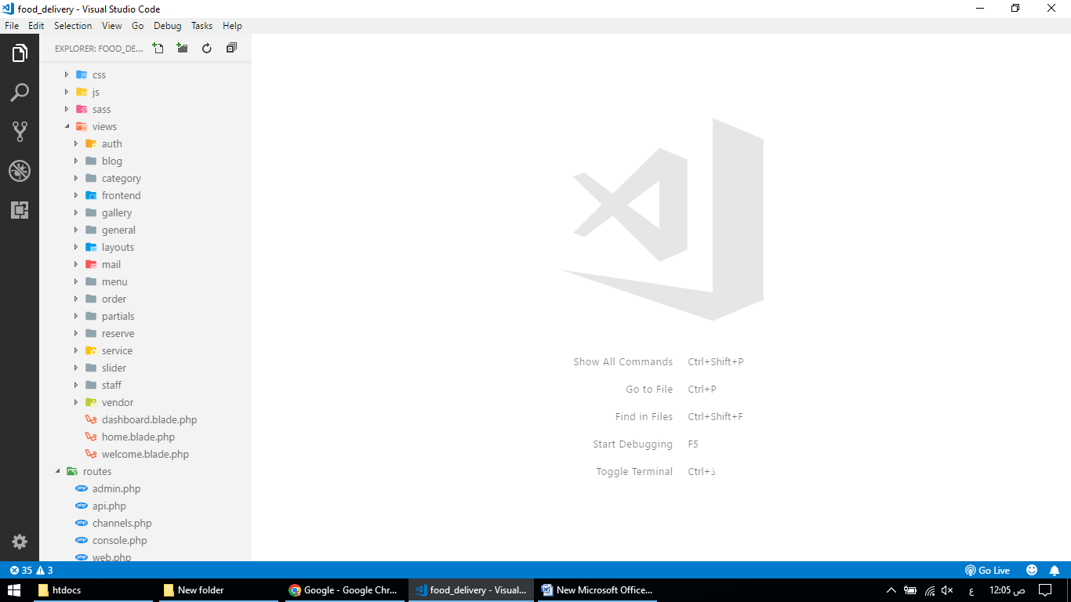

Layouts

backend.blade.php

<!doctype html>

<html lang="{{ str_replace('_', '-', app()->getLocale()) }}">

<head>

<meta charset="utf-8">

<meta name="viewport" content="width=device-width, initial-scale=1">

<!-- CSRF Token -->

<meta name="csrf-token" content="{{ csrf_token() }}">

<title>{{ config('app.name', 'Laravel') }} | @yield('title')</title>

<!-- General CSS Files -->

<link rel="stylesheet" href="{{ asset('assets/modules/bootstrap/css/bootstrap.min.css') }}">

<link rel="stylesheet" href="{{ asset('assets/modules/fontawesome/css/all.min.css') }}">

<!-- CSS Libraries -->

<link rel="stylesheet" href="{{ asset('assets/modules/summernote/summernote-bs4.css') }}">

<link rel="stylesheet" href="{{ asset('assets/modules/jquery-selectric/selectric.css') }}">

<!-- Template CSS -->

<link rel="stylesheet" href="{{ asset('assets/css/style.css') }}">

<link rel="stylesheet" href="{{ asset('assets/css/components.css') }}">

<!-- Start GA -->

<script async src="https://www.googletagmanager.com/gtag/js?id=UA-94034622-3"></script>

<script>

window.dataLayer = window.dataLayer || [];

function gtag() {

dataLayer.push(arguments);

}

gtag('js', new Date());

gtag('config', 'UA-94034622-3');

</script>

<!-- /END GA -->

</head>

<body>

<div id="app">

<div class="main-wrapper main-wrapper-1">

<div class="navbar-bg"></div>

<!-- Navbar included -->

@include('partials.navbar')

<!-- Sidebar included -->

@include('partials.sidebar')

<!-- Sweetalert included -->

@include('sweetalert::alert')

<!-- Main Content -->

<div class="main-content">

@yield('content')

</div>

</div>

</div>

<!-- General JS Scripts -->

<script src="{{ asset('assets/modules/jquery.min.js') }}"></script>

<script src="{{ asset('assets/modules/popper.js') }}"></script>

<script src="{{ asset('assets/modules/tooltip.js') }}"></script>

<script src="{{ asset('assets/modules/bootstrap/js/bootstrap.min.js') }}"></script>

<script src="{{ asset('assets/modules/nicescroll/jquery.nicescroll.min.js') }}"></script>

<script src="{{ asset('assets/modules/moment.min.js') }}"></script>

<script src="{{ asset('assets/js/stisla.js') }}"></script>

<!-- JS Libraies -->

<script src="{{ asset('assets/modules/summernote/summernote-bs4.js') }}"></script>

<script src="{{ asset('assets/modules/jquery-selectric/jquery.selectric.min.js') }}"></script>

<script src="{{ asset('assets/modules/upload-preview/assets/js/jquery.uploadPreview.min.js') }}"></script>

<!-- Page Specific JS File -->

@yield('scripts')

<!-- Template JS File -->

<script src="{{ asset('assets/js/scripts.js') }}"></script>

<script src="{{ asset('assets/js/custom.js') }}"></script>

</body>

</html>

frontend.blade.php

<!doctype html>

<html lang="{{ str_replace('_', '-', app()->getLocale()) }}">

<head>

<meta charset="utf-8">

<meta name="viewport" content="width=device-width, initial-scale=1">

<!-- CSRF Token -->

<meta name="csrf-token" content="{{ csrf_token() }}">

<title>{{ config('app.name', 'Laravel') }} | @yield('title')</title>

    <!-- Favicons-->

    <link rel="shortcut icon" href="img/favicon.ico" type="image/x-icon">

    <link rel="apple-touch-icon" type="image/x-icon" href="img/apple-touch-icon-57x57-precomposed.png">

    <link rel="apple-touch-icon" type="image/x-icon" sizes="72x72" href="img/apple-touch-icon-72x72-precomposed.png">

    <link rel="apple-touch-icon" type="image/x-icon" sizes="114x114"

        href="img/apple-touch-icon-114x114-precomposed.png">

    <link rel="apple-touch-icon" type="image/x-icon" sizes="144x144"

        href="img/apple-touch-icon-144x144-precomposed.png">

    <!-- GOOGLE WEB FONT -->

    <link rel="preconnect" href="https://fonts.googleapis.com/">

    <link rel="preconnect" href="https://fonts.gstatic.com/" crossorigin>

    <link

        href="https://fonts.googleapis.com/css2?family=Lora:ital@1&amp;family=Poppins:wght@400;500;600;700&amp;display=swap"

        rel="stylesheet">

    <link rel="stylesheet" href="https://use.fontawesome.com/releases/v5.15.4/css/all.css"

        integrity="sha384-DyZ88mC6Up2uqS4h/KRgHuoeGwBcD4Ng9SiP4dIRy0EXTlnuz47vAwmeGwVChigm" crossorigin="anonymous" />

    <!-- BASE CSS -->

    <link href="{{ asset('assets/frontend/css/vendors.min.css') }}" rel="stylesheet">

    <link href="{{ asset('assets/frontend/css/style.css') }}" rel="stylesheet">

    <!-- SPECIFIC CSS -->

    <link href="{{ asset('assets/frontend/css/wizard.css') }}" rel="stylesheet">

    <link href="{{ asset('assets/frontend/css/blog.css') }}" rel="stylesheet">

    <link href="{{ asset('assets/frontend/css/shop.css') }}" rel="stylesheet">

    <!-- YOUR CUSTOM CSS -->

    <link href="{{ asset('assets/frontend/css/custom.css') }}" rel="stylesheet">

</head>

<body>

    <div id="preloader">

        <div data-loader="circle-side"></div>

    </div>

    <!-- Sweetalert included -->

    @include('sweetalert::alert')

    {{-- Header start --}}

@include('partials.frontend.header')

    {{-- Header end --}}

<main>

        @if (!Route::is('home'))

        <div class="hero_single inner_pages background-image mb-4" data-background="url({{ asset('assets/frontend/img/hero_general.jpg') }})">

            <div class="opacity-mask" data-opacity-mask="rgba(0, 0, 0, 0.6)">

                <div class="container">

                    <div class="row justify-content-center">

                        @yield('breadcrumb')

                    </div>

                </div>

            </div>

            <div class="frame gray"></div>

        </div>

        @endif

@yield('content')

</main>

    {{-- Header start --}}

@include('partials.frontend.footer')

    {{-- Header end --}}

    <div id="toTop"></div>

    <!-- Login Modal -->

    <div class="modal fade" id="exampleModal" tabindex="-1" aria-labelledby="exampleModalLabel" aria-hidden="true">

        <div class="modal-dialog modal-dialog-centered">

            <div class="modal-content">

                <div class="modal-header border-0 pb-0">

                    <button type="button" class="btn-close" data-bs-dismiss="modal" aria-label="Close">

                    </button>

                </div>

                <div class="modal-body pt-0">

                    <div class="col-12">

                        <div class="main_title text-center">

                            <h2>Sign In</h2>

                        </div>

                        <form method="POST" action="{{ route('login') }}">

                            @csrf

                            <div class="form-group mb-3">

                                <label for="email">Email</label>

                                <input class="form-control" type="email" placeholder="Enter Your Email" id="email"

                                    name="email">

                                @error('email')

<span class="invalid-feedback" role="alert">

<strong>{{ $message }}</strong>

</span>

@enderror

                            </div>

                            <div class="form-group mb-5">

                                <label for="password">Password</label>

                                <input class="form-control" type="password" placeholder="Enter Your Password" id="password"

                                    name="password">

                                @error('password')

<span class="invalid-feedback" role="alert">

<strong>{{ $message }}</strong>

</span>

@enderror

                            </div>

                            <div class="form-group mb-2">

                                <input class="btn_1 full-width" type="submit" value="LogIn" id="submit-contact">

                            </div>

                        </form>

                    </div>

                </div>

            </div>

        </div>

    </div>

    <!-- Register Modal -->

    <div class="modal fade" id="registerModal" tabindex="-1" aria-labelledby="exampleModalLabel" aria-hidden="true">

        <div class="modal-dialog modal-dialog-centered">

            <div class="modal-content">

                <div class="modal-header border-0 pb-0">

                    <button type="button" class="btn-close" data-bs-dismiss="modal" aria-label="Close">

                    </button>

                </div>

                <div class="modal-body pt-0">

                    <div class="col-12">

                        <div class="main_title text-center">

                            <h2>Sign Up</h2>

                        </div>

                        <form method="POST" action="{{ route('register') }}">

                            @csrf

                            <div class="form-group mb-3">

                                <label for="name">Name</label>

                                <input class="form-control" type="text" placeholder="Enter Your Name" id="name"

                                    name="name">

                                @error('name')

<span class="invalid-feedback" role="alert">

<strong>{{ $message }}</strong>

</span>

@enderror

                            </div>

                            <div class="form-group mb-3">

                                <label for="email">Email</label>

                                <input class="form-control" type="email" placeholder="Enter Your Email" id="email"

                                    name="email">

                                @error('email')

<span class="invalid-feedback" role="alert">

<strong>{{ $message }}</strong>

</span>

@enderror

                            </div>

                            <div class="form-group mb-3">

                                <label for="password">Password</label>

                                <input class="form-control" type="password" placeholder="Enter Your Password" id="password"

                                    name="password">

                                @error('password')

<span class="invalid-feedback" role="alert">

<strong>{{ $message }}</strong>

</span>

@enderror

                            </div>

                            <div class="form-group mb-5">

                                <label for="password_confirmation">Confirm Password</label>

                                <input class="form-control" type="password" placeholder="Enter Your Password" id="password_confirmation"

                                    name="password_confirmation">

                                @error('password_confirmation')

<span class="invalid-feedback" role="alert">

<strong>{{ $message }}</strong>

</span>

@enderror

                            </div>

                            <div class="form-group mb-2">

                                <input class="btn_1 full-width" type="submit" value="Register" id="submit-contact">

                            </div>

                        </form>

                    </div>

                </div>

            </div>

        </div>

    </div>

<!-- COMMON SCRIPTS -->

    <script src="{{ asset('assets/frontend/js/common_scripts.min.js') }}"></script>

    <script src="{{ asset('assets/frontend/js/slider.js') }}"></script>

    <script src="{{ asset('assets/frontend/js/common_func.js') }}"></script>

    <script src="{{ asset('assets/frontend/phpmailer/validate.js') }}"></script>

    <!-- SPECIFIC SCRIPTS (wizard form) -->

    <script src="{{ asset('assets/frontend/js/wizard/wizard_scripts.min.js') }}"></script>

    <script src="{{ asset('assets/frontend/js/wizard/wizard_func.js') }}"></script>

<!-- Page Specific JS File -->

@yield('scripts')

</body>

</html>

Auth

login.blade.php

blog

create.blade.php

@extends('layouts.backend')

@section('title', 'Blog Create')

@section('content')

<div class="card">

<form action="{{ route('blog.store') }}" method="POST" enctype="multipart/form-data">

@csrf

<div class="card-header">

<h4>{{ $page_title }}</h4>

</div>

<div class="card-body">

<div class="form-group row mb-4">

<label class="col-form-label text-md-right col-12 col-md-3 col-lg-3">Title</label>

<div class="col-sm-12 col-md-7">

<input type="text" class="form-control" name="title">

</div>

</div>

<div class="form-group row mb-4">

<label class="col-form-label text-md-right col-12 col-md-3 col-lg-3">Category</label>

<div class="col-sm-12 col-md-7">

<select name="category_id" class="form-control selectric">

@foreach ($categories as $item)

<option value="{{ $item->id }}">{{ $item->name }}</option>

@endforeach

</select>

</div>

</div>

<div class="form-group row mb-4">

<label class="col-form-label text-md-right col-12 col-md-3 col-lg-3">Description</label>

<div class="col-sm-12 col-md-7">

<textarea name="description" class="summernote-simple"></textarea>

</div>

</div>

<div class="form-group row mb-4">

<label class="col-form-label text-md-right col-12 col-md-3 col-lg-3">Thumbnail</label>

<div class="col-sm-12 col-md-7">

<div style="background-image: url();" id="image-preview" class="image-preview">

<label for="image-upload" id="image-label">Choose File</label>

<input type="file" name="thumbnail" id="image-upload" />

</div>

</div>

</div>

<div class="form-group row mb-4">

<label class="col-form-label text-md-right col-12 col-md-3 col-lg-3">Status</label>

<div class="col-sm-12 col-md-7">

<select class="form-control selectric" name="status">

<option value="1">Publish</option>

<option value="0">Draft</option>

</select>

</div>

</div>

</div>

<div class="card-footer">

<button type="submit" class="btn btn-primary">Submit</button>

</div>

</form>

</div>

@endsection

@section('scripts')

<script src="{{ asset('assets/js/page/features-post-create.js') }}"></script>

@endsection

edit.blade.php

@extends('layouts.backend')

@section('title', 'Blog Edit')

@section('content')

<div class="card">

<form action="{{ route('blog.update', $blog->id) }}" method="POST" enctype="multipart/form-data">

@csrf

@method('PUT')

<div class="card-header">

<h4>{{ $page_title }}</h4>

</div>

<div class="card-body">

<div class="form-group row mb-4">

<label class="col-form-label text-md-right col-12 col-md-3 col-lg-3">Title</label>

<div class="col-sm-12 col-md-7">

<input type="text" class="form-control" name="title" value="{{ $blog->title }}">

</div>

</div>

<div class="form-group row mb-4">

<label class="col-form-label text-md-right col-12 col-md-3 col-lg-3">Category</label>

<div class="col-sm-12 col-md-7">

<select name="category_id" class="form-control selectric">

@foreach ($categories as $item)

@if ($item->id == $blog->category_id)

<option selected value="{{ $item->id }}">{{ $item->name }}</option>

@else

<option value="{{ $item->id }}">{{ $item->name }}</option>

@endif

@endforeach

</select>

</div>

</div>

<div class="form-group row mb-4">

<label class="col-form-label text-md-right col-12 col-md-3 col-lg-3">Description</label>

<div class="col-sm-12 col-md-7">

<textarea name="description" class="summernote-simple">{{ $blog->description }}"</textarea>

</div>

</div>

<div class="form-group row mb-4">

<label class="col-form-label text-md-right col-12 col-md-3 col-lg-3">Thumbnail</label>

<div class="col-sm-12 col-md-7">

<div style="background-image: url({{ asset($blog->thumbnail) }});background-size: cover; background-position: center;" id="image-preview" class="image-preview">

<label for="image-upload" id="image-label">Choose File</label>

<input type="file" name="thumbnail" id="image-upload" />

</div>

</div>

</div>

<div class="form-group row mb-4">

<label class="col-form-label text-md-right col-12 col-md-3 col-lg-3">Status</label>

<div class="col-sm-12 col-md-7">

<select class="form-control selectric" name="status">

<option {{ $blog->status == 1 ? 'checked':'' }} value="1">Publish</option>

<option {{ $blog->status == 0 ? 'checked':'' }} value="0">Draft</option>

</select>

</div>

</div>

</div>

<div class="card-footer">

<button type="submit" class="btn btn-primary">Submit</button>

</div>

</form>

</div>

@endsection

@section('scripts')

<script src="{{ asset('assets/js/page/features-post-create.js') }}"></script>

@endsection

index.blade.php

@extends('layouts.backend')

@section('title', 'Blog List')

@section('content')

<div class="row">

<div class="col-12">

<div class="card">

<div class="card-header">

<h4>{{ $page_title }}</h4>

</div>

<div class="card-body">

<table class="table table-striped">

<thead>

<tr>

<th>Sl No.</th>

<th>Thumnail</th>

<th>Title</th>

<th>Category</th>

<th>User</th>

<th>Status</th>

<th>Action</th>

</tr>

</thead>

<tbody>

@foreach ($blogs as $item)

<tr>

<td>{{ $loop->index + 1 }}</td>

<td>

<img src="{{ asset($item->thumbnail) }}" alt="{{ $item->name }}" width="60">

</td>

<td>{{ $item->title }}</td>

<td>{{ $item->category->name }}</td>

<td>{{ $item->user->name }}</td>

<td><span class="badge {{ $item->status == 1 ? 'badge-primary':'badge-warning' }}">{{ $item->status == 1 ? 'Published':'Draft' }}</span></td>

<td>

<a class="btn btn-primary" href="{{ route('blog.edit', $item->id) }}">Edit</a>

<button class="btn btn-danger delete" type="button" id="{{ $item->id }}" class="btn btn-primary"

data-toggle="modal" data-target="#exampleModal">Delete</button>

</td>

</tr>

@endforeach

</tbody>

</table>

</div>

</form>

</div>

</div>

</div>

<!-- Modal -->

<div class="modal fade" id="exampleModal" tabindex="-1" aria-labelledby="exampleModalLabel" aria-hidden="true">

<div class="modal-dialog">

<form id="deleteModal" method="POST">

@csrf

@method('DELETE')

<div class="modal-content">

<div class="modal-header">

<button type="button" class="close" data-dismiss="modal" aria-label="Close">

<span aria-hidden="true">&times;</span>

</button>

</div>

<div class="modal-body">

Are you sure want to delete this item?

</div>

<div class="modal-footer">

<button type="button" class="btn btn-success" data-dismiss="modal">Close</button>

<button type="submit" class="btn btn-danger">Delete</button>

</div>

</div>

</form>

</div>

</div>

@endsection

@section('scripts')

<script>

$('.delete').on('click', function () {

const id = this.id;

$('#deleteModal').attr('action', "{{ route('blog.destroy', '') }}" + '/' + id);

});

</script>

@endsection

Category

create.blade.php

@extends('layouts.backend')

@section('title', 'Category Create')

@section('content')

<div class="card">

<form action="{{ route('category.store') }}" method="POST" enctype="multipart/form-data">

@csrf

<div class="card-header">

<h4>{{ $page_title }}</h4>

</div>

<div class="card-body">

<div class="form-group row">

<label for="name" class="col-sm-3 col-form-label">Name</label>

<div class="col-sm-9">

<input type="text" class="form-control" id="name" name="name" placeholder="Category Name">

</div>

</div>

<div class="form-group row">

<label for="thumbnail" class="col-sm-3 col-form-label">Thumbnail</label>

<div class="col-sm-9">

<input type="file" class="form-control" id="thumbnail" name="thumbnail">

</div>

</div>

<fieldset class="form-group">

<div class="row">

<div class="col-form-label col-sm-3 pt-0">Category Type</div>

<div class="col-sm-9">

<div class="form-check">

<input class="form-check-input" type="radio" name="type" id="menu" value="0"

checked>

<label class="form-check-label" for="menu">

Menu

</label>

</div>

<div class="form-check">

<input class="form-check-input" type="radio" name="type" id="blog" value="1">

<label class="form-check-label" for="blog">

Blog

</label>

</div>

</div>

</div>

</fieldset>

</div>

<div class="card-footer">

<button type="submit" class="btn btn-primary">Submit</button>

</div>

</form>

</div>

@endsection

edit.blade.php

@extends('layouts.backend')

@section('title', 'Category Edit')

@section('content')

<div class="card">

<form action="{{ route('category.update', $category->id) }}" method="POST" enctype="multipart/form-data">

@csrf

@method('PUT')

<div class="card-header">

<h4>{{ $page_title }}</h4>

</div>

<div class="card-body">

<div class="form-group row">

<label for="name" class="col-sm-3 col-form-label">Name</label>

<div class="col-sm-9">

<input type="text" class="form-control" id="name" name="name" placeholder="Category Name" value="{{ $category->name }}">

</div>

</div>

<div class="form-group row">

<label for="thumbnail" class="col-sm-3 col-form-label">Thumbnail</label>

<div class="col-sm-9">

<input type="file" class="form-control" id="thumbnail" name="thumbnail">

<img src="{{ $category->thumbnail }}" alt="Category Image" width="80">

</div>

</div>

<fieldset class="form-group">

<div class="row">

<div class="col-form-label col-sm-3 pt-0">Category Type</div>

<div class="col-sm-9">

<div class="form-check">

<input class="form-check-input" type="radio" name="type" id="menu" value="0"

{{ $category->type == 0 ? 'checked':'' }}>

<label class="form-check-label" for="menu">

Menu

</label>

</div>

<div class="form-check">

<input class="form-check-input" type="radio" name="type" id="blog" value="1" {{ $category->type == 1 ? 'checked':'' }}>

<label class="form-check-label" for="blog">

Blog

</label>

</div>

</div>

</div>

</fieldset>

</div>

<div class="card-footer">

<button type="submit" class="btn btn-primary">Submit</button>

</div>

</form>

</div>

@endsection

index.blade.php

@extends('layouts.backend')

@section('title', 'Category List')

@section('content')

<div class="row">

<div class="col-12">

<div class="card">

<div class="card-header">

<h4>{{ $page_title }}</h4>

</div>

<div class="card-body">

<table class="table table-striped">

<thead>

<tr>

<th>Sl No.</th>

<th>Thumnail</th>

<th>Name</th>

<th>Action</th>

</tr>

</thead>

<tbody>

@foreach ($categories as $item)

<tr>

<td>{{ $loop->index + 1 }}</td>

<td>

<img src="{{ asset($item->thumbnail) }}" alt="{{ $item->name }}" width="60">

</td>

<td>{{ $item->name }}</td>

<td>

<a class="btn btn-primary" href="{{ route('category.edit', $item->id) }}">Edit</a>

<button class="btn btn-danger delete" type="button" id="{{ $item->id }}" class="btn btn-primary"

data-toggle="modal" data-target="#exampleModal">Delete</button>

</td>

</tr>

@endforeach

</tbody>

</table>

</div>

</form>

</div>

</div>

</div>

<!-- Modal -->

<div class="modal fade" id="exampleModal" tabindex="-1" aria-labelledby="exampleModalLabel" aria-hidden="true">

<div class="modal-dialog">

<form id="deleteModal" method="POST">

@csrf

@method('DELETE')

<div class="modal-content">

<div class="modal-header">

<button type="button" class="close" data-dismiss="modal" aria-label="Close">

<span aria-hidden="true">&times;</span>

</button>

</div>

<div class="modal-body">

Are you sure want to delete this item?

</div>

<div class="modal-footer">

<button type="button" class="btn btn-success" data-dismiss="modal">Close</button>

<button type="submit" class="btn btn-danger">Delete</button>

</div>

</div>

</form>

</div>

</div>

@endsection

@section('scripts')

<script>

$('.delete').on('click', function () {

const id = this.id;

$('#deleteModal').attr('action', "{{ route('category.destroy', '') }}" + '/' + id);

});

</script>

@endsection

--

Gallery

create.blade.php

@extends('layouts.backend')

@section('title', 'Gallery Create')

@section('content')

<div class="card">

<form action="{{ route('gallery.store') }}" method="POST" enctype="multipart/form-data">

@csrf

<div class="card-header">

<h4>{{ $page_title }}</h4>

</div>

<div class="card-body">

<div class="form-group row mb-4">

<label class="col-form-label text-md-right col-12 col-md-3 col-lg-3">Caption</label>

<div class="col-sm-12 col-md-7">

<input type="text" class="form-control" name="caption">

</div>

</div>

<div class="form-group row mb-4">

<label class="col-form-label text-md-right col-12 col-md-3 col-lg-3">Thumbnail</label>

<div class="col-sm-12 col-md-7">

<div style="background-image: url();" id="image-preview" class="image-preview">

<label for="image-upload" id="image-label">Choose File</label>

<input type="file" name="thumbnail" id="image-upload" />

</div>

</div>

</div>

<div class="form-group row mb-4">

<label class="col-form-label text-md-right col-12 col-md-3 col-lg-3">Type</label>

<div class="col-sm-12 col-md-7">

<select name="type" class="form-control selectric" id="type">

<option selected value="0">Photo</option>

<option value="1">Video</option>

</select>

</div>

</div>

<div class="form-group row mb-4 d-none" id="video_link">

<label class="col-form-label text-md-right col-12 col-md-3 col-lg-3">Video Link</label>

<div class="col-sm-12 col-md-7">

<input type="text" class="form-control" name="video_link">

</div>

</div>

</div>

<div class="card-footer">

<button type="submit" class="btn btn-primary">Submit</button>

</div>

</form>

</div>

@endsection

@section('scripts')

<script>

$('#type').on('change', function () {

const val = $(this).val();

if (val == 1) {

$('#video_link').removeClass('d-none');

}else{

$('#video_link').addClass('d-none');

}

});

</script>

<script src="{{ asset('assets/js/page/features-post-create.js') }}"></script>

@endsection

edit.blade.php

@extends('layouts.backend')

@section('title', 'Gallery Edit')

@section('content')

<div class="card">

<form action="{{ route('gallery.update', $gallery->id) }}" method="POST" enctype="multipart/form-data">

@csrf

@method('PUT')

<div class="card-header">

<h4>{{ $page_title }}</h4>

</div>

<div class="card-body">

<div class="form-group row mb-4">

<label class="col-form-label text-md-right col-12 col-md-3 col-lg-3">Caption</label>

<div class="col-sm-12 col-md-7">

<input type="text" class="form-control" name="caption" value="{{ $gallery->caption }}">

</div>

</div>

<div class="form-group row mb-4">

<label class="col-form-label text-md-right col-12 col-md-3 col-lg-3">Thumbnail</label>

<div class="col-sm-12 col-md-7">

<div style="background-image: url({{ asset($gallery->thumbnail) }});" id="image-preview" class="image-preview">

<label for="image-upload" id="image-label">Choose File</label>

<input type="file" name="thumbnail" id="image-upload" />

</div>

</div>

</div>

<div class="form-group row mb-4">

<label class="col-form-label text-md-right col-12 col-md-3 col-lg-3">Type</label>

<div class="col-sm-12 col-md-7">

<select name="type" class="form-control selectric" id="type">

<option {{ $gallery->type == 0 ? 'selected':'' }} value="0">Photo</option>

<option {{ $gallery->type == 1 ? 'selected':'' }} value="1">Video</option>

</select>

</div>

</div>

<div class="form-group row mb-4 {{ $gallery->type == 0 ? 'd-none':'' }}" id="video_link">

<label class="col-form-label text-md-right col-12 col-md-3 col-lg-3">Video Link</label>

<div class="col-sm-12 col-md-7">

<input type="text" class="form-control" name="video_link" value="{{ $gallery->video_link }}">

</div>

</div>

</div>

<div class="card-footer">

<button type="submit" class="btn btn-primary">Submit</button>

</div>

</form>

</div>

@endsection

@section('scripts')

<script>

$('#type').on('change', function () {

const val = $(this).val();

if (val == 1) {

$('#video_link').removeClass('d-none');

}else{

$('#video_link').addClass('d-none');

}

});

</script>

<script src="{{ asset('assets/js/page/features-post-create.js') }}"></script>

@endsection

@extends('layouts.backend')

@section('title', 'Gallery List')

@section('content')

<div class="row">

<div class="col-12">

<div class="card">

<div class="card-header">

<h4>{{ $page_title }}</h4>

</div>

<div class="card-body">

<table class="table table-striped">

<thead>

<tr>

<th>Sl No.</th>

<th>Thumnail</th>

<th>Caption</th>

<th>Type</th>

<th>Action</th>

</tr>

</thead>

<tbody>

@foreach ($galleries as $item)

<tr>

<td>{{ $loop->index + 1 }}</td>

<td>

<img src="{{ asset($item->thumbnail) }}" alt="{{ $item->name }}" width="60">

</td>

<td>{{ $item->caption }}</td>

<td><span class="badge {{ $item->type == 1 ? 'badge-primary':'badge-warning' }}">{{ $item->type == 1 ? 'Video':'Photo' }}</span></td>

<td>

<a class="btn btn-primary" href="{{ route('gallery.edit', $item->id) }}">Edit</a>

<button class="btn btn-danger delete" type="button" id="{{ $item->id }}" class="btn btn-primary"

data-toggle="modal" data-target="#exampleModal">Delete</button>

</td>

</tr>

@endforeach

</tbody>

</table>

</div>

</form>

</div>

</div>

</div>

<!-- Modal -->

<div class="modal fade" id="exampleModal" tabindex="-1" aria-labelledby="exampleModalLabel" aria-hidden="true">

<div class="modal-dialog">

<form id="deleteModal" method="POST">

@csrf

@method('DELETE')

<div class="modal-content">

<div class="modal-header">

<button type="button" class="close" data-dismiss="modal" aria-label="Close">

<span aria-hidden="true">&times;</span>

</button>

</div>

<div class="modal-body">

Are you sure want to delete this item?

</div>

<div class="modal-footer">

<button type="button" class="btn btn-success" data-dismiss="modal">Close</button>

<button type="submit" class="btn btn-danger">Delete</button>

</div>

</div>

</form>

</div>

</div>

@endsection

@section('scripts')

<script>

$('.delete').on('click', function () {

const id = this.id;

$('#deleteModal').attr('action', "{{ route('gallery.destroy', '') }}" + '/' + id);

});

</script>

@endsection

General

index.blade.php

@extends('layouts.backend')

@section('title', $page_title)

@section('content')

<div class="card">

<form action="{{ route('admin.general.store', $general ? 'update':'create') }}" method="POST" enctype="multipart/form-data">

@csrf

@method('PUT')

<div class="card-header">

<h4>{{ $page_title }}</h4>

</div>

<div class="card-body">

<div class="form-group row mb-4">

<label class="col-form-label text-md-right col-12 col-md-3 col-lg-3">Company Name</label>

<div class="col-sm-12 col-md-7">

<input type="text" class="form-control" name="company_name"

value="{{ $general ? $general->company_name : '' }}">

</div>

</div>

<div class="form-group row mb-4">

<label class="col-form-label text-md-right col-12 col-md-3 col-lg-3">Logo</label>

<div class="col-sm-12 col-md-7">

<div style="background-image: url({{ asset($general ? $general->logo : '') }});background-size: cover; background-position: center;"

id="image-preview" class="image-preview">

<label for="image-upload" id="image-label">Choose File</label>

<input type="file" name="logo" id="image-upload" />

</div>

</div>

</div>

<div class="form-group row mb-4">

<label class="col-form-label text-md-right col-12 col-md-3 col-lg-3">Story Title</label>

<div class="col-sm-12 col-md-7">

<input type="text" class="form-control" name="story_title"

value="{{ $general ? $general->story_title : '' }}">

</div>

</div>

<div class="form-group row mb-4">

<label class="col-form-label text-md-right col-12 col-md-3 col-lg-3">Story Description</label>

<div class="col-sm-12 col-md-7">

<textarea name="story_description" class="summernote-simple">{{ $general ? $general->story_description : '' }}"</textarea>

</div>

</div>

<div class="form-group row mb-4">

<label class="col-form-label text-md-right col-12 col-md-3 col-lg-3">Why Choose Us</label>

<div class="col-sm-12 col-md-7">

<textarea name="why_choose_us" class="summernote-simple">{{ $general ? $general->why_choose_us : '' }}"</textarea>

</div>

</div>

<div class="form-group row mb-4">

<label class="col-form-label text-md-right col-12 col-md-3 col-lg-3">Address</label>

<div class="col-sm-12 col-md-7">

<textarea name="address" class="summernote-simple">{{ $general ? $general->address : '' }}"</textarea>

</div>

</div>

<div class="form-group row mb-4">

<label class="col-form-label text-md-right col-12 col-md-3 col-lg-3">Primary Phone</label>

<div class="col-sm-12 col-md-7">

<input type="text" class="form-control" name="primary_phone"

value="{{ $general ? $general->primary_phone : '' }}">

</div>

</div>

<div class="form-group row mb-4">

<label class="col-form-label text-md-right col-12 col-md-3 col-lg-3">Secondary Phone</label>

<div class="col-sm-12 col-md-7">

<input type="text" class="form-control" name="secondary_phone"

value="{{ $general ? $general->secondary_phone : '' }}">

</div>

</div>

<div class="form-group row mb-4">

<label class="col-form-label text-md-right col-12 col-md-3 col-lg-3">Company Email</label>

<div class="col-sm-12 col-md-7">

<input type="email" class="form-control" name="email"

value="{{ $general ? $general->email : '' }}">

</div>

</div>

<div class="form-group row mb-4">

<label class="col-form-label text-md-right col-12 col-md-3 col-lg-3">Facebook Link</label>

<div class="col-sm-12 col-md-7">

<input type="text" class="form-control" name="facebook"

value="{{ $general ? $general->facebook : '' }}">

</div>

</div>

<div class="form-group row mb-4">

<label class="col-form-label text-md-right col-12 col-md-3 col-lg-3">Twitter Link</label>

<div class="col-sm-12 col-md-7">

<input type="text" class="form-control" name="twitter"

value="{{ $general ? $general->twitter : '' }}">

</div>

</div>

<div class="form-group row mb-4">

<label class="col-form-label text-md-right col-12 col-md-3 col-lg-3">Instagram Link</label>

<div class="col-sm-12 col-md-7">

<input type="text" class="form-control" name="instagram"

value="{{ $general ? $general->instagram : '' }}">

</div>

</div>

<div class="form-group row mb-4">

<label class="col-form-label text-md-right col-12 col-md-3 col-lg-3">Delivery Fee</label>

<div class="col-sm-12 col-md-7">

<input type="text" class="form-control" name="delivery_fee"

value="{{ $general ? $general->delivery_fee : '' }}">

</div>

</div>

</div>

<div class="card-footer">

<button type="submit" class="btn btn-primary">Submit</button>

</div>

</form>

</div>

@endsection

@section('scripts')

<script src="{{ asset('assets/js/page/features-post-create.js') }}"></script>

@endsection

Mail

contact.blade.php

<!DOCTYPE html>

<html lang="en">

<head>

<meta charset="UTF-8">

<meta name="viewport" content="width=device-width, initial-scale=1.0">

<meta http-equiv="X-UA-Compatible" content="ie=edge">

<title>Contact Mail</title>

</head>

<body>

<h3>Name: {{ $data['name'] }}</h3>

<h3>Email: {{ $data['email'] }}</h3>

<p>{{ $data['message'] }}</p>

</body>

</html>

reserve.blade.php

<!DOCTYPE html>

<html lang="en">

<head>

<meta charset="UTF-8">

<meta name="viewport" content="width=device-width, initial-scale=1.0">

<meta http-equiv="X-UA-Compatible" content="ie=edge">

<title>{{ $data['title'] }}</title>

</head>

<body>

<p>{{ $data['message'] }}</p>

</body>

</html>

Menu

create.blade.php

@extends('layouts.backend')

@section('title', 'Menu Create')

@section('content')

<div class="card">

<form action="{{ route('menu.store') }}" method="POST" enctype="multipart/form-data">

@csrf

<div class="card-header">

<h4>{{ $page_title }}</h4>

</div>

<div class="card-body">

<div class="form-group row mb-4">

<label class="col-form-label text-md-right col-12 col-md-3 col-lg-3">Title</label>

<div class="col-sm-12 col-md-7">

<input type="text" class="form-control" name="title">

</div>

</div>

<div class="form-group row mb-4">

<label class="col-form-label text-md-right col-12 col-md-3 col-lg-3">Category</label>

<div class="col-sm-12 col-md-7">

<select name="category_id" class="form-control selectric">

@foreach ($categories as $item)

<option value="{{ $item->id }}">{{ $item->name }}</option>

@endforeach

</select>

</div>

</div>

<div class="form-group row mb-4">

<label class="col-form-label text-md-right col-12 col-md-3 col-lg-3">Price</label>

<div class="col-sm-12 col-md-7">

<input type="text" class="form-control" name="price">

</div>

</div>

<div class="form-group row mb-4">

<label class="col-form-label text-md-right col-12 col-md-3 col-lg-3">Description</label>

<div class="col-sm-12 col-md-7">

<textarea name="description" class="summernote-simple"></textarea>

</div>

</div>

<div class="form-group row mb-4">

<label class="col-form-label text-md-right col-12 col-md-3 col-lg-3">Thumbnail</label>

<div class="col-sm-12 col-md-7">

<div style="background-image: url();" id="image-preview" class="image-preview">

<label for="image-upload" id="image-label">Choose File</label>

<input type="file" name="thumbnail" id="image-upload" />

</div>

</div>

</div>

<div class="form-group row mb-4">

<label class="col-form-label text-md-right col-12 col-md-3 col-lg-3">Status</label>

<div class="col-sm-12 col-md-7">

<select class="form-control selectric" name="status">

<option value="1">Publish</option>

<option value="0">Draft</option>

</select>

</div>

</div>

</div>

<div class="card-footer">

<button type="submit" class="btn btn-primary">Submit</button>

</div>

</form>

</div>

@endsection

@section('scripts')

<script src="{{ asset('assets/js/page/features-post-create.js') }}"></script>

@endsection

edit.blade.php

@extends('layouts.backend')

@section('title', 'Menu Edit')

@section('content')

<div class="card">

<form action="{{ route('menu.update', $menu->id) }}" method="POST" enctype="multipart/form-data">

@csrf

@method('PUT')

<div class="card-header">

<h4>{{ $page_title }}</h4>

</div>

<div class="card-body">

<div class="form-group row mb-4">

<label class="col-form-label text-md-right col-12 col-md-3 col-lg-3">Title</label>

<div class="col-sm-12 col-md-7">

<input type="text" class="form-control" name="title" value="{{ $menu->title }}">

</div>

</div>

<div class="form-group row mb-4">

<label class="col-form-label text-md-right col-12 col-md-3 col-lg-3">Category</label>

<div class="col-sm-12 col-md-7">

<select name="category_id" class="form-control selectric">

@foreach ($categories as $item)

@if ($item->id == $menu->category_id)

<option selected value="{{ $item->id }}">{{ $item->name }}</option>

@else

<option value="{{ $item->id }}">{{ $item->name }}</option>

@endif

@endforeach

</select>

</div>

</div>

<div class="form-group row mb-4">

<label class="col-form-label text-md-right col-12 col-md-3 col-lg-3">Price</label>

<div class="col-sm-12 col-md-7">

<input type="text" class="form-control" name="price" value="{{ $menu->price }}">

</div>

</div>

<div class="form-group row mb-4">

<label class="col-form-label text-md-right col-12 col-md-3 col-lg-3">Description</label>

<div class="col-sm-12 col-md-7">

<textarea name="description" class="summernote-simple">{{ $menu->description }}"</textarea>

</div>

</div>

<div class="form-group row mb-4">

<label class="col-form-label text-md-right col-12 col-md-3 col-lg-3">Thumbnail</label>

<div class="col-sm-12 col-md-7">

<div style="background-image: url({{ asset($menu->thumbnail) }});background-size: cover; background-position: center;" id="image-preview" class="image-preview">

<label for="image-upload" id="image-label">Choose File</label>

<input type="file" name="thumbnail" id="image-upload" />

</div>

</div>

</div>

<div class="form-group row mb-4">

<label class="col-form-label text-md-right col-12 col-md-3 col-lg-3">Status</label>

<div class="col-sm-12 col-md-7">

<select class="form-control selectric" name="status">

<option {{ $menu->status == 1 ? 'checked':'' }} value="1">Publish</option>

<option {{ $menu->status == 0 ? 'checked':'' }} value="0">Draft</option>

</select>

</div>

</div>

</div>

<div class="card-footer">

<button type="submit" class="btn btn-primary">Submit</button>

</div>

</form>

</div>

@endsection

@section('scripts')

<script src="{{ asset('assets/js/page/features-post-create.js') }}"></script>

@endsection

index.blade.php

@extends('layouts.backend')

@section('title', 'Menu List')

@section('content')

<div class="row">

<div class="col-12">

<div class="card">

<div class="card-header">

<h4>{{ $page_title }}</h4>

</div>

<div class="card-body">

<table class="table table-striped">

<thead>

<tr>

<th>Sl No.</th>

<th>Thumnail</th>

<th>Title</th>

<th>Category</th>

<th>Price</th>

<th>Status</th>

<th>Action</th>

</tr>

</thead>

<tbody>

@foreach ($menues as $item)

<tr>

<td>{{ $loop->index + 1 }}</td>

<td>

<img src="{{ asset($item->thumbnail) }}" alt="{{ $item->name }}" width="60">

</td>

<td>{{ $item->title }}</td>

<td>{{ $item->category->name }}</td>

<td>${{ $item->price }}</td>

<td><span class="badge {{ $item->status == 1 ? 'badge-primary':'badge-warning' }}">{{ $item->status == 1 ? 'Published':'Draft' }}</span></td>

<td>

<a class="btn btn-primary" href="{{ route('menu.edit', $item->id) }}">Edit</a>

<button class="btn btn-danger delete" type="button" id="{{ $item->id }}" class="btn btn-primary"

data-toggle="modal" data-target="#exampleModal">Delete</button>

</td>

</tr>

@endforeach

</tbody>

</table>

</div>

</form>

</div>

</div>

</div>

<!-- Modal -->

<div class="modal fade" id="exampleModal" tabindex="-1" aria-labelledby="exampleModalLabel" aria-hidden="true">

<div class="modal-dialog">

<form id="deleteModal" method="POST">

@csrf

@method('DELETE')

<div class="modal-content">

<div class="modal-header">

<button type="button" class="close" data-dismiss="modal" aria-label="Close">

<span aria-hidden="true">&times;</span>

</button>

</div>

<div class="modal-body">

Are you sure want to delete this item?

</div>

<div class="modal-footer">

<button type="button" class="btn btn-success" data-dismiss="modal">Close</button>

<button type="submit" class="btn btn-danger">Delete</button>

</div>

</div>

</form>

</div>

</div>

@endsection

@section('scripts')

<script>

$('.delete').on('click', function () {

const id = this.id;

$('#deleteModal').attr('action', "{{ route('menu.destroy', '') }}" + '/' + id);

});

</script>

@endsection

Order

index.blade.php

@extends('layouts.backend')

@section('title', 'All Orders')

@section('content')

<div class="row">

<div class="col-12">

<div class="card">

<div class="card-header">

<h4>{{ $page_title }}</h4>

</div>

<div class="card-body">

<table class="table table-striped table-responsive">

<thead>

<tr>

<th>Sl No.</th>

<th>Name</th>

<th>Email</th>

<th>Phone</th>

<th>Address</th>

<th>City</th>

<th>Postal Code</th>

<th>Payment Method</th>

<th>Payment Status</th>

<th>Status</th>

<th>Action</th>

</tr>

</thead>

<tbody>

@foreach ($orders as $item)

<tr>

<td>{{ $loop->index + 1 }}</td>

<td>{{ $item->name }}</td>

<td>{{ $item->email }}</td>

<td>{{ $item->phone }}</td>

<td>{{ $item->address }}</td>

<td>{{ $item->city }}</td>

<td>{{ $item->postal_code }}</td>

<td><span class="badge badge-primary">{{ $item->payment_method === 1 ? 'Cash On Delivery':($item->payment_method === 2 ? 'Paypal':'Stripe') }}</span></td>

<td><span class="badge {{ $item->payment_status === 0 ? 'badge-danger':'badge-success' }}">{{ $item->payment_status === 0 ? 'Due':'Paid' }}</span></td>

<td><span class="badge {{ $item->order_status === 0 ? 'badge-warning':($item->order_status === 1 ? 'badge-success':'badge-danger') }}">{{ $item->order_status === 0 ? 'pending':($item->order_status === 1 ? 'completed':'canceled') }}</span></td>

<td style="white-space: nowrap">

<a class="btn btn-primary" href="{{ route('admin.order.confirmation',['accept', $item->id] ) }}">Complete</a>

<a class="btn btn-warning" href="{{ route('admin.order.confirmation',['decline', $item->id] ) }}">Cancel</a>

<button class="btn btn-danger delete" type="button" id="{{ $item->id }}" class="btn btn-primary"

data-toggle="modal" data-target="#exampleModal">Delete</button>

<button class="btn btn-success" type="button" data-toggle="collapse" data-target="#order_{{ $item->id }}" >Details</button>

</td>

</tr>

<tr class="collapse" id="order_{{ $item->id }}">

<td colspan="11">

<table class="w-100">

<thead>

<th>Sl No.</th>

<th>Thumbnail</th>

<th>Quantity</th>

<th>price</th>

<th>Subtotal</th>

</thead>

<tbody>

@php

$total = 0;

@endphp

@foreach ($item->details as $order)

@php

$total += $order->price * $order->quantity;

@endphp

<tr>

<td>{{ $loop->index + 1 }}</td>

<td>

<img width="60" src="{{ asset($order->menu->thumbnail) }}" alt="thumbnail">

</td>

<td>{{ $order->quantity }}</td>

<td>{{ $order->price }}</td>

<td>{{ $order->price * $order->quantity }}</td>

</tr>

@endforeach

</tbody>

<tfoot>

<th colspan="4">Total</th>

<th>{{ $total }}</th>

</tfoot>

</table>

</td>

</tr>

@endforeach

</tbody>

</table>

</div>

</form>

</div>

</div>

</div>

<!-- Modal -->

<div class="modal fade" id="exampleModal" tabindex="-1" aria-labelledby="exampleModalLabel" aria-hidden="true">

<div class="modal-dialog">

<form id="deleteModal" method="POST">

@csrf

@method('DELETE')

<div class="modal-content">

<div class="modal-header">

<button type="button" class="close" data-dismiss="modal" aria-label="Close">

<span aria-hidden="true">&times;</span>

</button>

</div>

<div class="modal-body">

Are you sure want to delete this item?

</div>

<div class="modal-footer">

<button type="button" class="btn btn-success" data-dismiss="modal">Close</button>

<button type="submit" class="btn btn-danger">Delete</button>

</div>

</div>

</form>

</div>

</div>

@endsection

@section('scripts')

<script>

$('.delete').on('click', function () {

const id = this.id;

$('#deleteModal').attr('action', "{{ route('admin.order.delete', '') }}" + '/' + id);

});

</script>

@endsection

Partials

navbar.blade.php

<nav class="navbar navbar-expand-lg main-navbar">

<form class="form-inline mr-auto">

<ul class="navbar-nav mr-3">

<li><a href="#" data-toggle="sidebar" class="nav-link nav-link-lg"><i class="fas fa-bars"></i></a></li>

<li><a href="#" data-toggle="search" class="nav-link nav-link-lg d-sm-none"><i

class="fas fa-search"></i></a></li>

</ul>

<div class="search-element">

<input class="form-control" type="search" placeholder="Search" aria-label="Search" data-width="250">

<button class="btn" type="submit"><i class="fas fa-search"></i></button>

<div class="search-backdrop"></div>

<div class="search-result">

<div class="search-header">

Histories

</div>

<div class="search-item">

<a href="#">How to hack NASA using CSS</a>

<a href="#" class="search-close"><i class="fas fa-times"></i></a>

</div>

<div class="search-item">

<a href="#">Kodinger.com</a>

<a href="#" class="search-close"><i class="fas fa-times"></i></a>

</div>

<div class="search-item">

<a href="#">#Stisla</a>

<a href="#" class="search-close"><i class="fas fa-times"></i></a>

</div>

<div class="search-header">

Result

</div>

<div class="search-item">

<a href="#">

<img class="mr-3 rounded" width="30" src="assets/img/products/product-3-50.png"

alt="product">

oPhone S9 Limited Edition

</a>

</div>

<div class="search-item">

<a href="#">

<img class="mr-3 rounded" width="30" src="assets/img/products/product-2-50.png"

alt="product">

Drone X2 New Gen-7

</a>

</div>

<div class="search-item">

<a href="#">

<img class="mr-3 rounded" width="30" src="assets/img/products/product-1-50.png"

alt="product">

Headphone Blitz

</a>

</div>

<div class="search-header">

Projects

</div>

<div class="search-item">

<a href="#">

<div class="search-icon bg-danger text-white mr-3">

<i class="fas fa-code"></i>

</div>

Stisla Admin Template

</a>

</div>

<div class="search-item">

<a href="#">

<div class="search-icon bg-primary text-white mr-3">

<i class="fas fa-laptop"></i>

</div>

Create a new Homepage Design

</a>

</div>

</div>

</div>

</form>

<ul class="navbar-nav navbar-right">

<li class="dropdown dropdown-list-toggle"><a href="#" data-toggle="dropdown"

class="nav-link nav-link-lg message-toggle beep"><i class="far fa-envelope"></i></a>

<div class="dropdown-menu dropdown-list dropdown-menu-right">

<div class="dropdown-header">Messages

<div class="float-right">

<a href="#">Mark All As Read</a>

</div>

</div>

<div class="dropdown-list-content dropdown-list-message">

<a href="#" class="dropdown-item dropdown-item-unread">

<div class="dropdown-item-avatar">

<img alt="image" src="assets/img/avatar/avatar-1.png" class="rounded-circle">

<div class="is-online"></div>

</div>

<div class="dropdown-item-desc">

<b>Kusnaedi</b>

<p>Hello, Bro!</p>

<div class="time">10 Hours Ago</div>

</div>

</a>

<a href="#" class="dropdown-item dropdown-item-unread">

<div class="dropdown-item-avatar">

<img alt="image" src="assets/img/avatar/avatar-2.png" class="rounded-circle">

</div>

<div class="dropdown-item-desc">

<b>Dedik Sugiharto</b>

<p>Lorem ipsum dolor sit amet, consectetur adipisicing elit</p>

<div class="time">12 Hours Ago</div>

</div>

</a>

<a href="#" class="dropdown-item dropdown-item-unread">

<div class="dropdown-item-avatar">

<img alt="image" src="assets/img/avatar/avatar-3.png" class="rounded-circle">

<div class="is-online"></div>

</div>

<div class="dropdown-item-desc">

<b>Agung Ardiansyah</b>

<p>Sunt in culpa qui officia deserunt mollit anim id est laborum.</p>

<div class="time">12 Hours Ago</div>

</div>

</a>

<a href="#" class="dropdown-item">

<div class="dropdown-item-avatar">

<img alt="image" src="assets/img/avatar/avatar-4.png" class="rounded-circle">

</div>

<div class="dropdown-item-desc">

<b>Ardian Rahardiansyah</b>

<p>Duis aute irure dolor in reprehenderit in voluptate velit ess</p>

<div class="time">16 Hours Ago</div>

</div>

</a>

<a href="#" class="dropdown-item">

<div class="dropdown-item-avatar">

<img alt="image" src="assets/img/avatar/avatar-5.png" class="rounded-circle">

</div>

<div class="dropdown-item-desc">

<b>Alfa Zulkarnain</b>

<p>Exercitation ullamco laboris nisi ut aliquip ex ea commodo</p>

<div class="time">Yesterday</div>

</div>

</a>

</div>

<div class="dropdown-footer text-center">

<a href="#">View All <i class="fas fa-chevron-right"></i></a>

</div>

</div>

</li>

<li class="dropdown dropdown-list-toggle"><a href="#" data-toggle="dropdown"

class="nav-link notification-toggle nav-link-lg beep"><i class="far fa-bell"></i></a>

<div class="dropdown-menu dropdown-list dropdown-menu-right">

<div class="dropdown-header">Notifications

<div class="float-right">

<a href="#">Mark All As Read</a>

</div>

</div>

<div class="dropdown-list-content dropdown-list-icons">

<a href="#" class="dropdown-item dropdown-item-unread">

<div class="dropdown-item-icon bg-primary text-white">

<i class="fas fa-code"></i>

</div>

<div class="dropdown-item-desc">

Template update is available now!

<div class="time text-primary">2 Min Ago</div>

</div>

</a>

<a href="#" class="dropdown-item">

<div class="dropdown-item-icon bg-info text-white">

<i class="far fa-user"></i>

</div>

<div class="dropdown-item-desc">

<b>You</b> and <b>Dedik Sugiharto</b> are now friends

<div class="time">10 Hours Ago</div>

</div>

</a>

<a href="#" class="dropdown-item">

<div class="dropdown-item-icon bg-success text-white">

<i class="fas fa-check"></i>

</div>

<div class="dropdown-item-desc">

<b>Kusnaedi</b> has moved task <b>Fix bug header</b> to <b>Done</b>

<div class="time">12 Hours Ago</div>

</div>

</a>

<a href="#" class="dropdown-item">

<div class="dropdown-item-icon bg-danger text-white">

<i class="fas fa-exclamation-triangle"></i>

</div>

<div class="dropdown-item-desc">

Low disk space. Let's clean it!

<div class="time">17 Hours Ago</div>

</div>

</a>

<a href="#" class="dropdown-item">

<div class="dropdown-item-icon bg-info text-white">

<i class="fas fa-bell"></i>

</div>

<div class="dropdown-item-desc">

Welcome to Stisla template!

<div class="time">Yesterday</div>

</div>

</a>

</div>

<div class="dropdown-footer text-center">

<a href="#">View All <i class="fas fa-chevron-right"></i></a>

</div>

</div>

</li>

<li class="dropdown"><a href="#" data-toggle="dropdown"

class="nav-link dropdown-toggle nav-link-lg nav-link-user">

<img alt="image" src="assets/img/avatar/avatar-1.png" class="rounded-circle mr-1">

<div class="d-sm-none d-lg-inline-block">Hi, {{ auth()->user()->name }}</div>

</a>

<div class="dropdown-menu dropdown-menu-right">

<div class="dropdown-divider"></div>

<a class="dropdown-item" href="{{ route('logout') }}"

onclick="event.preventDefault();

document.getElementById('logout-form').submit();"><i

class="fas fa-sign-out-alt"></i>

{{ __('Logout') }}

</a>

<form id="logout-form" action="{{ route('logout') }}" method="POST" class="d-none">

@csrf

</form>

</div>

</li>

</ul>

</nav>

sidebar.blade.php

<div class="main-sidebar sidebar-style-2">

<aside id="sidebar-wrapper">

<div class="sidebar-brand">

<a href="index.html">Stisla</a>

</div>

<div class="sidebar-brand sidebar-brand-sm">

<a href="index.html">St</a>

</div>

<ul class="sidebar-menu">

<li class="menu-header">Dashboard</li>

<li class="{{ request()->routeIs('admin.home') ? 'active':'' }}">

<a href="{{ route('admin.home') }}" class="nav-link"><i class="fas fa-fire"></i><span>Dashboard</span></a>

</li>

<li class="menu-header">Starter</li>

<li class="dropdown {{ request()->routeIs('category.*') ? 'active':'' }}">

<a href="#" class="nav-link has-dropdown" data-toggle="dropdown"><i class="fas fa-columns"></i>

<span>Category</span></a>

<ul class="dropdown-menu">

<li class="{{ request('type') == 'menu' ? 'active':'' }}"><a class="nav-link" href="{{ route('category.index').'?type=menu' }}">Menu Category</a></li>

<li class="{{ request('type') == 'blog' ? 'active':'' }}"><a class="nav-link" href="{{ route('category.index').'?type=blog' }}">Blog Category</a></li>

<li class="{{ request()->routeIs('category.create') ? 'active':'' }}"><a class="nav-link" href="{{ route('category.create') }}">Create Category</a></li>

</ul>

</li>

<li class="dropdown {{ request()->routeIs('menu.*') ? 'active':'' }}">

<a href="#" class="nav-link has-dropdown" data-toggle="dropdown"><i class="fas fa-columns"></i>

<span>Menu</span></a>

<ul class="dropdown-menu">

<li class="{{ request()->routeIs('menu.index') ? 'active':'' }}"><a class="nav-link" href="{{ route('menu.index') }}">Menu List</a></li>

<li class="{{ request()->routeIs('menu.create') ? 'active':'' }}"><a class="nav-link" href="{{ route('menu.create') }}">Create Menu</a></li>

</ul>

</li>

<li class="dropdown {{ request()->routeIs('blog.*') ? 'active':'' }}">

<a href="#" class="nav-link has-dropdown" data-toggle="dropdown"><i class="fas fa-columns"></i>

<span>Blog</span></a>

<ul class="dropdown-menu">

<li class="{{ request()->routeIs('blog.index') ? 'active':'' }}"><a class="nav-link" href="{{ route('blog.index') }}">Blog List</a></li>

<li class="{{ request()->routeIs('blog.create') ? 'active':'' }}"><a class="nav-link" href="{{ route('blog.create') }}">Create Blog</a></li>

</ul>

</li>

<li class="dropdown {{ request()->routeIs('gallery.*') ? 'active':'' }}">

<a href="#" class="nav-link has-dropdown" data-toggle="dropdown"><i class="fas fa-columns"></i>

<span>Gallery</span></a>

<ul class="dropdown-menu">

<li class="{{ request('type') == 'photo' ? 'active':'' }}"><a class="nav-link" href="{{ route('gallery.index').'?type=photo' }}">Photo Gallery</a></li>

<li class="{{ request('type') == 'video' ? 'active':'' }}"><a class="nav-link" href="{{ route('gallery.index').'?type=video' }}">Video Gallery</a></li>

<li class="{{ request()->routeIs('gallery.create') ? 'active':'' }}"><a class="nav-link" href="{{ route('gallery.create') }}">Add Gallery</a></li>

</ul>

</li>

<li class="dropdown {{ request()->routeIs('slider.*') ? 'active':'' }}">

<a href="#" class="nav-link has-dropdown" data-toggle="dropdown"><i class="fas fa-columns"></i>

<span>Slider</span></a>

<ul class="dropdown-menu">

<li class="{{ request()->routeIs('slider.index') ? 'active':'' }}"><a class="nav-link" href="{{ route('slider.index') }}">All Slider Image</a></li>

<li class="{{ request()->routeIs('slider.create') ? 'active':'' }}"><a class="nav-link" href="{{ route('slider.create') }}">Add Slider Image</a></li>

</ul>

</li>

<li class="dropdown {{ request()->routeIs('service.*') ? 'active':'' }}">

<a href="#" class="nav-link has-dropdown" data-toggle="dropdown"><i class="fas fa-columns"></i>

<span>Service</span></a>

<ul class="dropdown-menu">

<li class="{{ request()->routeIs('service.index') ? 'active':'' }}"><a class="nav-link" href="{{ route('service.index') }}">All Services</a></li>

<li class="{{ request()->routeIs('service.create') ? 'active':'' }}"><a class="nav-link" href="{{ route('service.create') }}">Create Service</a></li>

</ul>

</li>

<li class="dropdown {{ request()->routeIs('staff.*') ? 'active':'' }}">

<a href="#" class="nav-link has-dropdown" data-toggle="dropdown"><i class="fas fa-columns"></i>

<span>Staff</span></a>

<ul class="dropdown-menu">

<li class="{{ request()->routeIs('staff.index') ? 'active':'' }}"><a class="nav-link" href="{{ route('staff.index') }}">All Staffs</a></li>

<li class="{{ request()->routeIs('staff.create') ? 'active':'' }}"><a class="nav-link" href="{{ route('staff.create') }}">Create Staff</a></li>

</ul>

</li>

<li class="{{ request()->routeIs('admin.reserve') ? 'active':'' }}">

<a href="{{ route('admin.reserve') }}" class="nav-link"><i class="fas fa-fire"></i><span>Reservations</span></a>

</li>

<li class="{{ request()->routeIs('admin.order') ? 'active':'' }}">

<a href="{{ route('admin.order') }}" class="nav-link"><i class="fas fa-fire"></i><span>Orders</span></a>

</li>

<li class="{{ request()->routeIs('admin.general') ? 'active':'' }}">

<a href="{{ route('admin.general') }}" class="nav-link"><i class="fas fa-fire"></i><span>General Information</span></a>

</li>

</ul>

</aside>

</div>

Partials

Frontend

blogSidebar.blade.php

<aside class="col-lg-3">

<div class="widget">

<div class="widget-title first">

<h4>Latest Post</h4>

</div>

<ul class="comments-list">

@if (!empty($latests))

@foreach ($latests as $latest)

<li>

<div class="alignleft">

<a href="{{ route('get.blog', $latest->id) }}"><img src="{{ asset($latest->thumbnail) }}" alt=""></a>

</div>

<small>{{ $latest->category->name }} - {{ $latest->created_at->format('d/m/Y') }}</small>

<h3><a href="{{ route('get.blog', $latest->id) }}" title="">{{ $latest->title }}</a></h3>

</li>

@endforeach

@endif

</ul>

</div>

<!-- /widget -->

<div class="widget">

<div class="widget-title">

<h4>Categories</h4>

</div>

<ul class="cats">

@if (!empty($categories))

@foreach ($categories as $category)

<li><a href="{{ route('category.blog', $category->id) }}">{{ $category->name }} <span>{{ $category->blogs->count() }}</span></a></li>

@endforeach

@endif

</ul>

</div>

</aside>

<!-- /aside -->

footer.blade.php

<footer>

<div class="container">

<div class="row justify-content-between">

<div class="col-xl-3 col-lg-6 col-md-6 col-sm-6">

<div class="footer_wp">

<i class="icon_pin_alt"></i>

<h3>Address</h3>

<p>{!! $general ? $general->address:'' !!}</p>

</div>

</div>

<div class="col-xl-3 col-lg-6 col-md-6 col-sm-6">

<div class="footer_wp">

<i class="icon_tag_alt"></i>

<h3>Reservations</h3>

<p>

<a href="tel:009442323221">{{ $general ? $general->primary_phone:'' }} </a>

<a href="tel:009442323221">{{ $general ? $general->secondary_phone:'' }} </a>

<a href="#0">{{ $general ? $general->email:'' }}</a>

</p>

</div>

</div>

<div class="col-xl-3 col-lg-6 col-md-6 col-sm-6">

<h3>Keep in touch</h3>

<div id="newsletter">

<div id="message-newsletter"></div>

<form>

<div class="form-group">

<input type="email" name="email_newsletter" id="email_newsletter" class="form-control"

placeholder="Your email">

<button type="submit" id="submit-newsletter"><i class="arrow_carrot-right"></i></button>

</div>

</form>

<div class="follow_us">

<ul>

<li><a href="{{ $general ? $general->facebook:'' }}"><i class="fab fa-facebook-f"></i></a></li>

<li><a href="{{ $general ? $general->twitter:'' }}"><i class="fab fa-twitter"></i></a></li>

<li><a href="{{ $general ? $general->instagram:'' }}"><i class="fab fa-instagram"></i></a></li>

</ul>

</div>

</div>

</div>

</div>

<hr>

<div class="row">

<div class="col-12 text-center">

<p class="copy">© {{ $general ? $general->company_name:'' }} - All rights reserved</p>

</div>

</div>

<p class="text-center"></p>

</div>

</footer>

header.blade.php

<header class="header clearfix element_to_stick">

<div class="layer"></div>

<div class="container-fluid">

<div id="logo">

<a href="{{ route('home') }}">

<img src="{{ asset($general ? $general->logo:'') }}" width="140" height="35" alt="" class="logo_normal">

<img src="{{ asset($general ? $general->logo:'') }}" width="140" height="35" alt="" class="logo_sticky">

</a>

</div>

<ul id="top_menu">

<li><a href="#0" class="search-overlay-menu-btn"><i class="fas fa-search"></i></a></li>

@guest

@else

<li>

<div class="dropdown dropdown-cart">

<a href="{{ route('getcart', auth()->user()->id) }}" class="cart_bt"><i class="fas fa-cart-plus"></i> <strong>{{ App\Models\Cart::where('user_id', auth()->user()->id)->sum('quantity'); }}</strong></a>

</div>

</li>

@endguest

</ul>

<!-- /top_menu -->

<a href="#" class="open_close">

<i class="icon_menu"></i><span>Menu</span>

</a>

<nav class="main-menu">

<div id="header_menu">

<a href="#0" class="open_close">

<i class="icon_close"></i><span>Menu</span>

</a>

<a href="index.html"><img src="img/logo.svg" width="140" height="35" alt=""></a>

</div>

<ul>

<li class="submenu">

<a href="{{ route('home') }}" class="show-submenu">Home</a>

</li>

<li class="submenu">

<a href="{{ route('about') }}" class="show-submenu">About Us</a>

</li>

<li class="submenu">

<a href="{{ route('menu') }}" class="show-submenu">Food Menu</a>

</li>

<li class="submenu">

<a href="#" class="show-submenu">Gallery</a>

<ul>

<li><a href="{{ route('gallery', 'photo') }}">Photo Gallery</a></li>

<li><a href="{{ route('gallery', 'video') }}">Video Gallery</a></li>

</ul>

</li>

<li class="submenu">

<a href="{{ route('allblogs') }}" class="show-submenu">Blog</a>

</li>

<li class="submenu">

<a href="{{ route('contact') }}" class="show-submenu">Contact Us</a>

</li>

@guest

<li><a href="javascript:void(0)" class="btn_top" data-bs-toggle="modal" data-bs-target="#exampleModal">Login</a></li>

<li><a href="javascript:void(0)" class="btn_top" data-bs-toggle="modal" data-bs-target="#registerModal">Register</a></li>

@else

<li>

<a class="btn_top" href="{{ route('logout') }}"

onclick="event.preventDefault();

document.getElementById('logout-form').submit();">

{{ __('Logout') }}

</a>

<form id="logout-form" action="{{ route('logout') }}" method="POST" class="d-none">

@csrf

</form>

</li>

@endguest

</ul>

</nav>

</div>

<!-- Search -->

<div class="search-overlay-menu">

<span class="search-overlay-close"><span class="closebt"><i class="icon_close"></i></span></span>

<form role="search" id="searchform" method="get">

<input value="" name="q" type="search" placeholder="Search..." />

<button type="submit"><i class="icon_search"></i></button>

</form>

</div><!-- End Search -->

</header>

Service

create.blade.php

@extends('layouts.backend')

@section('title', 'Service Create')

@section('content')

<div class="card">

<form action="{{ route('service.store') }}" method="POST" enctype="multipart/form-data">

@csrf

<div class="card-header">

<h4>{{ $page_title }}</h4>

</div>

<div class="card-body">

<div class="form-group row mb-4">

<label class="col-form-label text-md-right col-12 col-md-3 col-lg-3">Title</label>

<div class="col-sm-12 col-md-7">

<input type="text" class="form-control" name="title">

</div>

</div>

<div class="form-group row mb-4">

<label class="col-form-label text-md-right col-12 col-md-3 col-lg-3">Description</label>

<div class="col-sm-12 col-md-7">

<textarea name="description" class="summernote-simple"></textarea>

</div>

</div>

<div class="form-group row mb-4">

<label class="col-form-label text-md-right col-12 col-md-3 col-lg-3">Thumbnail</label>

<div class="col-sm-12 col-md-7">

<div style="background-image: url();" id="image-preview" class="image-preview">

<label for="image-upload" id="image-label">Choose File</label>

<input type="file" name="thumbnail" id="image-upload" />

</div>

</div>

</div>

</div>

<div class="card-footer">

<button type="submit" class="btn btn-primary">Submit</button>

</div>

</form>

</div>

@endsection

@section('scripts')

<script src="{{ asset('assets/js/page/features-post-create.js') }}"></script>

@endsection

edit.blade.php

@extends('layouts.backend')

@section('title', 'Service Edit')

@section('content')

<div class="card">

<form action="{{ route('service.update', $service->id) }}" method="POST" enctype="multipart/form-data">

@csrf

@method('PUT')

<div class="card-header">

<h4>{{ $page_title }}</h4>

</div>

<div class="card-body">

<div class="form-group row mb-4">

<label class="col-form-label text-md-right col-12 col-md-3 col-lg-3">Title</label>

<div class="col-sm-12 col-md-7">

<input type="text" class="form-control" name="title" value="{{ $service->title }}">

</div>

</div>

<div class="form-group row mb-4">

<label class="col-form-label text-md-right col-12 col-md-3 col-lg-3">Description</label>

<div class="col-sm-12 col-md-7">

<textarea name="description" class="summernote-simple">{{ $service->description }}"</textarea>

</div>

</div>

<div class="form-group row mb-4">

<label class="col-form-label text-md-right col-12 col-md-3 col-lg-3">Thumbnail</label>

<div class="col-sm-12 col-md-7">

<div style="background-image: url({{ asset($service->thumbnail) }});background-size: cover; background-position: center;" id="image-preview" class="image-preview">

<label for="image-upload" id="image-label">Choose File</label>

<input type="file" name="thumbnail" id="image-upload" />

</div>

</div>

</div>

</div>

<div class="card-footer">

<button type="submit" class="btn btn-primary">Submit</button>

</div>

</form>

</div>

@endsection

@section('scripts')

<script src="{{ asset('assets/js/page/features-post-create.js') }}"></script>

@endsection

index.blade.php

@extends('layouts.backend')

@section('title', 'Service List')

@section('content')

<div class="row">

<div class="col-12">

<div class="card">

<div class="card-header">

<h4>{{ $page_title }}</h4>

</div>

<div class="card-body">

<table class="table table-striped">

<thead>

<tr>

<th>Sl No.</th>

<th>Thumnail</th>

<th>Title</th>

<th>Short Description</th>

<th>Action</th>

</tr>

</thead>

<tbody>

@foreach ($services as $item)

<tr>

<td>{{ $loop->index + 1 }}</td>

<td>

<img src="{{ asset($item->thumbnail) }}" alt="{{ $item->name }}" width="60">

</td>

<td>{{ $item->title }}</td>

<td>{!! Str::limit($item->description, 50) !!}</td>

<td>

<a class="btn btn-primary" href="{{ route('service.edit', $item->id) }}">Edit</a>

<button class="btn btn-danger delete" type="button" id="{{ $item->id }}" class="btn btn-primary"

data-toggle="modal" data-target="#exampleModal">Delete</button>

</td>

</tr>

@endforeach

</tbody>

</table>

</div>

</form>

</div>

</div>

</div>

<!-- Modal -->

<div class="modal fade" id="exampleModal" tabindex="-1" aria-labelledby="exampleModalLabel" aria-hidden="true">

<div class="modal-dialog">

<form id="deleteModal" method="POST">

@csrf

@method('DELETE')

<div class="modal-content">

<div class="modal-header">

<button type="button" class="close" data-dismiss="modal" aria-label="Close">

<span aria-hidden="true">&times;</span>

</button>

</div>

<div class="modal-body">

Are you sure want to delete this item?

</div>

<div class="modal-footer">

<button type="button" class="btn btn-success" data-dismiss="modal">Close</button>

<button type="submit" class="btn btn-danger">Delete</button>

</div>

</div>

</form>

</div>

</div>

@endsection

@section('scripts')

<script>

$('.delete').on('click', function () {

const id = this.id;

$('#deleteModal').attr('action', "{{ route('service.destroy', '') }}" + '/' + id);

});

</script>

@endsection

Slider

create.blade.php

@extends('layouts.backend')

@section('title', 'Slider Create')

@section('content')

<div class="card">

<form action="{{ route('slider.store') }}" method="POST" enctype="multipart/form-data">

@csrf

<div class="card-header">

<h4>{{ $page_title }}</h4>

</div>

<div class="card-body">

<div class="form-group row mb-4">

<label class="col-form-label text-md-right col-12 col-md-3 col-lg-3">Title</label>

<div class="col-sm-12 col-md-7">

<input type="text" class="form-control" name="title">

</div>

</div>

<div class="form-group row mb-4">

<label class="col-form-label text-md-right col-12 col-md-3 col-lg-3">Sub Title</label>

<div class="col-sm-12 col-md-7">

<input type="text" class="form-control" name="sub_title">

</div>

</div>

<div class="form-group row mb-4">

<label class="col-form-label text-md-right col-12 col-md-3 col-lg-3">Thumbnail</label>

<div class="col-sm-12 col-md-7">

<div style="background-image: url();" id="image-preview" class="image-preview w-100">

<label for="image-upload" id="image-label">Choose File</label>

<input type="file" name="thumbnail" id="image-upload" />

</div>

</div>

</div>

</div>

<div class="card-footer">

<button type="submit" class="btn btn-primary">Submit</button>

</div>

</form>

</div>

@endsection

@section('scripts')

<script>

$('#type').on('change', function () {

const val = $(this).val();

if (val == 1) {

$('#video_link').removeClass('d-none');

}else{

$('#video_link').addClass('d-none');

}

});

</script>

<script src="{{ asset('assets/js/page/features-post-create.js') }}"></script>

@endsection

edit.blade.php

@extends('layouts.backend')

@section('title', 'Slider Edit')

@section('content')

<div class="card">

<form action="{{ route('slider.update', $slider->id) }}" method="POST" enctype="multipart/form-data">

@csrf

@method('PUT')

<div class="card-header">

<h4>{{ $page_title }}</h4>

</div>

<div class="card-body">

<div class="form-group row mb-4">

<label class="col-form-label text-md-right col-12 col-md-3 col-lg-3">Title</label>

<div class="col-sm-12 col-md-7">

<input type="text" class="form-control" name="title" value="{{ $slider->title }}">

</div>

</div>

<div class="form-group row mb-4">

<label class="col-form-label text-md-right col-12 col-md-3 col-lg-3">Sub Title</label>

<div class="col-sm-12 col-md-7">

<input type="text" class="form-control" name="sub_title" value="{{ $slider->sub_title }}">

</div>

</div>

<div class="form-group row mb-4">

<label class="col-form-label text-md-right col-12 col-md-3 col-lg-3">Thumbnail</label>

<div class="col-sm-12 col-md-7">

<div style="background-image: url({{ asset($slider->thumbnail) }});background-size: cover;" id="image-preview" class="image-preview w-100">

<label for="image-upload" id="image-label">Choose File</label>

<input type="file" name="thumbnail" id="image-upload" />

</div>

</div>

</div>

</div>

<div class="card-footer">

<button type="submit" class="btn btn-primary">Submit</button>

</div>

</form>

</div>

@endsection

@section('scripts')

<script src="{{ asset('assets/js/page/features-post-create.js') }}"></script>

@endsection

index.blade.php

@extends('layouts.backend')

@section('title', 'Slider Image')

@section('content')

<div class="row">

<div class="col-12">

<div class="card">

<div class="card-header">

<h4>{{ $page_title }}</h4>

</div>

<div class="card-body">

<table class="table table-striped">

<thead>

<tr>

<th>Sl No.</th>

<th>Thumnail</th>

<th>Title</th>

<th>Action</th>

</tr>

</thead>

<tbody>

@foreach ($sliders as $item)

<tr>

<td>{{ $loop->index + 1 }}</td>

<td>

<img src="{{ asset($item->thumbnail) }}" alt="{{ $item->title }}" width="60">

</td>

<td>{{ $item->title }}</td>

<td>

<a class="btn btn-primary" href="{{ route('slider.edit', $item->id) }}">Edit</a>

<button class="btn btn-danger delete" type="button" id="{{ $item->id }}" class="btn btn-primary"

data-toggle="modal" data-target="#exampleModal">Delete</button>

</td>

</tr>

@endforeach

</tbody>

</table>

</div>

</form>

</div>

</div>

</div>

<!-- Modal -->

<div class="modal fade" id="exampleModal" tabindex="-1" aria-labelledby="exampleModalLabel" aria-hidden="true">

<div class="modal-dialog">

<form id="deleteModal" method="POST">

@csrf

@method('DELETE')

<div class="modal-content">

<div class="modal-header">

<button type="button" class="close" data-dismiss="modal" aria-label="Close">

<span aria-hidden="true">&times;</span>

</button>

</div>

<div class="modal-body">

Are you sure want to delete this item?

</div>

<div class="modal-footer">

<button type="button" class="btn btn-success" data-dismiss="modal">Close</button>

<button type="submit" class="btn btn-danger">Delete</button>

</div>

</div>

</form>

</div>

</div>

@endsection

@section('scripts')

<script>

$('.delete').on('click', function () {

const id = this.id;

$('#deleteModal').attr('action', "{{ route('slider.destroy', '') }}" + '/' + id);

});

</script>

@endsection

Staff

create.blade.php

@extends('layouts.backend')

@section('title', 'Staff Create')

@section('content')

<div class="card">

<form action="{{ route('staff.store') }}" method="POST" enctype="multipart/form-data">

@csrf

<div class="card-header">

<h4>{{ $page_title }}</h4>

</div>

<div class="card-body">

<div class="form-group row mb-4">

<label class="col-form-label text-md-right col-12 col-md-3 col-lg-3">Name</label>

<div class="col-sm-12 col-md-7">

<input type="text" class="form-control" name="name">

</div>

</div>

<div class="form-group row mb-4">

<label class="col-form-label text-md-right col-12 col-md-3 col-lg-3">Designation</label>

<div class="col-sm-12 col-md-7">

<input type="text" class="form-control" name="designation">

</div>

</div>

<div class="form-group row mb-4">

<label class="col-form-label text-md-right col-12 col-md-3 col-lg-3">Thumbnail</label>

<div class="col-sm-12 col-md-7">

<div style="background-image: url();" id="image-preview" class="image-preview">

<label for="image-upload" id="image-label">Choose File</label>

<input type="file" name="thumbnail" id="image-upload" />

</div>

</div>

</div>

</div>

<div class="card-footer">

<button type="submit" class="btn btn-primary">Submit</button>

</div>

</form>

</div>

@endsection

@section('scripts')

<script src="{{ asset('assets/js/page/features-post-create.js') }}"></script>

@endsection

edit.blade.php

@extends('layouts.backend')

@section('title', 'Staff Edit')

@section('content')

<div class="card">

<form action="{{ route('staff.update', $staff->id) }}" method="POST" enctype="multipart/form-data">

@csrf

@method('PUT')

<div class="card-header">

<h4>{{ $page_title }}</h4>

</div>

<div class="card-body">

<div class="form-group row mb-4">

<label class="col-form-label text-md-right col-12 col-md-3 col-lg-3">Name</label>

<div class="col-sm-12 col-md-7">

<input type="text" class="form-control" name="name" value="{{ $staff->name }}">

</div>

</div>

<div class="form-group row mb-4">

<label class="col-form-label text-md-right col-12 col-md-3 col-lg-3">Designation</label>

<div class="col-sm-12 col-md-7">

<input type="text" class="form-control" name="designation" value="{{ $staff->designation }}">

</div>

</div>

<div class="form-group row mb-4">

<label class="col-form-label text-md-right col-12 col-md-3 col-lg-3">Thumbnail</label>

<div class="col-sm-12 col-md-7">

<div style="background-image: url({{ asset($staff->thumbnail) }});background-size: cover; background-position: center;" id="image-preview" class="image-preview">

<label for="image-upload" id="image-label">Choose File</label>

<input type="file" name="thumbnail" id="image-upload" />

</div>

</div>

</div>

</div>

<div class="card-footer">

<button type="submit" class="btn btn-primary">Submit</button>

</div>

</form>

</div>

@endsection

@section('scripts')

<script src="{{ asset('assets/js/page/features-post-create.js') }}"></script>

@endsection

index.blade.php

@extends('layouts.backend')

@section('title', 'Staff List')

@section('content')

<div class="row">

<div class="col-12">

<div class="card">

<div class="card-header">

<h4>{{ $page_title }}</h4>

</div>

<div class="card-body">

<table class="table table-striped">

<thead>

<tr>

<th>Sl No.</th>

<th>Thumnail</th>

<th>Name</th>

<th>Designation</th>

<th>Action</th>

</tr>

</thead>

<tbody>

@foreach ($staffs as $item)

<tr>

<td>{{ $loop->index + 1 }}</td>

<td>

<img src="{{ asset($item->thumbnail) }}" alt="{{ $item->name }}" width="60">

</td>

<td>{{ $item->name }}</td>

<td>{{ $item->designation }}</td>

<td>

<a class="btn btn-primary" href="{{ route('staff.edit', $item->id) }}">Edit</a>

<button class="btn btn-danger delete" type="button" id="{{ $item->id }}" class="btn btn-primary"

data-toggle="modal" data-target="#exampleModal">Delete</button>

</td>

</tr>

@endforeach

</tbody>

</table>

</div>

</form>

</div>

</div>

</div>

<!-- Modal -->

<div class="modal fade" id="exampleModal" tabindex="-1" aria-labelledby="exampleModalLabel" aria-hidden="true">

<div class="modal-dialog">

<form id="deleteModal" method="POST">

@csrf

@method('DELETE')

<div class="modal-content">

<div class="modal-header">

<button type="button" class="close" data-dismiss="modal" aria-label="Close">

<span aria-hidden="true">&times;</span>

</button>

</div>

<div class="modal-body">

Are you sure want to delete this item?

</div>

<div class="modal-footer">

<button type="button" class="btn btn-success" data-dismiss="modal">Close</button>

<button type="submit" class="btn btn-danger">Delete</button>

</div>

</div>

</form>

</div>

</div>

@endsection

@section('scripts')

<script>

$('.delete').on('click', function () {

const id = this.id;

$('#deleteModal').attr('action', "{{ route('staff.destroy', '') }}" + '/' + id);

});

</script>

@endsection

dashboard.blade.php

@extends('layouts.backend')

@section('title', 'Dashboard')

@section('content')

<section class="section">

<div class="row">

<div class="col-lg-4 col-md-4 col-sm-12">

<div class="card card-statistic-2">

<div class="card-chart">

<canvas id="sales-chart" height="80"></canvas>

</div>

<div class="card-icon shadow-primary bg-primary">

<i class="fas fa-dollar-sign"></i>

</div>

<div class="card-wrap">

<div class="card-header">

<h4>Today's Sale</h4>

</div>

<div class="card-body">

${{ $todaySale ?? 0 }}

</div>

</div>

</div>

</div>

<div class="col-lg-4 col-md-4 col-sm-12">

<div class="card card-statistic-2">

<div class="card-chart">

<canvas id="balance-chart" height="80"></canvas>

</div>

<div class="card-icon shadow-primary bg-primary">

<i class="fas fa-shopping-bag"></i>

</div>

<div class="card-wrap">

<div class="card-header">

<h4>Today's Order</h4>

</div>

<div class="card-body">

{{ $todayOrder ?? 0 }}

</div>

</div>

</div>

</div>

<div class="col-lg-4 col-md-4 col-sm-12">

<div class="card card-statistic-2">

<div class="card-chart">

<canvas id="sales-chart" height="80"></canvas>

</div>

<div class="card-icon shadow-primary bg-primary">

<i class="fas fa-shopping-bag"></i>

</div>

<div class="card-wrap">

<div class="card-header">

<h4>Pending order</h4>

</div>

<div class="card-body">

{{ $pendingOrder ?? 0 }}

</div>

</div>

</div>

</div>

</div>

<div class="row">

<div class="col-md-6">

<div class="card">

<div class="card-header">

<h4>Order List</h4>

<div class="card-header-action">

<a href="{{ route('admin.order') }}" class="btn btn-danger">View all Orders <i class="fas fa-chevron-right"></i></a>

</div>

</div>

<div class="card-body p-0">

<div class="table-responsive table-invoice">

<table class="table table-striped">

<tr>

<th>Name</th>

<th>Phone</th>

<th>Status</th>

</tr>

@foreach ($orders as $item)

<tr>

<td>{{ $item->name }}</td>

<td>{{ $item->phone }}</td>

<td><span class="badge {{ $item->order_status === 0 ? 'badge-warning':($item->order_status === 1 ? 'badge-success':'badge-danger') }}">{{ $item->order_status === 0 ? 'pending':($item->order_status === 1 ? 'completed':'canceled') }}</span></td>

</tr>

@endforeach

</table>

</div>

</div>

</div>

</div>

<div class="col-md-6">

<div class="card">

<div class="card-header">

<h4>Reservation List</h4>

<div class="card-header-action">

<a href="{{ route('admin.reserve') }}" class="btn btn-danger">View all Reservation <i class="fas fa-chevron-right"></i></a>

</div>

</div>

<div class="card-body p-0">

<div class="table-responsive table-invoice">

<table class="table table-striped">

<tr>

<th>Name</th>

<th>Phone</th>

<th>Status</th>

</tr>

@foreach ($reservations as $item)

<tr>

<td>{{ $item->name }}</td>

<td>{{ $item->phone }}</td>

<td><span class="badge {{ $item->status === 0 ? 'badge-warning':($item->status === 1 ? 'badge-success':'badge-danger') }}">{{ $item->status === 0 ? 'pending':($item->status === 1 ? 'completed':'canceled') }}</span></td>

</tr>

@endforeach

</table>

</div>

</div>

</div>

</div>

</div>

</section>

@endsection

[home.blade.php](http://home.blade.php)

@extends('layouts.frontend')

@section('content')

<div id="carousel-home">

<div class="owl-carousel owl-theme">

@if (!empty($sliders))

@foreach ($sliders as $slider)

<div class="owl-slide cover lazy" data-bg="url({{ asset($slider->thumbnail) }})">

<div class="opacity-mask d-flex align-items-center" data-opacity-mask="rgba(0, 0, 0, 0.5)">

<div class="container">

<div class="row">

<div class="col-lg-6 m-auto static">

<div class="slide-text white text-center">

<h2 class="owl-slide-animated owl-slide-title">{{ $slider->title }}</h2>

<p class="owl-slide-animated owl-slide-subtitle">

{{ $slider->sub_title }}

</p>

<div class="owl-slide-animated owl-slide-cta"><a class="btn_1 btn_scroll"

href="{{ route('menu') }}" role="button">Check Our Menu</a></div>

</div>

</div>

</div>

</div>

</div>

</div>

@endforeach

@endif

</div>

<div id="icon_drag_mobile"></div>

</div>

<div class="pattern_2">

<div class="container margin_120_100 home_intro">

<div class="row justify-content-center d-flex align-items-center">

<div class="col-lg-5 text-lg-center d-none d-lg-block" data-cue="slideInUp">

<figure>

<img src="{{ asset('assets/frontend/img/home_1.jpg') }}" data-src="{{ asset('assets/frontend/img/home_1.jpg') }}" width="354" height="440"

alt="" class="img-fluid lazy">

<a href="https://www.youtube.com/watch?v=MO7Hi_kBBBg" class="btn_play" data-cue="zoomIn"

data-delay="500"><span class="pulse_bt"><i class="arrow_triangle-right"></i></span></a>

</figure>

</div>

<div class="col-lg-5 pt-lg-4" data-cue="slideInUp" data-delay="500">

<div class="main_title">

<span><em></em></span>

<h2>About us</h2>

<p>{{ $general ? $general->story_title:'' }}</p>

</div>

<p>{!! $general ? $general->story_description:'' !!}</p>

<p><img src="{{ asset('assets/frontend/img/signature.png') }}" width="140" height="50" alt="" class="mt-3"></p>

</div>

</div>

</div>

</div>

<section class="container margin_120_100">

<div class="row">

<div class="col-xl-4">

<a href="{{ route('menu') }}" class="img_container">

<img src="{{ asset('assets/frontend/img/banner_1.jpg') }}" class="lazy">

<div class="short_info opacity-mask" data-opacity-mask="rgba(0, 0, 0, 0.5)">

<h3>Our Menu</h3>

<p>View Our Specialites</p>

</div>

</a>

</div>

<div class="col-xl-4">

<a href="menu.html" class="img_container">

<img src="{{ asset('assets/frontend/img/banner_3.jpg') }}" class="lazy">

<div class="short_info opacity-mask" data-opacity-mask="rgba(0, 0, 0, 0.5)">

<h3>Our Blogs</h3>

<p>Checkout our latest blogs</p>

</div>

</a>

</div>

<div class="col-xl-4">

<a href="menu.html" class="img_container">

<img src="{{ asset('assets/frontend/img/banner_4.jpg') }}" class="lazy">

<div class="short_info opacity-mask" data-opacity-mask="rgba(0, 0, 0, 0.5)">

<h3>Say Something?</h3>

<p>Send us a message</p>

</div>

</a>

</div>

<div class="col-xl-4">

<a href="menu.html" class="img_container">

<img src="{{ asset('assets/frontend/img/banner_6.jpg') }}" class="lazy">

<div class="short_info opacity-mask" data-opacity-mask="rgba(0, 0, 0, 0.5)">

<h3>Photo Gallery</h3>

<p>See photos from our latest event</p>

</div>

</a>

</div>

<div class="col-xl-4">

<a href="menu.html" class="img_container">

<img src="{{ asset('assets/frontend/img/banner_5.jpg') }}" class="lazy">

<div class="short_info opacity-mask" data-opacity-mask="rgba(0, 0, 0, 0.5)">

<h3>BOOK A TABLE</h3>

<p>Reserve a table for you</p>

</div>

</a>

</div>

<div class="col-xl-4">

<a href="menu.html" class="img_container">

<img src="{{ asset('assets/frontend/img/banner_6.jpg') }}" class="lazy">

<div class="short_info opacity-mask" data-opacity-mask="rgba(0, 0, 0, 0.5)">

<h3>Video Gallery</h3>

<p>See videos from our latest event</p>

</div>

</a>

</div>

</div>

</section>

<div class="bg_gray">

<div class="container margin_120_100" data-cue="slideInUp">

<div class="main_title center mb-5">

<span><em></em></span>

<h2>Our Menu</h2>

</div>

<div class="row homepage add_bottom_25">

<div class="col-xl-8">

<div class="row">

@if (!empty($menus))

@foreach ($menus as $menu)

<div class="col-lg-6">

<div class="menu_item">

<figure class="magnific-gallery" data-cue="slideInUp">

<a href="{{ $menu->thumbnail }}" title="{{ $menu->title }}"

data-effect="mfp-zoom-in">

<img src="{{ $menu->thumbnail }}"

data-src="{{ $menu->thumbnail }}" class="lazy" alt="">

</a>

</figure>

<div class="menu_title">

<h3>{{ $menu->title }}</h3><em>${{ $menu->price }}</em>

</div>

<p>Raspberries, Blackberries</p>

@guest

<a href="javascript:void(0)" class="btn_1" data-bs-toggle="modal" data-bs-target="#exampleModal">add to cart</a>

@else

<a class="btn_1" href="{{ route('cart.add', [$menu->id, auth()->user()->id]) }}">add to cart</a>

@endguest

</div>

</div>

@endforeach

@endif

</div>

</div>

<div class="col-xl-4">

<div class="banner lazy" data-bg="url({{ asset('assets/frontend/img/banner_bg.jpg') }})">

<div class="wrapper opacity-mask" data-opacity-mask="rgba(0, 0, 0, 0.5)">

<div class="text">

<small>Reserve a Table</small>

<p>Hamburgher, Chips, Mix Sausages, Beer, Muffin</p>

<a href="reservations.html" class="btn_1">Reserve now</a>

</div>

<!-- <figure class="d-none d-lg-block"><img src="img/banner.svg" alt="" width="200"

height="200" class="img-fluid"></figure> -->

</div>

</div>

</div>

</div>

<p class="text-center"><a href="#0" class="btn_1 outline" data-cue="zoomIn">Download Menu (PDF)</a></p>

</div>

</div>

<div class="call_section lazy">

<div class="overlay">

<div class="container clearfix">

<div class="row">

<div class="col-xl-6 col-lg-5 col-md-6 text-center">

<div class="box_1" data-cue="slideInUp">

<h2>Enjoy<span>a Special Event with us!</span></h2>

<p>Nemo enim ipsam voluptatem quia voluptas sit aspernatur aut odit aut fugit, sed quia

consequuntur magni dolores eos qui ratione voluptatem sequi nesciunt.</p>

<a href="contacts.html" class="btn_1 mt-3">Contact us</a>

</div>

</div>

<div class="col-xl-6 col-lg-5 col-md-6 text-center">

<div class="call_section_img" data-cue="slideInUp">

<img src="{{ asset('assets/frontend/img/bg_call_section.jpg') }}" alt="call" class="img-fluid">

</div>

</div>

</div>

</div>

</div>

<div class="pattern_2 pattern_calendar">

<div class="container">

<div class="row justify-content-center">

<div class="col-lg-12" data-cue="slideInUp">

<div class="main_title">

<span><em></em></span>

<h2>Reserve a table</h2>

<p>or Call us at {{$general ? $general->primary_phone:''}}</p>

</div>

<div id="wizard_container">

<form action="{{ route('reserve') }}" method="POST">

@csrf

<input type="text" name="websiste" id="website" value="">

<div id="middle-wizard">

<div class="step">

<h3 class="main_question"><strong>1/3</strong> Please Select a date</h3>

<div class="form-group">

<input type="hidden" name="date" id="datepicker_field"

class="required">

</div>

<div id="DatePicker"></div>

</div>

<!-- /step-->

<div class="step">

<h3 class="main_question"><strong>2/3</strong> Select time and guests</h3>

<div class="step_wrapper">

<h4>Time</h4>

<div class="radio_select add_bottom_15">

<ul>

<li>

<input type="radio" id="time_1" name="time" value="12.00am"

class="required">

<label for="time_1">12.00</label>

</li>

<li>

<input type="radio" id="time_2" name="time" value="12.30pm"

class="required">

<label for="time_2">12.30</label>

</li>

<li>

<input type="radio" id="time_3" name="time" value="1.00pm"

class="required">

<label for="time_3">1.00</label>

</li>

<li>

<input type="radio" id="time_4" name="time" value="1.30pm"

class="required">

<label for="time_4">1.30</label>

</li>

<li>

<input type="radio" id="time_5" name="time" value="08.00pm"

class="required">

<label for="time_5">8.00</label>

</li>

<li>

<input type="radio" id="time_6" name="time" value="08.30pm"

class="required">

<label for="time_6">8.30</label>

</li>

<li>

<input type="radio" id="time_7" name="time" value="09.00pm"

class="required">

<label for="time_7">9.00</label>

</li>

<li>

<input type="radio" id="time_8" name="time" value="09.30pm"

class="required">

<label for="time_8">9.30</label>

</li>

</ul>

</div>

</div>

<div class="step_wrapper">

<h4>How many people?</h4>

<div class="radio_select">

<ul>

<li>

<input type="radio" id="people_1" name="people" value="1"

class="required">

<label for="people_1">1</label>

</li>

<li>

<input type="radio" id="people_2" name="people" value="2"

class="required">

<label for="people_2">2</label>

</li>

<li>

<input type="radio" id="people_3" name="people" value="3"

class="required">

<label for="people_3">3</label>

</li>

<li>

<input type="radio" id="people_4" name="people" value="4"

class="required">

<label for="people_4">4</label>

</li>

</ul>

</div>

</div>

</div>

<div class="submit step">

<h3 class="main_question"><strong>3/3</strong> Please fill with your details

</h3>

<div class="form-group">

<input type="text" name="name" class="form-control required"

placeholder="First and Last Name">

</div>

<div class="row">

<div class="col-lg-6">

<div class="form-group">

<input type="email" name="email"

class="form-control required" placeholder="Your Email">

</div>

</div>

<div class="col-lg-6">

<div class="form-group">

<input type="text" name="phone"

class="form-control required" placeholder="Your Telephone">

</div>

</div>

</div>

<div class="form-group">

<textarea class="form-control" name="description"

placeholder="Please provide any additional info"></textarea>

</div>

<div class="form-group terms">

<label class="container_check">Please accept our <a href="#"

data-bs-toggle="modal" data-bs-target="#terms-txt">Terms and

conditions</a>

<input type="checkbox" name="terms" value="Yes" class="required">

<span class="checkmark"></span>

</label>

</div>

</div>

</div>

<div id="bottom-wizard">

<button type="button" name="backward" class="backward">Prev</button>

<button type="button" name="forward" class="forward">Next</button>

<button type="submit" name="process" class="submit">Submit</button>

</div>

</form>

</div>

</div>

</div>

</div>

</div>

@endsection

Views

Frontend

Blog

de@extends('layouts.frontend')

@section('title', 'Blog Details')

@section('breadcrumb')

<div class="col-xl-9 col-lg-10 col-md-8">

<h1>{{ $blog->title }}</h1>

<p>Cooking delicious and tasty food since</p>

</div>

@endsection

@section('content')

<div class="container margin_60_40">

<div class="row">

<div class="col-lg-9">

<div class="singlepost">

<figure><img alt="" class="img-fluid w-100" src="{{ asset($blog->thumbnail) }}"></figure>

<h1>{{ $blog->title }}</h1>

<div class="postmeta">

<ul>

<li><a href="#"><i class="fas fa-folder-open"></i></i> {{ $blog->category->name }}</a></li>

<li><i class="fas fa-calendar-alt"></i> {{ $blog->created_at->format('d/m/Y') }}</li>

</ul>

</div>

<div class="post-content">

<div class="dropcaps">

<p>{!! $blog->description !!}</p>

</div>

</div>

</div>

</div>

@include('partials.frontend.blogSidebar', [$categories, $latests])

</div>

</div>

@endsection

tails.blade.php

index.blade.php

@extends('layouts.frontend')

@section('title', 'Blog')

@section('breadcrumb')

<div class="col-xl-9 col-lg-10 col-md-8">

<h1>Blog</h1>

<p>Cooking delicious and tasty food since</p>

</div>

@endsection

@section('content')

<div class="container margin_60_40">

<div class="row">

<div class="col-lg-9">

<div class="row">

@if (!empty($blogs))

@foreach ($blogs as $blog)

<div class="col-md-6" data-cue="slideInUp">

<article class="blog">

<figure>

<a href="{{ route('get.blog', $blog->id) }}"><img src="{{ asset($blog->thumbnail) }}" alt="">

<div class="preview"><span>Read more</span></div>

</a>

</figure>

<div class="post_info">

<small>{{ $blog->category->name }} - {{ $blog->created_at->format('d/m/Y') }}</small>

<h2><a href="{{ route('get.blog', $blog->id) }}">{{ $blog->title }}</a></h2>

<p>{!! Str::limit($blog->description, 200) !!}</p>

</div>

</article>

</div>

@endforeach

@endif

</div>

</div>

<!-- /col -->

@include('partials.frontend.blogSidebar', [$categories, $latests])

</div>

<!-- /row -->

</div>

@endsection

Gallery

photo.blade.php

@extends('layouts.frontend')

@section('title', 'Photo Gallery')

@section('breadcrumb')

<div class="col-xl-9 col-lg-10 col-md-8">

<h1>Photo Gallery</h1>

<p>Cooking delicious and tasty food since</p>

</div>

@endsection

@section('content')

<div class="container margin_60_40">

<div class="grid">

<ul class="magnific-gallery" data-cues="zoomIn">

<div class="row">

@if (!empty($data))

@foreach ($data as $item)

<div class="col-xl-3">

<div class="item">

<div class="item-img" data-cue="slideInUp">

<img src="{{ asset($item->thumbnail) }}" alt="">

<div class="content">

<a href="{{ asset($item->thumbnail) }}" title="Photo title"

data-effect="mfp-zoom-in"><i class="fas fa-plus"></i></a>

</div>

</div>

</div>

</div>

@endforeach

@endif

</div>

</ul>

</div>

</div>

@endsection

video.blade.php

@extends('layouts.frontend')

@section('title', 'Video Gallery')

@section('breadcrumb')

<div class="col-xl-9 col-lg-10 col-md-8">

<h1>Video Gallery</h1>

<p>Cooking delicious and tasty food since</p>

</div>

@endsection

@section('content')

<div class="container margin_60_40">

<div class="grid">

<ul class="magnific-gallery" data-cues="zoomIn">

<div class="row">

@if (!empty($data))

@foreach ($data as $item)

<div class="col-xl-3">

<div class="item">

<div class="item-img" data-cue="slideInUp">

<img src="{{ asset($item->thumbnail) }}" alt="" />

<div class="content">

<a href="{{ $item->video_link }}" class="video"

title="Video Youtube"><i class="fas fa-play"></i></a>

</div>

</div>

</div>

</div>

@endforeach

@endif

</div>

</ul>

</div>

</div>

@endsection

about.blade.php

@extends('layouts.frontend')

@section('title', 'About')

@section('breadcrumb')

<div class="col-xl-9 col-lg-10 col-md-8">

<h1>About</h1>

<p>Cooking delicious and tasty food since</p>

</div>

@endsection

@section('content')

<div class="pattern_2">

<div class="container margin_120_100 home_intro">

<div class="row justify-content-center text-center">

<div class="col-lg-7" data-cue="slideInUp" data-delay="500">

<div class="main_title center">

<span><em></em></span>

<h2>Our Story</h2>

<p>{{ $general ? $general->story_title:'' }}</p>

</div>

<p>{!! $general ? $general->story_description:'' !!}</p>

</div>

</div>

</div>

</div>

<div class="bg_gray">

<div class="container margin_120_100">

<div class="row flex-lg-row-reverse">

<div class="col-lg-5 offset-lg-1 align-self-center mb-4 mb-md-0">

<div class="intro_txt" data-cue="slideInUp" data-delay="500">

<div class="main_title">

<span><em></em></span>

<h2>Why Choose Foore</h2>

</div>

<p class="lead">{!! $general ? $general->why_choose_us:'' !!}</p>

</div>

</div>

<div class="col-lg-6">

<div class="row">

<div class="col-lg-6">

@if (!empty($services))

@foreach ($services as $item)

@if ($loop->index < 2)

<div class="box_how" data-cue="slideInUp">

<figure><img src="{{asset($item->thumbnail)}}" data-src="{{asset($item->thumbnail)}}"

alt="" width="100" height="110" class="lazy"></figure>

<h3>{{ $item->name }}</h3>

<p>{!! $item->description !!}</p>

</div>

@endif

@endforeach

@endif

</div>

<div class="col-lg-6 align-self-center">

@if (!empty($services))

@foreach ($services as $item)

@if ($loop->index > 1)

<div class="box_how" data-cue="slideInUp">

<figure><img src="{{asset($item->thumbnail)}}" data-src="{{asset($item->thumbnail)}}"

alt="" width="100" height="110" class="lazy"></figure>

<h3>{{ $item->name }}</h3>

<p>{!! $item->description !!}</p>

</div>

@endif

@endforeach

@endif

</div>

</div>

</div>

</div>

</div>

</div>

<div class="pattern_2">

<div class="container margin_120_100">

<div class="main_title center mb-5">

<span><em></em></span>

<h2>Chefs and Staff</h2>

</div>

<div id="staff" class="owl-carousel owl-theme">

@if (!empty($staffs))

@foreach ($staffs as $item)

<div class="item">

<a href="#0">

<div class="title">

<h4>{{ $item->name }}<em>{{ $item->designation }}</em></h4>

</div><img src="{{ $item->thumbnail }}" alt="" width="350" height="500">

</a>

</div>

@endforeach

@endif

</div>

</div>

</div>

@endsection

cart.blade.php

@extends('layouts.frontend')

@section('title', 'Cart')

@section('breadcrumb')

<div class="col-xl-9 col-lg-10 col-md-8">

<h1>Order</h1>

<p>Cooking delicious and tasty food since</p>

</div>

@endsection

@section('content')

<div class="bg_gray">

<div class="container margin_60_40">

<form action="{{ route('cart.update', auth()->user()->id) }}" method="POST">

@csrf

<table class="table table-striped cart-list">

<thead>

<tr>

<th>

Product

</th>

<th>

Price

</th>

<th>

Quantity

</th>

<th>

Subtotal

</th>

<th>

</th>

</tr>

</thead>

<tbody>

@if (!empty($carts))

@foreach ($carts as $cart)

<tr>

<td>

<div class="thumb_cart">

<img width="80" src="{{ asset($cart->menu->thumbnail) }}"

data-src="{{ asset($cart->menu->thumbnail) }}" class="lazy" alt="Image">

</div>

<span class="item_cart">{{ $cart->quantity }}x {{ $cart->menu->title }}</span>

</td>

<td>

<strong>$ <span>{{ $cart->menu->price }}</span></strong>

</td>

<td>

<div class="numbers-row">

<input type="text" value="{{ $cart->quantity }}" id="quantity_1"

class="qty2" name="item_{{ $cart->menu_id }}">

<div class="inc button_inc">+</div>

<div class="dec button_inc">-</div>

</div>

</td>

<td>

<strong>$<span>{{ $cart->menu->price * $cart->quantity }}</span></strong>

</td>

<td class="options">

<a href="{{ route('cart.delete', [$cart->id, auth()->user()->id]) }}" class="btn btn-link text-danger" type="submit"><i class="fas fa-trash"></i></a>

</td>

</tr>

@endforeach

@endif

</tbody>

</table>

<div class="row add_top_30 flex-sm-row-reverse cart_actions">

<div class="col-sm-4 text-end">

<button type="submit" class="btn_1 outline">Update Cart</button>

</div>

<div class="col-sm-8">

</div>

</div>

<!-- /cart_actions -->

</form>

</div>

<!-- /container -->

</div>

<div class="box_cart">

<div class="container">

<div class="row justify-content-end">

<div class="col-xl-4 col-lg-4 col-md-6">

<ul>

<li>

<span>Subtotal</span> $ {{ $subtotal }}

</li>

<li>

<span>Delivery fee</span> $ {{ $general ? $general->delivery_fee:'' }}

</li>

<li>

<span>Total</span> ${{ $general ? ($general->delivery_fee + $subtotal):$subtotal }}

</li>

</ul>

<a href="{{ route('checkout', auth()->user()->id) }}" class="btn_1 full-width cart">Proceed to Checkout</a>

</div>

</div>

</div>

</div>

<!-- /box_cart -->

@endsection

@section('scripts')

<script src="{{ asset('assets/frontend/js/specific_shop.js') }}"></script>

@endsection

checkout.blade.php

@extends('layouts.frontend')

@section('title', 'Checkout')

@section('breadcrumb')

<div class="col-xl-9 col-lg-10 col-md-8">

<h1>CheckOut</h1>

<p>Cooking delicious and tasty food since</p>

</div>

@endsection

@section('content')

<form action="{{ route('order', auth()->user()->id) }}" method="POST">

@csrf

<div class="pattern_2">

<div class="container margin_60_40">

<div class="row justify-content-center">

<div class="col-xl-6 col-lg-8">

<div class="box_booking_2 style_2">

<div class="head">

<div class="title">

<h3>Personal Details</h3>

</div>

</div>

<div class="main">

<div class="form-group">

<label>First and Last Name</label>

<input class="form-control" name="name" placeholder="First and Last Name">

</div>

<div class="row">

<div class="col-md-6">

<div class="form-group">

<label>Email Address</label>

<input class="form-control" name="email" placeholder="Email Address">

</div>

</div>

<div class="col-md-6">

<div class="form-group">

<label>Phone</label>

<input class="form-control" name="phone" placeholder="Phone">

</div>

</div>

</div>

<div class="form-group">

<label>Full Address</label>

<input class="form-control" name="address" placeholder="Full Address">

</div>

<div class="row">

<div class="col-md-6">

<div class="form-group">

<label>City</label>

<input class="form-control" name="city" placeholder="City">

</div>

</div>

<div class="col-md-6">

<div class="form-group">

<label>Postal Code</label>

<input class="form-control" name="postal_code" placeholder="0123">

</div>

</div>

</div>

</div>

</div>

<div class="box_booking_2 style_2">

<div class="head">

<div class="title">

<h3>Payment Method</h3>

</div>

</div>

<div class="main">

<div class="payment_select">

<label class="container_radio">Credit Card

<input type="radio" value="3" checked name="payment_method">

<span class="checkmark"></span>

</label>

<i class="icon_creditcard"></i>

</div>

<div class="form-group">

<label>Name on card</label>

<input type="text" class="form-control" id="name_card_order" name="name_card_order"

placeholder="First and last name">

</div>

<div class="form-group">

<label>Card number</label>

<input type="text" id="card_number" name="number" class="form-control"

placeholder="Card number">

</div>

<div class="row">

<div class="col-md-6">

<label>Expiration date</label>

<div class="row">

<div class="col-md-6 col-6">

<div class="form-group">

<input type="text" id="expire_month" name="exp_month"

class="form-control" placeholder="mm">

</div>

</div>

<div class="col-md-6 col-6">

<div class="form-group">

<input type="text" id="expire_year" name="exp_year"

class="form-control" placeholder="yyyy">

</div>

</div>

</div>

</div>

<div class="col-md-6 col-sm-12">

<div class="form-group">

<label>Security code</label>

<div class="row">

<div class="col-md-4 col-6">

<div class="form-group">

<input type="text" id="ccv" name="cvc" class="form-control"

placeholder="CCV">

</div>

</div>

<div class="col-md-8 col-6">

<img src="img/icon_ccv.gif" width="50" height="29"

alt="ccv"><small>Last

3 digits</small>

</div>

</div>

</div>

</div>

</div>

<div class="payment_select" id="paypal">

<label class="container_radio">Pay with Paypal

<input type="radio" value="2" name="payment_method">

<span class="checkmark"></span>

</label>

</div>

<div class="payment_select">

<label class="container_radio">Pay with Cash

<input type="radio" value="1" name="payment_method">

<span class="checkmark"></span>

</label>

<i class="icon_wallet"></i>

</div>

</div>

</div>

</div>

<div class="col-xl-4 col-lg-4" id="sidebar_fixed">

<div class="box_booking">

<div class="head">

<h3>Order Summary</h3>

</div>

<div class="main">

<ul class="clearfix">

@foreach ($carts as $cart)

<input type="hidden" name="menu_id[]" value="{{ $cart->menu_id }}">

<input type="hidden" name="quantity[]" value="{{ $cart->quantity }}">

<input type="hidden" name="price[]" value="{{ $cart->menu->price }}">

<li>{{ $cart->quantity }}x {{ $cart->menu->title }}<span>${{ $cart->menu->price * $cart->quantity }}</span></li>

@endforeach

</ul>

<ul class="clearfix">

<li>Subtotal<span>${{ $subtotal }}</span></li>

<li>Delivery fee<span>${{ $general ? $general->delivery_fee:'' }}</span></li>

<li class="total">Total<span>${{ $general ? ($general->delivery_fee + $subtotal):$subtotal }}</span></li>

<input type="hidden" name="total" value="{{ $general ? ($general->delivery_fee + $subtotal):$subtotal }}">

</ul>

<button type="submit" class="btn_1 full-width mb_5">Order Now</button>

<div class="text-center"><small>Or Call Us at <strong>{{ $general ? $general->primary_phone:'' }}</strong></small>

</div>

</div>

</div>

</div>

</div>

</div>

</div>

</form>

@endsection

@section('scripts')

<script src="{{ asset('assets/frontend/js/sticky_sidebar.min.js') }}"></script>

<script src="{{ asset('assets/frontend/js/shop_order_func.js') }}"></script>

@endsection

contact.blade.php

@extends('layouts.frontend')

@section('title', 'Contact')

@section('breadcrumb')

<div class="col-xl-9 col-lg-10 col-md-8">

<h1>Contact</h1>

<p>Cooking delicious and tasty food since</p>

</div>

@endsection

@section('content')

<div class="bg_gray">

<div class="container margin_60_40">

<div class="row justify-content-center">

<div class="col-lg-4">

<div class="box_contacts">

<i class="icon_tag_alt"></i>

<h2>Reservations</h2>

<a href="#">{{ $general ? $general->primary_phone:'' }}</a>

<a href="#">{{ $general ? $general->email:'' }}</a>

</div>

</div>

<div class="col-lg-4">

<div class="box_contacts">

<i class="icon_pin_alt"></i>

<h2>Address</h2>

<div>{!! $general ? $general->address:'' !!}</div>

</div>

</div>

<div class="col-lg-4">

<div class="box_contacts">

<i class="icon_clock_alt"></i>

<h2>Opening Hours</h2>

<div>MON to FRI 9am-6pm</div>

<div>SAT 9am-2pm</div>

</div>

</div>

</div>

</div>

</div>

<div class="container margin_60_40">

<h5 class="mb_5">Drop Us a Line</h5>

<div class="row">

<div class="col-lg-4 col-md-6 add_bottom_25">

<div id="message-contact"></div>

<form action="{{ route('mail') }}" method="POST">

@csrf

<div class="form-group mb-3">

<input class="form-control" type="text" placeholder="Name" id="name_contact"

name="name">

</div>

<div class="form-group mb-3">

<input class="form-control" type="email" placeholder="Email" id="email_contact"

name="email">

</div>

<div class="form-group mb-3">

<textarea class="form-control" style="height: 150px;" placeholder="Message"

id="message_contact" name="message"></textarea>

</div>

<div class="form-group">

<input class="btn_1 full-width" type="submit" value="Submit" id="submit-contact">

</div>

</form>

</div>

<div class="col-lg-8 col-md-6 add_bottom_25">

<iframe class="map_contact"

src="https://www.google.com/maps/embed?pb=!1m18!1m12!1m3!1d7297.073003182172!2d90.3769254742574!3d23.8705871381209!2m3!1f0!2f0!3f0!3m2!1i1024!2i768!4f13.1!3m3!1m2!1s0x3755c40f82bd8f7b%3A0x8c888da8fc05ec94!2sSector%2012%2C%20Dhaka%201230!5e0!3m2!1sen!2sbd!4v1665155473199!5m2!1sen!2sbd"

width="600" height="450" style="border:0;" allowfullscreen="" loading="lazy"

referrerpolicy="no-referrer-when-downgrade"></iframe>

</div>

</div>

</div>

@endsection

menu.blade.php

@extends('layouts.frontend')

@section('title', 'Menu')

@section('breadcrumb')

<div class="col-xl-9 col-lg-10 col-md-8">

<h1>Menu</h1>

<p>Cooking delicious and tasty food since</p>

</div>

@endsection

@section('content')

<div class="pattern_2">

<div class="container margin_60_40" data-cues="slideInUp">

<div class="main_title center">

<span><em></em></span>

<h2>Starters</h2>

<p>Cum doctus civibus efficiantur in imperdiet</p>

</div>

<div class="row justify-content-center mb-5">

@if (!empty($starters))

@foreach ($starters as $item)

<div class="col-md-4 col-xl-3" data-cue="slideInUp">

<div class="item menu_item_grid">

<div class="item-img magnific-gallery" data-cue="slideInUp">

<img src="{{ $item->thumbnail }}" alt="menu item">

<div class="content">

<a href="{{ $item->thumbnail }}" title="Chicken with Garlic"

data-effect="mfp-zoom-in"><i class="fas fa-plus"></i></a>

</div>

</div>

<h3>{{ $item->title }}</h3>

<p>{{ $item->category->name }}</p>

<div class="price_box">

<span class="new_price">${{ $item->price }}</span>

{{-- <span class="old_price">${{ $item->price }}</span> --}}

</div>

@guest

<a href="javascript:void(0)" class="btn_1" data-bs-toggle="modal" data-bs-target="#exampleModal">add to cart</a>

@else

<a class="btn_1" href="{{ route('cart.add', [$item->id, auth()->user()->id]) }}">add to cart</a>

@endguest

</div>

</div>

@endforeach

@endif

</div>

<div class="main_title center" data-cue="slideInUp">

<span><em></em></span>

<h2>All Dishes</h2>

<p>Cum doctus civibus efficiantur in imperdiet</p>

</div>

<div class="row justify-content-center mb-3">

@if (!empty($menus))

@foreach ($menus as $item)

<div class="col-md-4 col-xl-3" data-cue="slideInUp">

<div class="item menu_item_grid">

<div class="item-img magnific-gallery" data-cue="slideInUp">

<img src="{{ $item->thumbnail }}" alt="menu item">

<div class="content">

<a href="{{ $item->thumbnail }}" title="Chicken with Garlic"

data-effect="mfp-zoom-in"><i class="fas fa-plus"></i></a>

</div>

</div>

<h3>{{ $item->title }}</h3>

<p>{{ $item->category->name }}</p>

<div class="price_box">

<span class="new_price">${{ $item->price }}</span>

{{-- <span class="old_price">${{ $item->price }}</span> --}}

</div>

@guest

<a href="javascript:void(0)" class="btn_1" data-bs-toggle="modal" data-bs-target="#exampleModal">add to cart</a>

@else

<a class="btn_1" href="{{ route('cart.add', [$item->id, auth()->user()->id]) }}">add to cart</a>

@endguest

</div>

</div>

@endforeach

@endif

</div>

<div class="banner lazy">

<p class="text-center"><a href="#0" class="btn_1 outline">Download Menu (PDF)</a></p>

</div>

</div>

@endsection